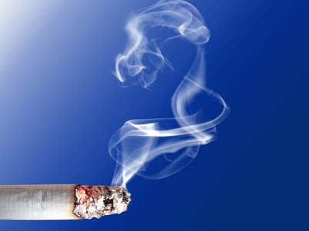


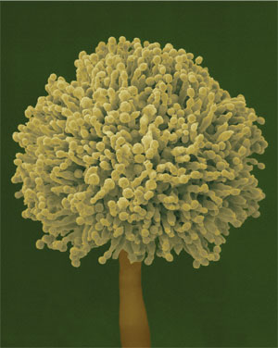

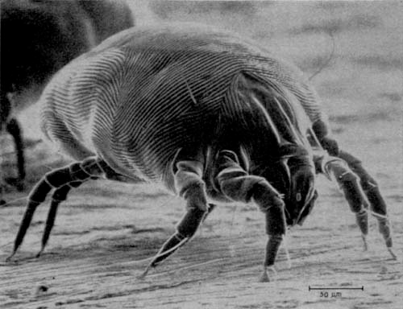
Tobacco Smoke and Other Triggers
•If you smoke, STOP!
•Do not allow smoking your house or car.
•Other triggers may include: weather changes, strong
odors, and high ozone.

Dust Mites:
Dust mites are tiny bugs that are found in every home.
•Put your pillow and mattress in a special dust-proof cover.
•Wash the sheets, blankets, and stuffed animals weekly in hot
water (>130°).

KNOW YOUR
ASTHMA TRIGGERS
Pollen and Outdoor Mold
•Keep windows closed; use air-conditioning when possible.
•Stay indoors from late morning to afternoon. Pollen and mold
spores are highest at that time.
•If you must be outdoors during high-pollen times, shower after
exposer.
Indoor Mold
• Fix leaky faucets, pipes, or other sources of water.
• Clean moldy surfaces with a cleaner that has bleach in it.

Animal Dander:
Dander is flakes of skin or dried saliva from animals with fur or feather.
• Removal of pets is the best option.
• Wash pets weekly, if possible.
• Keeps pets out of your bedroom or at least keep the door closed.
• HEPA filters may reduce airborne allergens from cats and dogs.
Not everyone reacts the same way to the same asthma triggers. Although it may be heard to always avoid them, here are some ways to help manage common asthma triggers.

