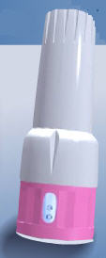
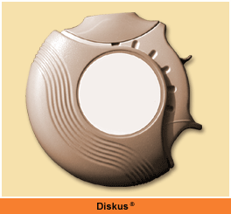
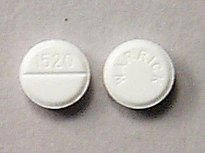
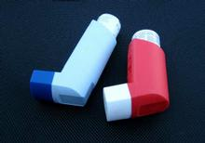

Reliever Medications
•Opens your airways and helps you to breathe
•Needs to be taken to treat the symptoms of asthma, such as
wheezing, shortness of breath, and chest tightness
•Are used to quickly relieve increased asthma symptoms
•Need to be kept with you wherever you are, at all times.

TREATING ASTHMA
Controller Medications
•Need to be taken every day to control your asthma, whether or not
you have symptoms
•Help prevent asthma symptoms before they start, so you should not
need to use your rescue inhaler as often
•Help keep the swelling and mucus in your lungs under control and
help stop asthma symptoms
•Can be taken as an inhaler or in tablets
The asthma medicine your Health Care Provider prescribes may be
CONTROLLER or RESCUE medications.

