
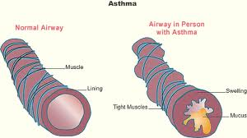
ASTHMA BASICS
What do asthma symptoms feel like?

•Wheezing: You hear a high-pitches whistling sound when you breathe.

• Chest tightness: It can feel as if someone is sitting on or squeezing our chest.

• Shortness of breath: You feel like you cannot catch your breath or are out of breath. You may even feel as if you cannot get enough air in or out of your lungs, like you are breathing through a straw.

•Coughing: Symptoms are often worse at night or in the early morning and may get worse with exertion. This may be one of many symptoms or it may occur on its own.

Asthma is a chronic disease that anyone may develop. People who have allergies have the greatest chance of getting it. If there is someone in your family with asthma, you may get it too. It is not always clear why people get asthma.

