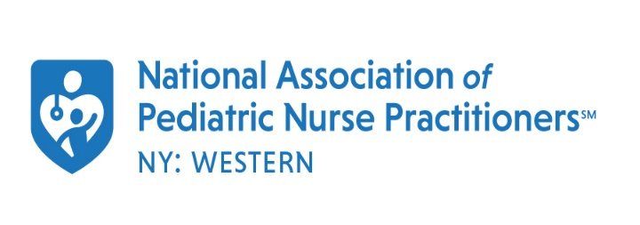

Nurse Practitioner of the Year Award

Criteria: Nominee must be a member in good standing of WNY Chapter of NAPNAP. The individual’s contribution must be significant in furthering the development of the NP role and promoting the health care of children.

Nominee’s name: _____________________________________________
Email: _____________________________________
Employer: ___________________________________________

Submitted by: ________________________________
Email: _____________________________________

Note: Please submit a statement in support of nominee highlighting particular strengths and initiative in clinical practice and health care delivery.

Return this form (with support statement) to:

WNY NAPNAP at napnapwny@gmail.com by April 1st

