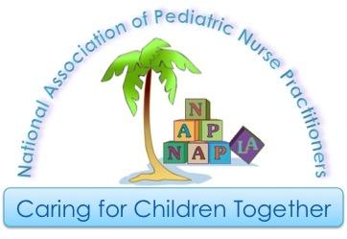

National Association of Pediatric Nurse Practitioners
Los Angeles Chapter

2017 NAPNAP-LA “Outstanding Nurse Practitioner of the Year” Award Nomination

The NAPNAP Los Angeles Chapter “Outstanding NP of the Year” Award is given to recognize a chapter member for outstanding contributions to the nurse practitioner role. Such contribution is through professional activity in the workplace, advocacy in the community, unique projects reflective of the NP role, mentoring members, precepting students, contributions to current literature, legislative activity, chapter offices, and/or other award worthy activities. If you are a member of NAPNAP-LA and you know someone whose commitment has been outstanding, please nominate the individual by completing the information below:

Name of Nominee:______________________________________________________________

Address:______________________________________________________________________

Phone: (H)________________________ (W)________________________________________

Title/Position:_________________________________________________________________

Name of Endorser:_____________________________________________________________

How long have you known nominee:_________ years
*If chosen, both the nominee and endorser need to be available to attend the Spring Conference on April 22, 2017

Discuss three reasons why you believe this person should be the recipient of the 2017 NAPNAP-LA “Outstanding Nurse Practitioner of the Year” Award

1.

2.

3.

Please email your nominations to Karla Haynes, RN, MPH, MS, CPNP at khaynes@chla.usc.edu. Thank you!
Deadline: March ^{1st}, 2017

