Proposed topics for discussion
1 Material and Corrosion Requirements for Net-Zero Emissions ships
  - Corrosion protection requirements for methanol fuel tanks
Methanol tanks can be constructed of either carbon steel or 300 series austenitic stainless steel.Carbon steel has the advantage of lower capital cost, but the disadvantage of higher life cycle cost due to increased maintenance and costs associated with corrosion protection. Currently, the corrosion protection of methanol fuel tanks is mainly applied with epoxy coatings or phenolic epoxy coatings, however, corrosion induced failures of carbon steel tanks have been reported. Is AMPP interested in developing corrosion protection standards for methanol fuel tanks?
  - Stress corrosion cracking test methods and material selection for ammonia fuels
1.2.1 stress corrosion cracking test methods for ammonia service
An important factor in the use of materials for ammonia service is the need to consider stress corrosion cracking of ammonia. However, no stress corrosion cracking test method has been found for materials in ammonia environments.Does AMPP have the standard of stress corrosion cracking test methods for ammonia service or plan to develop one?
1.2.2 material selection for ammonia fuels
Noting that NACE Committee T5E-JCI (1971-1972) established guidelines for ammonia containers. Has NACE released reports and guidelines to the public?

2 Corrosion in Arctic and Antarctic environments
2.1 stainless steel clad for ice breakers
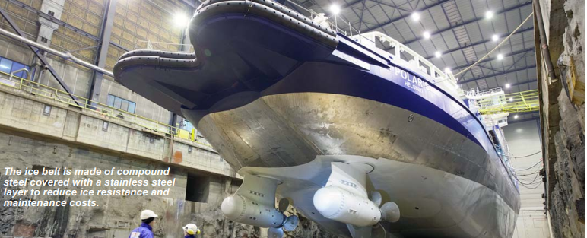
For ice breakers, wear of the structures can remove protective coating and accelerate corrosion damage. Some ice breakers are equipped with stainless steel clad as an ice belt in areas subjected to ice impact, mainly in the bow area and along the side of the hull.The Finnish icebreakers Fennica, Botnica and Nordica are equipped with explosion welded stainless steel ice belt, and reduced the need for maintenance of the hull. The Japanese icebreaker Shirase was equipped with rolled stainless steel clad plates, see Figure 1. For long term operation with ice interaction these solutions are considered to have longer durability than traditional coating systems.
- For stainless steel clad plates in direct contact with seawater, what type of stainless steel should be selected for its cladding and what is the minimum PREN?
- If stainless steel cladding is used, cathodic protection is required to avoid galvanic effects between the clad material and the carbon steel surfaces. Does AMPP's cathodic protection standard (such as NACE 7L198) apply to this situation?
- Due to its high strength, martensitic stainless steel propellers may be used in ice breakers, however, martensitic stainless steel propellers are in direct contact with seawater, how to consider its corrosion resistance approach?

3 High solid content coatings and water-borne coatings
Due to the demand for environmental protection, high solid content marine coatings and water-borne coatings are required to be developed for marine coatings.However are waterborne coatings capable of achieving the required corrosion protection? Does AMPP have the standard of high solid content coatings and water-borne coatings for marine applications or plan to develop one?
4 IACS EG M&W TECHNICAL FORUM
The IACS Materials&Welding technical forum will be held in Beijing in September 2024, and AMPP will be invited to participate in the technical forum on the first day.

