6 Things to Know About Opioids

1. chronic pain can often be well managed without drugs
Talk with your doctor about pain relief options that don’t involve drugs. Many of these are effective and have fewer risks.

2. there are serious risks even if you take opioids as prescribed
Many people can use opioids safely for a short time. But long-term use often comes with serious side effects and risks, even when taken as prescribed.

3. half of all opioid overdoses involve a prescription

If you are prescribed an opioid, ask for the lowest dose and smallest number of pills. Risk of overdose goes up when the drug is taken for long periods of time and at higher doses.

4. opioid use has become more common
Between 1999 and 2014, the amount of prescribed opioids sold in the U.S. nearly quadrupled but the amount of pain reported by Americans remained the same.

5. opioid overdose is a growing problem among women
When compared to men, women are more likely to have chronic pain, be prescribed a pain killer, be given higher doses and use the drug longer.

6. opioids don’t work well for long-term pain
They were first used to manage pain after surgery or during recovering from an accident. Now more doctors are prescribing opioids for conditions like low back pain and arthritis even though there is little data to support this.

Learn more at cdc.gov/drugoverdose
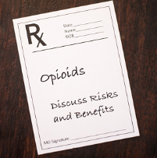
Using Opioids to Manage Pain?
Be prepared, be safe
If you are prescribed an opioid to manage pain, take steps to lessen your risk of side effects and serious harm, including addiction or overdose.

It’s important to be open and honest with your doctor

- Share your medical/family history and any medicines you are taking
- Speak up if your pain is not controlled by the dose prescribed
- Report any side effects – most can be relieved or treated

When prescribed an opioid, follow your doctor’s directions

- Take the prescribed dose as often as the doctor tells you to
- Follow up often with your doctor or health care team
- Do not drink alcohol or drive while taking opioids
- Never share your prescription drugs with others

Talk with your doctor about non-opioid options

- Before using prescription opioids consider aspirin, ibuprofen or naproxen
- Discuss using practices like acupuncture, yoga and massage
- These options, either alone or combined, can often manage pain as effectively as opioids with fewer side effects and risks

Learn more at cdc.gov/drugoverdose

Facts About Opioid Overdose

Did you know?

- The Centers for Disease Control (CDC) reports that 115 people in the U.S. die every day from opioid overdose

- Opioid overdose does not always happen because a person misuses or abuses the drug

- Overdose can happen when someone doesn’t understand the doctor’s directions about how much of the drug to take or how often

- Opioid overdose is a life-threatening emergency that requires immediate medical help

Watch for these signs and symptoms of opioid overdose

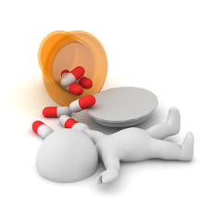
Small “pinpoint” pupils
Unable to stay awake or loss of consciousness
Pale, blue or clammy skin; blue fingernails and lips
Slow, shallow breathing or trouble breathing
Limp or lifeless body
Slow or stopped heart rate

Learn more at cdc.gov/drugoverdose

