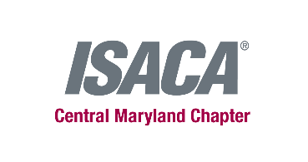
ISACA Central Maryland Chapter is hosting our 2nd annual golf tournament on September 13, 2019 at The Woodlands Golf Course.
The clubhouse is shared with Diamond Ridge Golf Course, for those at last year’s event we will be located in the same spot for registration.
Join us for at 7:00 with a Continental Breakfast followed by a warmup with Range Balls. At 7:40 we will hold a putting contest prior to teeing off. At 8:00 we will tee off and enjoy a beverage cart filled with water, soda, and beer. During the round around 11:30 the beverage cart will bring each team hot dogs. When finished we meet at the 19th hole for the BBQ BLAST luncheon including BBQ Pork, BBQ Chicken, Rotisserie Chicken, traditional side dishes, and a dessert tray of cookies and brownies. We will hold an awards and prizes ceremony about 30 minutes after the last team arrives for lunch. 19th hole is scheduled from 1:45 – 4:00.
Event Sponsorship opportunities
Company’s name is displayed at the event and placed on our ISACA-CMC website
- Hole sponsor $200 (sign with company name)
- Prize sponsor $200 (raffle giveaways at the awards and prizes ceremony)
- Game sponsor $300/per contest (putting, hole-in-one, closest to the pin, longest drive)
- Food/beverage sponsor $400
- Cart sponsor $500 (company name in each cart)
Main Sponsorship levels
- Silver $1000 – each includes free foursome, listing of company on website, table space for company brochures during morning registration, chance to say a few words during awards and prizes.
- Gold $2000 – same as Silver and signage at 2 holes
- Platinum $3000 – same as Silver, name in each cart, and signage at 6 holes

If you are interested in a sponsorship, please complete this form and email to contactus@isaca-cmc.org
Sincerely,
Dave, Stef, and John – your ISACA CMC Golf Committee

Business Name:
Contact Name:
Phone Number:
Email Address:
Signature:

