SASIG Webinars 6Sept 10Sept
ISACA Scotland Members Invited
Monday 6 September 2021, 11am-12noon (BST)
Exclusive preview of the new National Cyber Resilience Group - the flagship UK policing project that needs you!
https://www.thesasig.com/calendar/event/21-09-06-collaboration/
In the sometimes frenzied activity of the last year, it has been difficult to recognise all the programmes of work which have continued very effectively and indeed at even faster pace than originally anticipated. This is the case with the set of nine policing cyber resilience centres that have been set in place across England and Wales. These not-for-profit centres have proved extremely popular and have been an excellent example of how private sector companies can come together with policing to support the business community – particularly to meet the needs of the small to medium size business community In addition to the nine centres, the concept for a national company has been born. The national company will be chaired by the previous Chief Constable who held national cyber responsibility, Peter Goodman.
Ahead of the formal launch in October, SASIG is delighted to have an insight into what this new company will provide and why it is such a flagship project for policing in the UK.

Wednesday 8 September 2021, 11am (BST)
Applying metrics to security awareness, behaviour and culture
https://www.thesasig.com/calendar/event/21-09-08-metrics/
The ‘click rate’ is the most common metric used in security awareness, however it is inaccurate and focusses on only a small aspect of the behavioural transformation we seek to cultivate. In this interactive session, we will explore alternative measurements that can provide deeper, actionable insights. Join us to discuss measurement and consequences; gamification; and wider cultural analysis. We’ll also explore how to communicate this topic to the Board. Please bring your opinions, examples and insight to share with the group.

Friday 10 September 2021, 2pm-3pm (BST)
Keeping Critical National Infrastructure Secure
https://www.thesasig.com/calendar/event/21-09-10-cybercrime/
Cyber attacks are now arguably the biggest threat to the UK’s national infrastructure. In recent months we have seen ransomware on food production and fuel transportation wreak havoc in the United States. So how are we keeping the UK safe?
Join Varonis Field CTO, Brian Vecci, and SASIG as we host a live panel session with senior experts from Sellafield, Royal BAM, The National Cyber Security Centre, and more.
We will discuss the threat landscape, responding to breaches, and how to implement controls and provide visibility across expansive and complex IT estates.Our panellists and IT experts will also dive into:
- Real-life war stories of APT attacks and more
- The actual cost of a breach and how to recover
- Understanding and implementing NIS directives
- Common entry points for attackers
- Supply chain attacks

Other Webinars
Virtual Cybersecurity & Fraud Summit: London
September 14-15, 2021
ISMG's virtual London Cybersecurity & Fraud Summit has confirmed participation from the UK Cyber Security Council, NHS Digital, Vodafone, Airbus, Mastercard and more.
RSVP for this complimentary event at
https://events.ismg.io/event/cybersecurity-and-fraud-summit-london-2021/

NGINX Complimentary App Security Training: 14–15 September F5, Inc.
Join our complimentary two-part NGINX Application Security Training conducted by an official NGINX University trainer on September 14 and 15.
https://www.nginx.com/resources/webinars/nginx-complimentary-app-security-training-14-15-september/

Raspberry PI free seminar series about AI, machine learning, and data science for AI in Schools

https://form.raspberrypi.org/f/research-seminar-sign-up
- Tues 7 September
- Tues 5 October
- Tues 3 November
- Tues 7 December
- Tues 11 January
- Tues 1 February
Datalab Series of Events September
https://www.thedatalab.com/events/
Events
The Global Women in Tech Festival
September 24 - September 25
Closing Scotland’s Data Gap, Transforming Health & Social Care
September 28 @ 2:00 pm - 4:00 pm
Inclusive Innovation: Saorsa 2030 & the University of Strathclyde
September 30 @ 11:00 am - 11:45 am
SDSTM: Martech – Connectivity is the priority for 2021 and beyond
September 30 @ 12:00 pm - 1:00 pm
Around The Web
Microsoft Azure cloud COSMOS DB vulnerability is the ‘worst you can imagine’
https://www.theverge.com/2021/8/27/22644161/microsoft-azure-database-vulnerabilty-chaosdb
https://us-cert.cisa.gov/ncas/current-activity/2021/08/27/microsoft-azure-cosmos-db-guidance
Mitigation Guide
https://www.wiz.io/blog/chaosdb-how-we-hacked-thousands-of-azure-customers-databases
Mitigation Guide

CSA Continuous Audit Metrics
https://cloudsecurityalliance.org/research/working-groups/continuous-audit-metrics/

CyberScotland Partnership release Cyber Incident Response Pack
https://cyberscotland.us3.list-manage.com/track/click?u=95521127d4a8eebda241ca1b6&id=f8caa9b3ce&e=db7fe15518

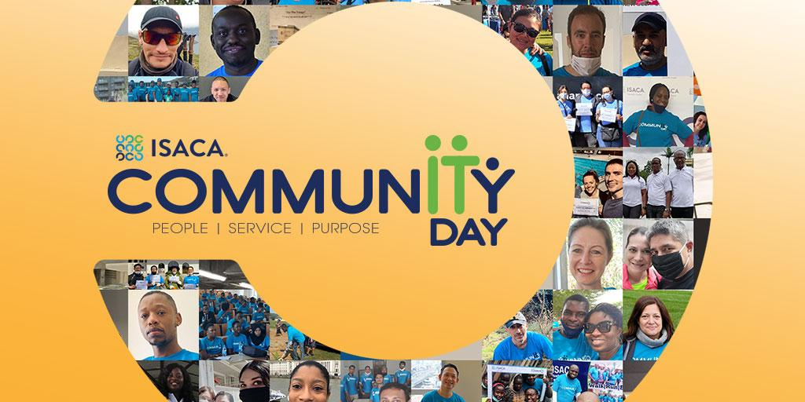

Senior Threat Intelligence Specialist
https://vacancies.virginmoney.com/ukw/en/job/692093/senior-threat-intelligence-specialist
Interested candidates should follow the information on the linked page to apply online
Closes 10 Sep 2021 GMT Daylight Time

