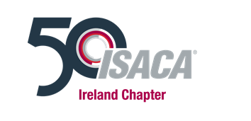
ISACA Ireland Mentoring Programme
Mentor application form

Thank you for your interest in the ISACA Ireland mentoring programme.

Our goal is to support the professional development of members, and to help Isaca lreland members set and achieve their goals and realise their full potential.

Please complete the form below and highlight the areas where you would be able to offer benefits to Isaca Ireland Mentees. This is a key part of the matching process as we will select a mentee for you based on this information.

Once you have completed the form please return it to Jackie Manning:
info@Isaca.ie

If you have any questions regarding the mentoring programme or the application process, please do not hesitate to contact us.

By completing this form, you are giving consent to the ISACA Ireland Mentoring team to use the details provided for the sole purpose of mentor-mentee matching. Your information will remain secure and confidential. It will not be disclosed outside of the team until you have been matched with a mentee, at which point your contact details will be passed on to the mentee.

For further information about how ISACA Ireland processes personal data please see our full privacy policy at https://engage.isaca.org/irelandchapter/privacypolicy

Name:
ISACA Membership number
Job Title:
Company:
Tel No:
Email:
Qualifications:

Why do you want to be a mentor?
What help would you like to offer a Mentee?
(Please be specific e.g. provide information; support in career progression; develop contacts; insight into a specific area, family life, working abroad etc.)
Would you prefer a mentor who is from the same geographic region as you?
Any other relevant information:

Date:

