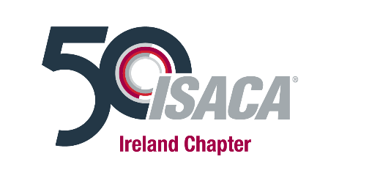

Why Should I Become a Mentor?
The ISACA Ireland Mentoring Programme provides a significant opportunity to build knowledge, skills and collaborative relationships across the ISACA Membership. We aim to foster coaching culture and enable mentees to realise their potential through empowerment and support. Mentoring is an investment in ISACA Ireland’s future and indeed your future success.
Contributing as a Mentor also brings many personal benefits including:
- Improving your own communication or people management and leadership skills: Effective managers and leaders need to know how to establish positive and trusting relationships. Working with a Mentee provides an opportunity to practice requisite skills, including empathy and active listening in a safe learning environment.
- Expanding connections and networks: Cultivating networks is a critical factor in career success and progression. Mentoring new individuals provides an opportunity to continue to build your own network, as you support your Mentee to expand theirs.
- Promoting self-reflection: Mentoring provides an opportunity to reflect not only on what you have achieved but also on how you got there. Which attributes and strengths were critical to your career path success? What should you be doing now to ensure you continue to learn and develop those attributes? Asking questions of a Mentee often supports deeper insights on your own learning path and achievements.
- On-going Support and Learning: During the Mentoring programme, we will be holding a number of meetup opportunities, regular updates via the ISACA Ireland newsletters covering key topics of interest to both Mentors and Mentees, maximising benefits of the Mentoring relationship.
- Gain feedback from your Mentee: Solicit valuable feedback from your mentee on your communication and coaching style. These insights serve to raise self-awareness and support your own development as a mentor and people manager. Feedback also helps to ensure that we can flex our styles to meet the needs of the mentee, and as required your own reports.
Next Steps
Ready to become a Mentor? Apply here for our 2019 programme, closing date is the 28th of June 2019.

