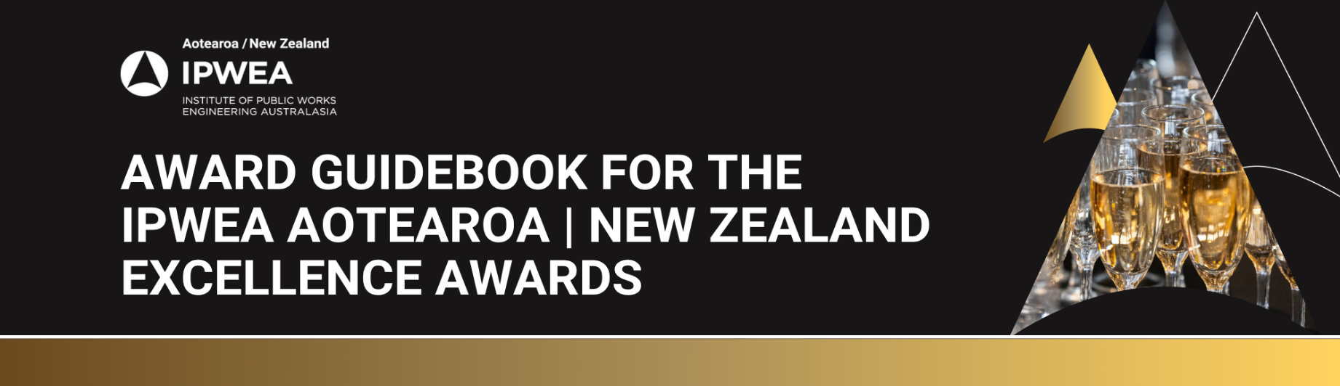

Example Submission Form
This is an example of the entry form to assist you with completion of you award submission. Please submit your entry online when ready via these links:
Project Award Submission or Individual Award Submission
Assessment Criteria for the following Awards:
- Best Public Works Project Under $2.0M
- Best Public Works Project Between $2.0M - $5.0M
- Best Public Works Project Over $5.0M
- Excellence in Project Innovation
- Excellence in Water Project
- Excellence in Road Safety
- Excellence in Environment & Sustainability
Executive Summary: Overview of the initiative and why it was undertaken.
Supporting Material: High-resolution images, testimonials, data, case studies, policies and engagement outcomes. (1000 words)
Project Objectives & Outcomes: How and why was the project developed?
Evidence of measurable outcomes and benefits achieved. (500 words)
Innovation: Evidence of originality or new approach.
How does the project demonstrate excellence and/or innovation?
Can the innovation be transferred/ shared? (500 words)
Community & Environment: What are the economic, financial, social, environmental, safety and community benefits?
Evidence of real benefits of the project. Quantify if applicable.
Who were the beneficiaries? (500 words)
Sustainability: How did the project demonstrate it meets sustainability objectives?
How effective were environmental issues managed? (500 words)

Assessment Criteria – Excellence in Asset Management and Excellence in Green Infrastructure Asset Management Awards Only
Executive Summary: Overview of the initiative and why it was undertaken.
Supporting Material: High-resolution images, testimonials, data, case studies, policies and engagement outcomes. (1000 words)
Project Objectives & Outcomes: How and why was the project developed?
Evidence of measurable outcomes and benefits achieved. (500 words)
Innovation: Evidence of originality or new approach.
How does the project demonstrate excellence and/or innovation?
Can the innovation be transferred/ shared? (500 words)
Community & Environment: What are the economic, financial, social, environmental, safety and community benefits?
Evidence of real benefits of the project. Quantify if applicable.
Who were the beneficiaries? (500 words)
Sustainability: How did the project demonstrate it meets sustainability objectives?
How effective were environmental issues managed? (500 words)
Asset Management Integration: Evidence of alignment with asset management principles.
Lifecycle planning and service outcomes. (500 words)

Assessment Criteria – Young IPWEA Emerging Leader Only
Active within the Institute (500 words)
Shows strong and active leadership (500 words)
Exerts a positive influence in the industry (500 words)
Demonstrates they are giving back to the industry (500 words)
Outstanding contribution to the industry (500 words)

Assessment Criteria – Excellence in Diversity & Inclusion Only
Executive Summary: Overview of the initiative and why it was undertaken.
Supporting Material: High-resolution images, testimonials, data, case studies, policies, engagement outcomes. (1000 words)
Project Objectives & Outcomes: How and why was the project developed?
Evidence of measurable outcomes and benefits achieved.
Could include workforce diversity improvements, engagement, retention, accessibility, cultural outcomes, community participation, or inclusion outcomes. Quantify where possible. (500 words)
Innovation: Evidence of originality, leadership, collaboration, or new approaches to advancing DEIB within public works and engineering.
Can the initiative be replicated or scaled? (500 words)
Community & Environment: Demonstrated benefit to staff, industry, stakeholders, or the broader community.
Who benefited and how? Consider social, cultural, accessibility, Indigenous, gender, disability or age-related outcomes. (500 words)
Sustainability: Evidence the initiative is embedded into organisational culture, policy, strategy, recruitment, leadership or operations.
What mechanisms ensure ongoing impact? (500 words)

