IPWEA Victoria helps people be their best!
We are the Education, Connection, Information & Support
provider of choice for public works professionals!
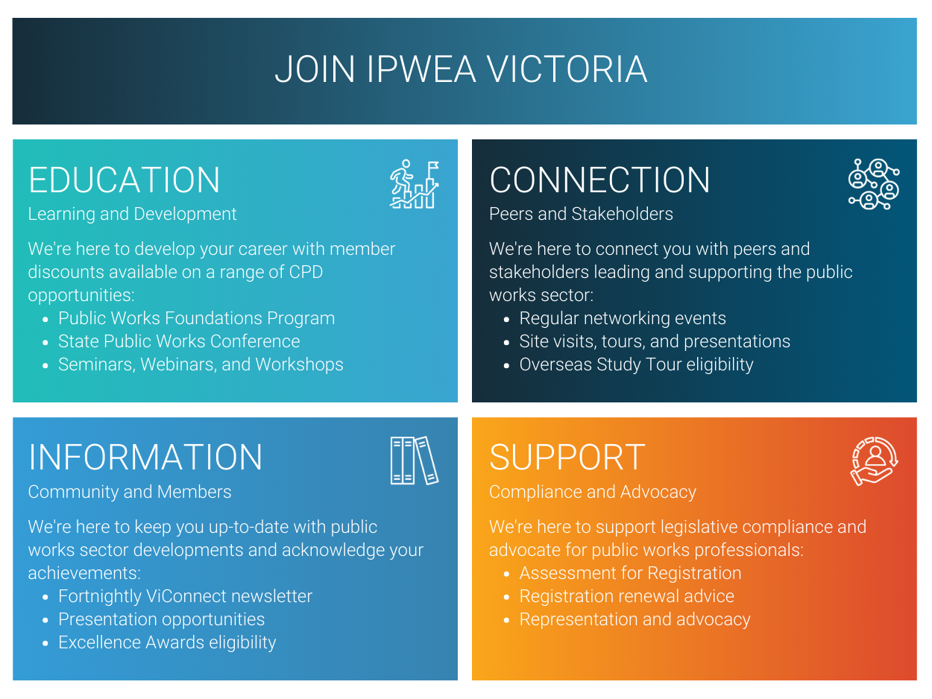
IPWEA Victoria membership supports staff and organisational development!
Group discounts are available for Councils and allied public works sector employers requiring memberships for multiple engineering and asset management staff. Organisations have the convenience of a single invoice and group members receive all the benefits of individual members:
Education: Discounts on role-relevant Learning & Development courses, Conferences & webinars
Connection: Site visits, social functions and peer networking events
Information: Sector newsletters, CPD Bulletins and IPWEA publications
Support: Compliance services, advice and advocacy for public works sector issues
Group Membership saves your organisation time and money:
- 2 – 5 members: 5% discount! | - 11-20 members: 15% discount!
- 6 – 10 members: 10% discount! | - 20+ members: 20% discount!
Contact David Hallett for further details or complete and send this form to vic@ipwea.org

Organisation
Name:
Address:
Applicant
I hereby apply for a group membership of IPWEA Victoria on behalf of the above organisation for the following staff.
Authorising Person: |  |  |  | Position:
Signature: |  |  |  | Date: | PO No:
Nominated Members
Category/Fee (incl. GST): Member $390.50 | Associate Member (< 5yrs experience) $242 | Senior Member (> 65yo) $115.50
 | Name | Email |  | Mobile | Category | Fee
1.
2.
3.
4.
5.
6.
7.
8.
9.
10.
11.
12.
13.
14.
15.
16.
17.
18.
19.
20.
Please include additional member details on a separate page |  |  |  | TOTAL Fee (incl. GST)
 |  |  |  | DISCOUNTED FEE (incl. GST)
Payment
Payment Method: □ Credit Card (details below) □ Cheque attached (payable to IPWEA Victoria) □ Please invoice
Card Type: □ VISA □ MasterCard |  |  |  | Name on Card:
No: |  | Expiry: / | CVC: | Signature:

