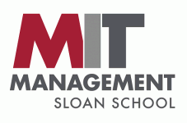 | 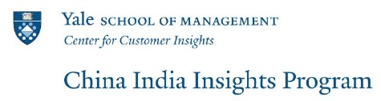

2019 China India Insights Conference
September 20-21, 2019
at MIT Sloan School of Management
100 Main Street, Cambridge, MA 02142

Call for Abstracts
Deadline for Submitting Abstracts: March 31, 2019
Send Abstracts to: ciip@yale.edu

Organizers
China India Insights Program at the Yale School of Management
&
MIT Sloan School of Management

This annual conference serves as a forum for academic scholars and research practitioners from diverse disciplines to share the best available research on both consumer and firm behavior related to China and India - two of the world’s largest and fastest growing emerging markets. Research on other emerging markets is also welcome. All interested academics and marketing practitioners are invited to register and attend, subject to conference capacity constraints. Last year's conference agenda is available here.
The conference will begin with a reception on Thursday evening, September 19 and end late afternoon on Saturday, September 21. There will be a celebratory dinner on Friday evening.
Abstract Submission
Researchers interested in presenting a paper should submit abstracts -- one to two pages in length and double-spaced in pdf format. Include the title of the paper, name, affiliation, mailing and email addresses of the authors. Please specify who will be the presenting author. Abstracts should be sent to ciip@yale.edu by March 31, 2019. Chosen presenters will be notified by April 30, 2019.
Abstracts will be reviewed by the conference chair Juanjuan Zhang (MIT) and a program committee comprised of Stephan Anderson (Stanford Graduate School of Business), Rajesh Chandy (London Business School), Yuxin Chen (NYU Shanghai), Debu Purohit (Duke University), Qiaowei Shen (Peking University), and Baohong Sun (CKGSB).

Registration
Academic researchers and industry practitioners interested in emerging markets are invited to register and attend. The registration fee for academics is $295 and for non-academics is $495. Registration fees are waived for all speakers at the conference. Registration for the conference will open on May 1, 2019.

Doctoral Students
The conference will provide a partial travel subsidy for selected doctoral students attending the conference. Doctoral students should submit an application including a paragraph detailing their interest in the conference, their name, address, email address, and institution as well as a recommendation from their advisors outlining their potential interest in research on emerging markets. The program committee will select students based on its assessment of fit and interests of the student with the conference. Applications should be sent to ciip@yale.edu with “PhD Student Support Application” in the subject line of the email. The deadline for applications for support is March 31, 2019. Selected students will be notified by April 30, 2019. PhD students may submit a request for exemption from conference fees to ciip@yale.edu. Requests will be honored on a space-available basis.

