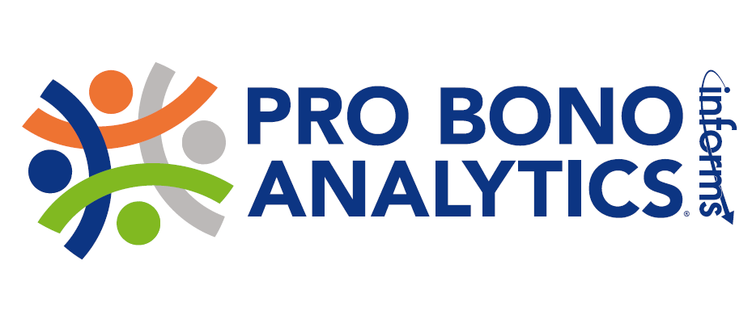
VOLUNTEER REQUEST FORM

Pro Bono Analytics Overview |  | The mission of the INFORMS Pro Bono Analytics program is to offer a platform for the operations research and analytics community to volunteer their skills for the benefit of underserved populations and developing communities in the U.S. and abroad. The program brings analytics techniques to non-profit organizations that may lack these skills internally and/or lack the resources to acquire these skills. The program also provides a new source of interesting real-world project experience to INFORMS members and other analytics/OR professionals, including experienced academics and practitioners as well as students and young professionals.
Project Overview
How to Volunteer |  | If you would like to be considered for this pro bono opportunity, please email probono@informs.org to express your tentative interest. We will then conduct conference calls during which you can learn more about the organization and the project, determine if there is a good fit with your interests and skills, and decide if you wish to submit a proposal to provide the Pro Bono service.  Note: To help us manage the program, we request that you please not contact the non-profit organization directly.
Questions |  | Contact us at probono@informs.org or visit us at www.probonoanalytics.org

THANK YOU FOR SUPPORTING PRO BONO ANALYTICS!
Project Description
Non-Profit | Name of Organization: I AM MENtality Youth Male Empowerment Project  http://www. iammentality.com/
Project Location:
Baltimore City and surrounding counties

Primary Objectives of the Organization:
Our mission is to enlighten the minds of male youth through mentorship and leadership development. We provide leadership development opportunities for youth ages ranging from 7-18 years of age.

Main Activities of the Organization:
We facilitate a comprehensive leadership development academy with the classes leadership skills, conflict resolution, anger management, financial literacy, professionalism, health & wellness, effective public speaking, self-awareness, life skills, and character building will be a part of the curriculum. Our purpose for choosing this focus is to support youth in underserved communities, void of quality programming, and resources that will promote their success. This initiative would utilize individual, peer-to-peer, virtual, and developmental skills mentoring components. The training and programming offered would engage every learning style.

 | Approximate number of staff and volunteers: 9 volunteers
 | INFORMS Pro Bono Analytics Project No.: 201810-#1
 | Project title: Data Collection for I AM MENtality
Project summary in 20 words or less:
Collecting data to support our efforts toward developing youth awareness of leadership, positive adult-youth relationships, engagement in life-skill building activities, and youth participation and leadership of valued community activities.
Desired start/end date: 11/15/18
Estimated time commitment by volunteers: NA
Project location: Baltimore
Is travel by the volunteer involved, and if so, where:
No travel required.
Desired special skills/qualifications for volunteers:
Data analysis and inference.
___________________________________________________________________________________
Project description:
Select outcome measures and models suitable for demonstrating the effectiveness of our programs.
Determine any additional variables necessary for those models.
Determine which if any data currently collected (as manual records) would be useful for documenting outcomes.

