Database Installed: Oracle 11g XE. Up and running

JDBC Pool = XE – tested and working.

Aliases connected to XE - tested and working

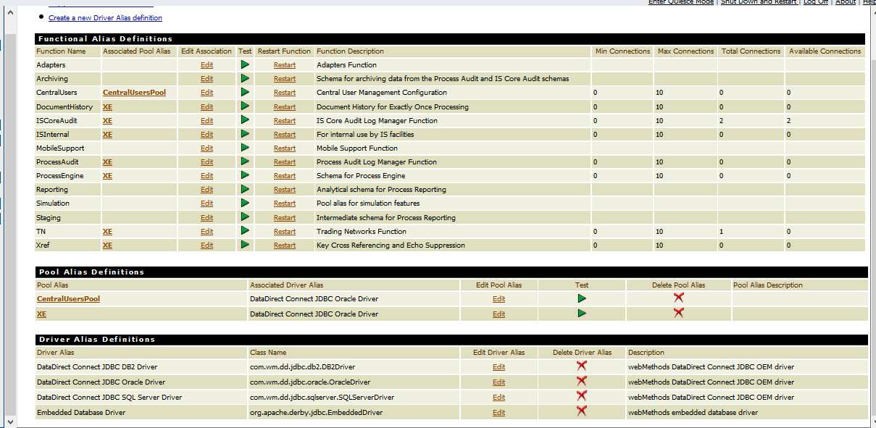

Triggers all active;

Simple.work:listenForSimpleDoc

simpleProject.simpleProcess.Default:subscriptionTrigger

simpleProject.simpleProcess.simpleProcess_1.Deafult:transitionTrigger

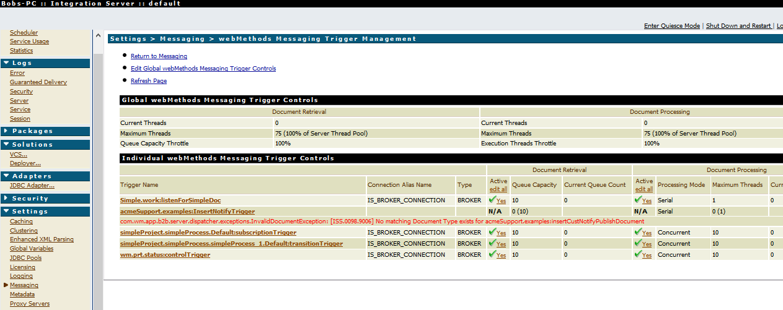

Error:

2015-01-24 16:59:23 CAT [ISS.0098.0049C] Exception:com.wm.app.b2b.server.ISRuntimeException: [Exception: Unable to connect to database!] not found in "com.wm.resources.CoreExcpMsgs". while executing trigger. Rejecting Document for TriggerStore:simpleProject.simpleProcess.Default:subscriptionTrigger.