Steps:
- This is my WS.
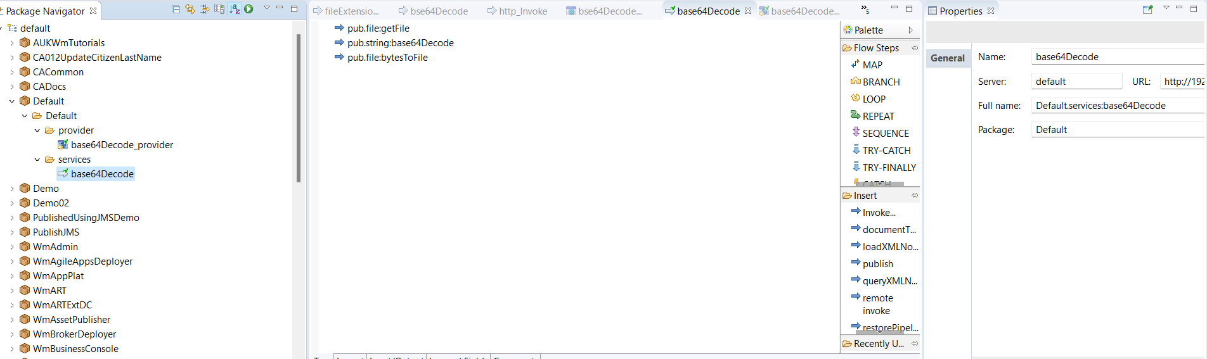

2.This is my provider.
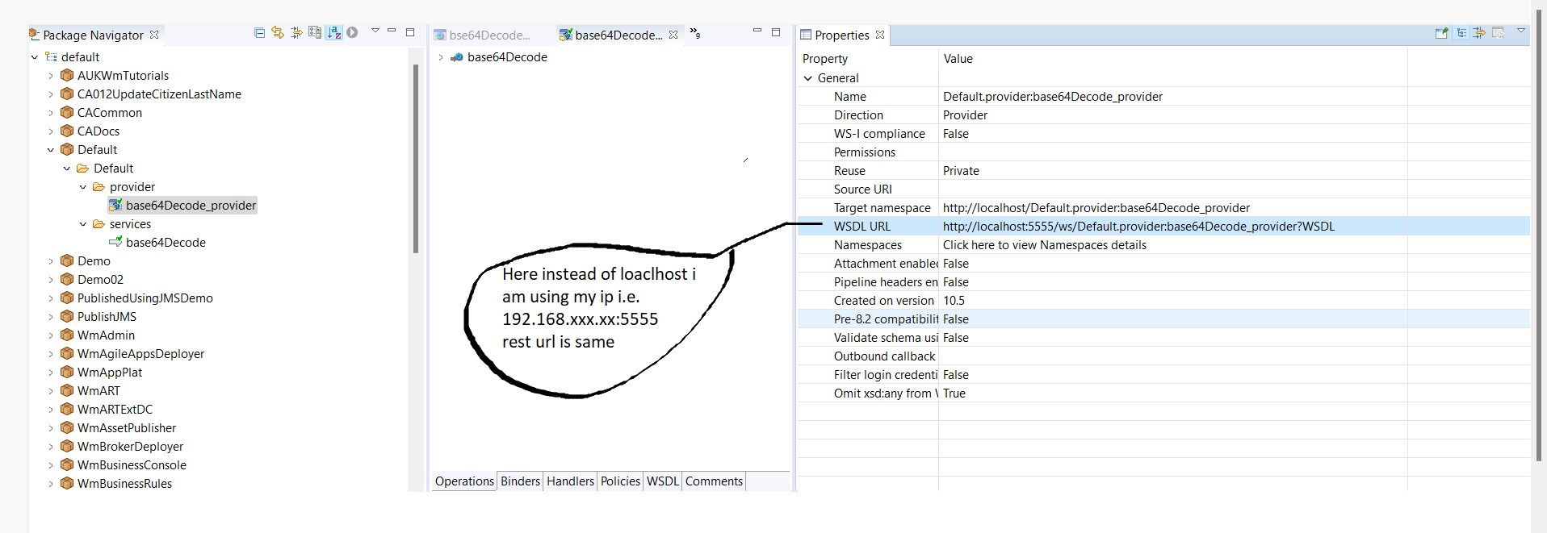
3.Importing the provide into SOAPUI using the base64Decode_provider.wsdl.

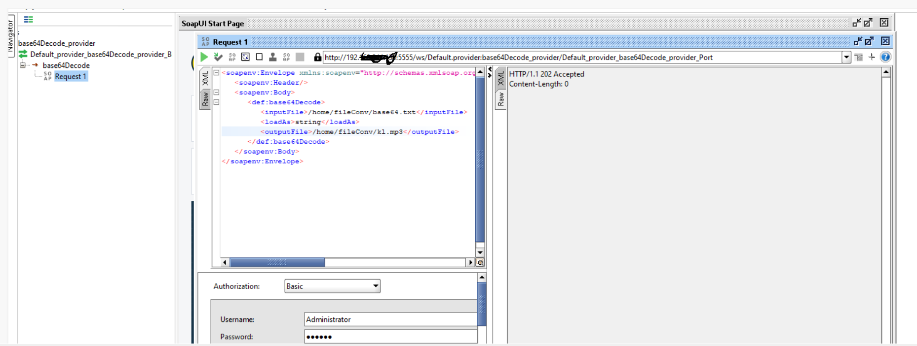
4. Result.
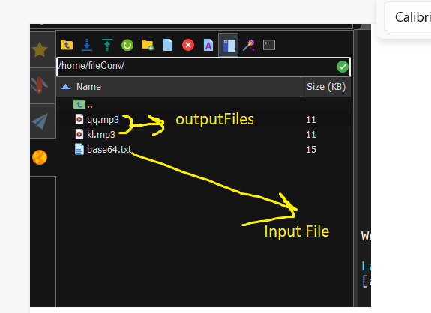

But the problem is when I am calling this url in the pub.client:http. The file is not creating.

