**Author:** Mahesh K Sreenivasulu

**Configuring Integration Server for MQTT Messaging on IS 10.5**

MQTT (Message Queuing Telemetry Transport) is a publish-and-subscribe messaging protocol often used with devices in the Internet of Things (IoT) and machine-to-machine (M2M) communication. MQTT was designed to be light-weight and used with devices for which resources and network bandwidth are constrained, such as a sensor on a smart device. The protocol supports telemetry applications which measure and transmit data from sensors and devices.

Integration Server, which supports MQTT version 3.1.1, can act as an MQTT client that publishes messages to a topic on an MQTT server and an MQTT client that subscribes to topics on the MQTT server.

**Supported MQTT Servers**

Integration Server supports MQTT version 3.1.1. Integration Server is certified to work with the MQTT servers listed in the following table.

**MQTT Server Version**

Eclipse Mosquito 1.5 and 1.6

Universal Messaging 10.5

**Setting up MQTT Server on your machine (Windows)**

* Download the “mosquitto-1.6.7-install-windows-x64.exe” from <https://mosquitto.org/download/> on your windows machine and run the installer file as Administrator
* Upon the successful installation, go to windows services and make sure “Mosquitto Broker” service is “Running” if the status is not “Running” start the service



* Upon the successful installation, go to windows services and make sure “Mosquitto Broker” service is “Running” if the status is not “Running” start the service
* You can also check if Mosquitto broker has started and running by the command **netstat -an** or **netstat -an|find "1883"** from the command prompt
* Note the default port is 1883

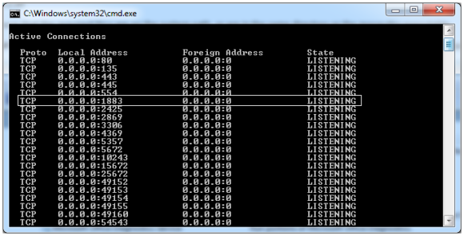

* To monitor and administer the “Mosquitto Broker” you can download and install client tools for example: mqttfx-1.7.1-windows-x64.exe from <https://mqttfx.jensd.de/index.php/download> and you can connect to MQTT server as shown below:

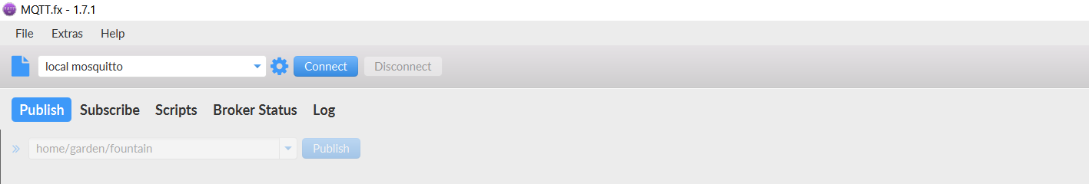

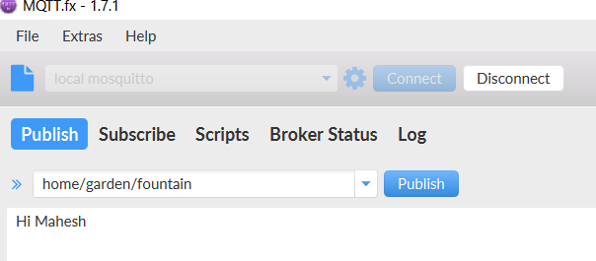

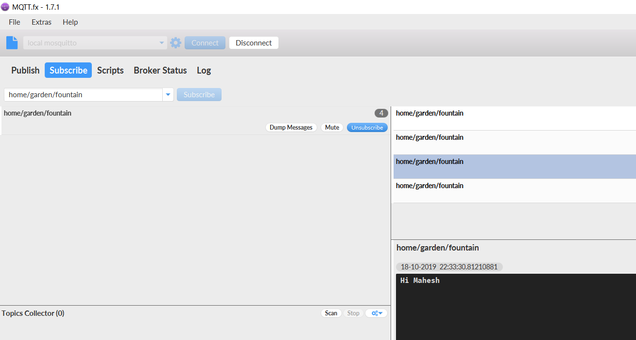

**Creating an MQTT Connection Alias**

* Open Integration Server Administrator.
* In the **Settings** menu of the Navigation panel, click **Messaging**.
* Under MQTT Configuration, click **MQTT Settings**.
* Click **Create MQTT Connection Alias** as shown below.

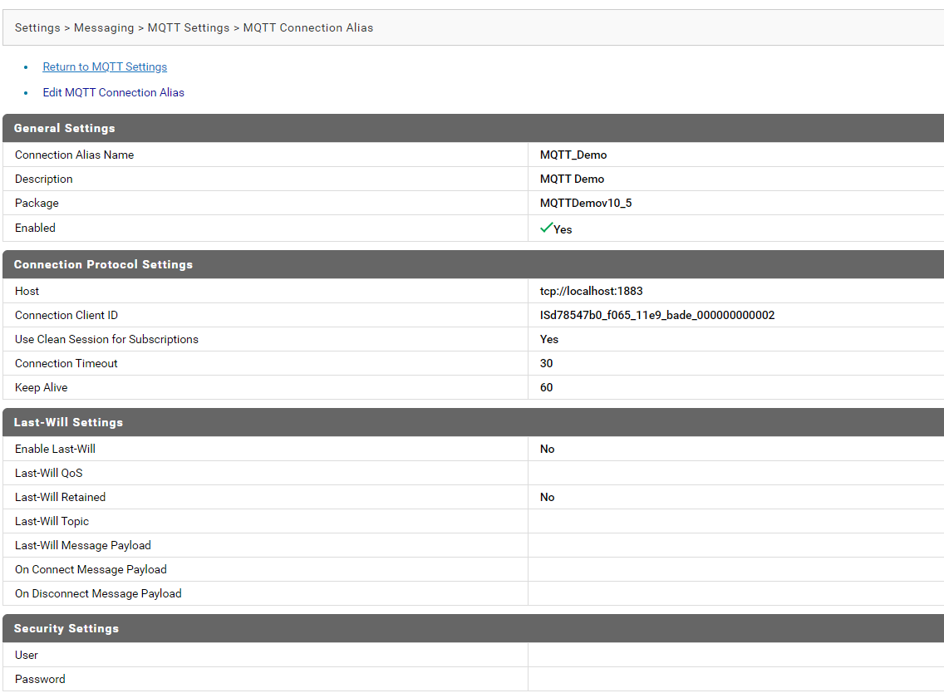

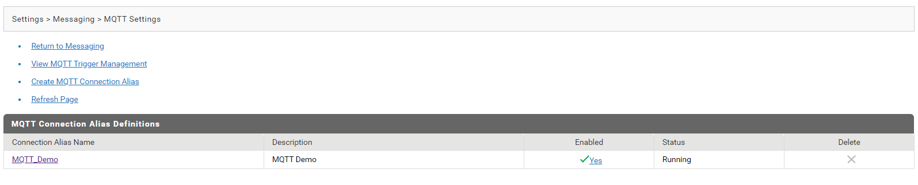

**Demo on MQTT Server Publish and Subscribe using Integration Server**

Refer the demo package attached “MQTTDemov10_5”

* Integration Server can publish MQTT messages to an MQTT server using the built-in

service **pub.mqtt:publish**.

* Integration Server can subscribe to topics by creating an MQTT trigger. The MQTT

trigger receives messages published to the topic on the MQTT server and then

invokes a trigger service to process the messages.

* Integration Server uses an MQTT connection alias to create a connection to the

MQTT server. An invocation of the **pub.mqtt:publish** service requires the MQTT

connection alias to publish the message to the MQTT server. Similarly, an MQTT

trigger specifies the MQTT connection alias that it uses to identify the MQTT server

from which it retrieves messages and on which the trigger creates subscriptions.

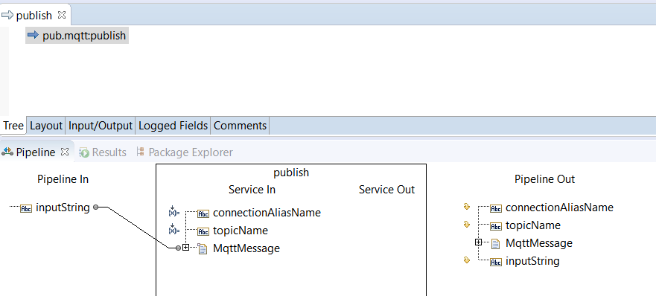

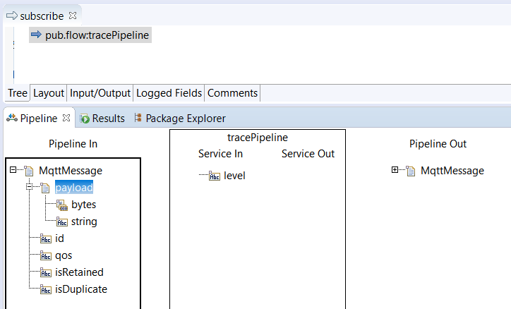

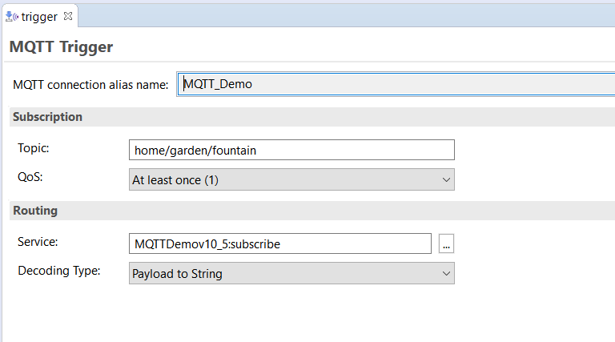

* Run the Publisher service

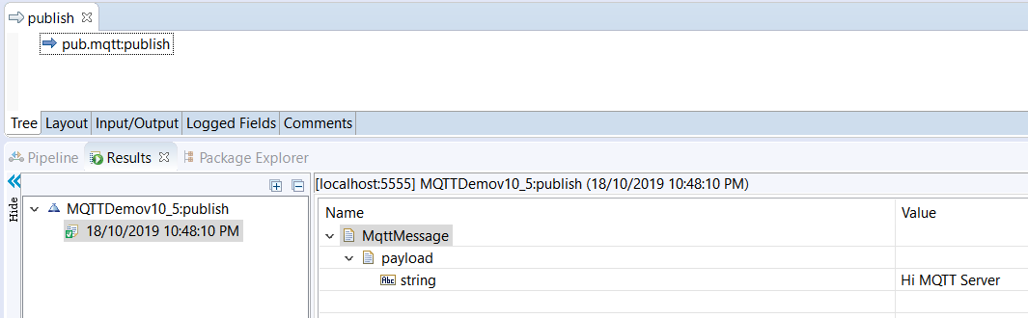

* Check the server.log file if the message is successfully subscribed from MQTT Server Topic

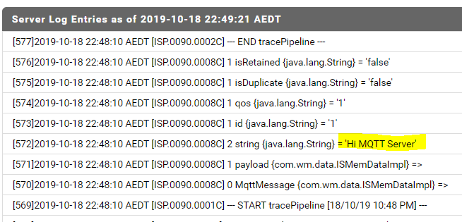

**References:** <http://techcommunity.softwareag.com/ecosystem/documentation/webmethods/integration_server/pie10-5/10-5_Integration_Server_Administrators_Guide.pdf>

<http://techcommunity.softwareag.com/ecosystem/documentation/webmethods/integration_server/pie10-5/10-5_Integration_Server_Built_In_Services_Reference.pdf>