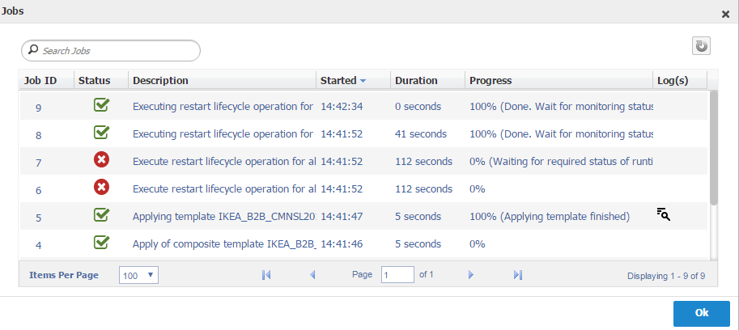

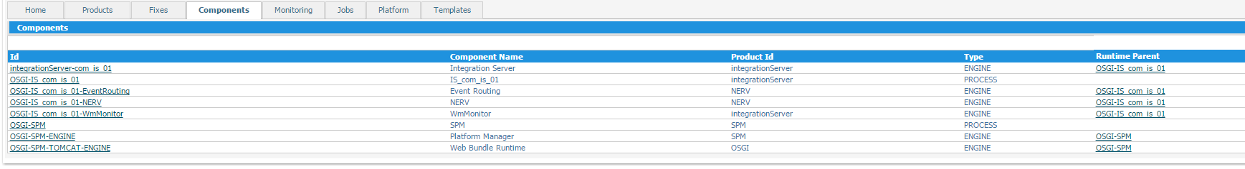

**INFO | jvm 1 | 2016/07/22 12:43:44 | at java.util.concurrent.ThreadPoolExecutor$Worker.run(ThreadPoolExecutor.java:617)**

**INFO | jvm 1 | 2016/07/22 12:43:44 | at java.lang.Thread.run(Thread.java:745)**

**INFO | jvm 1 | 2016/07/22 12:43:44 | 2016-07-22 12:43:44.741 UTC (com.softwareag.platform.management. ... .JobImpl ) [SPM.JobImpl.SPMJOBE0003] ERROR: Job 1 failed!**

**INFO | jvm 1 | 2016/07/22 12:43:44 | 2016-07-22 12:43:44.741 UTC (com.softwareag.platform.management. ... .JobImpl ) [SPM.JobImpl.SPMJOBE0003] ERROR: com.softwareag.platform.management.common.exceptions.PlatformManagerException: Un-handled internal server error. The specified runtime component OSGI-IS_com_is_01-WmMonitor could not be found on node http://CFSEELM-LX4359.ikeadt.com:8092.**

**INFO | jvm 1 | 2016/07/22 12:43:44 | 2016-07-22 12:43:44.741 UTC (com.softwareag.platform.management. ... .JobImpl ) [SPM.JobImpl.SPMJOBE0003] ERROR: at com.softwareag.platform.management.jobmanager.impl.JobImpl.waitForResult(JobImpl.java:156)**

**INFO | jvm 1 | 2016/07/22 12:43:44 | 2016-07-22 12:43:44.741 UTC (com.softwareag.platform.management. ... .JobImpl ) [SPM.JobImpl.SPMJOBE0003] ERROR: wraps: com.softwareag.platform.management.common.exceptions.PlatformManagerException: Un-handled internal server error. The specified runtime component OSGI-IS_com_is_01-WmMonitor could not be found on node http://CFSEELM-LX4359.ikeadt.com:8092.**

**INFO | jvm 1 | 2016/07/22 12:43:44 | 2016-07-22 12:43:44.741 UTC (com.softwareag.platform.management. ... .JobImpl ) [SPM.JobImpl.SPMJOBE0003] ERROR: at com.softwareag.platform.management.jobmanager.impl.JobImpl.waitForResult(JobImpl.java:156)**

**INFO | jvm 1 | 2016/07/22 12:43:44 | 2016-07-22 12:43:44.741 UTC (com.softwareag.platform.management. ... .JobImpl ) [SPM.JobImpl.SPMJOBE0003] ERROR: wraps: com.softwareag.platform.management.common.exceptions.NotFoundResourceException: The specified runtime component OSGI-IS_com_is_01-WmMonitor could not be found on node http://CFSEELM-LX4359.ikeadt.com:8092.**

**INFO | jvm 1 | 2016/07/22 12:43:44 | 2016-07-22 12:43:44.741 UTC (com.softwareag.platform.management. ... .JobImpl ) [SPM.JobImpl.SPMJOBE0003] ERROR: at com.softwareag.platform.management.jobmanager.impl.JobImpl.waitForResult(JobImpl.java:156)**

**INFO | jvm 1 | 2016/07/22 12:43:44 | 2016-07-22 12:43:44.741 UTC (com.softwareag.platform.management. ... .JobImpl ) [SPM.JobImpl.SPMJOBE0003] ERROR: wraps: com.sun.jersey.api.client.UniformInterfaceException: GET http://CFSEELM-LX4359.ikeadt.com:8092/spm/monitoring/runtimestatus/OSGI-IS_com_is_01-WmMonitor returned a response status of 404 Not Found**

**INFO | jvm 1 | 2016/07/22 12:43:44 | at com.sun.jersey.api.client.WebResource.handle(WebResource.java:686)**

**INFO | jvm 1 | 2016/07/22 12:43:44 | at com.sun.jersey.api.client.WebResource.access$200(WebResource.java:74)**

**INFO | jvm 1 | 2016/07/22 12:43:44 | at com.sun.jersey.api.client.WebResource$Builder.method(WebResource.java:621)**

**INFO | jvm 1 | 2016/07/22 12:43:44 | at com.softwareag.platform.management.client.remote.requests.Request.syncCall(Request.java:397)**

**INFO | jvm 1 | 2016/07/22 12:43:44 | at com.softwareag.platform.management.client.remote.services.BaseProxyService.syncCall(BaseProxyService.java:66)**

**INFO | jvm 1 | 2016/07/22 12:43:44 | at com.softwareag.platform.management.client.remote.services.BaseProxyService.syncCall(BaseProxyService.java:58)**

**INFO | jvm 1 | 2016/07/22 12:43:44 | at com.softwareag.platform.management.client.remote.services.BaseProxyService.syncGet(BaseProxyService.java:27)**

**INFO | jvm 1 | 2016/07/22 12:43:44 | at com.softwareag.platform.management.client.remote.services.LandscapeMonitoringServiceEndpointRemoteProxy.getRuntimeStatus(LandscapeMonitoringSe**