1. Install step ended with the below message in screen

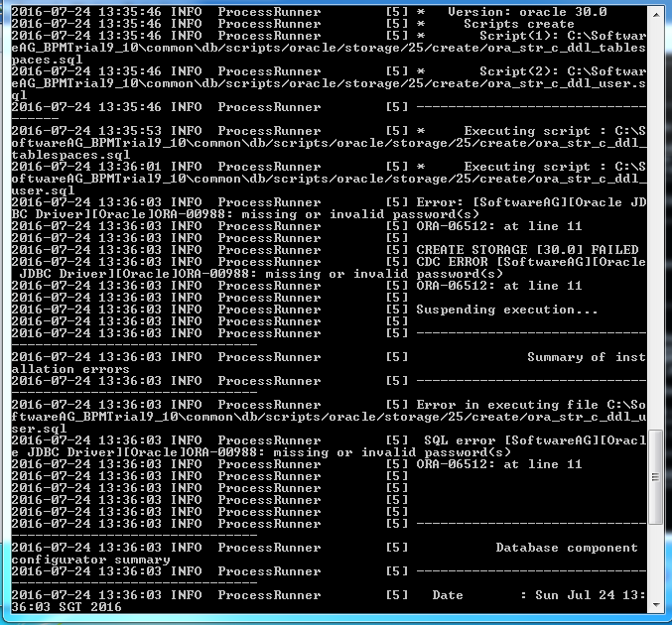

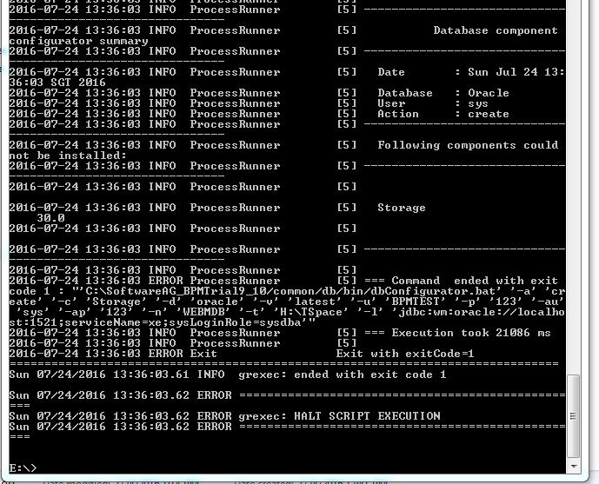

1. Below the partial log from install log. As the full log is more than 100MB size.

