1. Admin user is created with below privileges

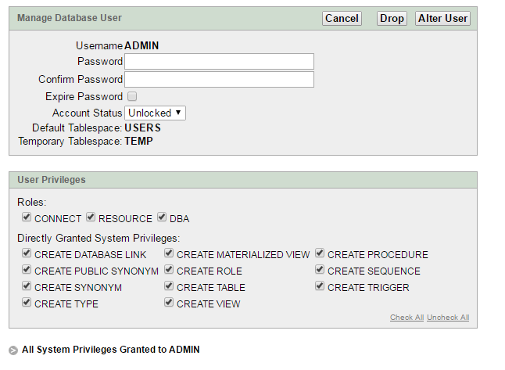

1. Properties File

