createArcFile

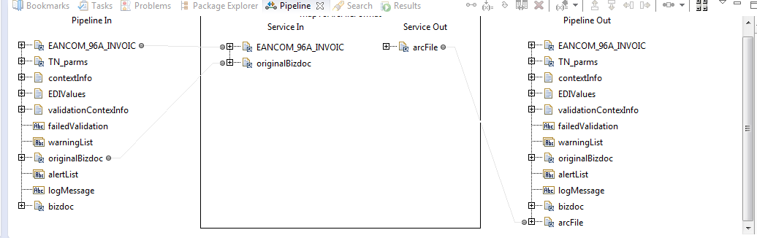

pub.xml:documentToXMLString

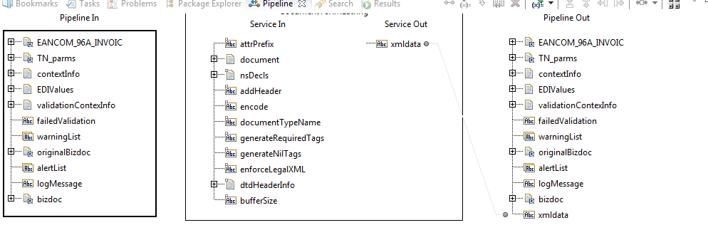

pub.xml:xmlStringToXMLNode

