webMethods 9.9, with latest fixes installed
IS and UM are running on my laptop, windows 10

IS with only one UM configured (nsp://mdias-PC:9000, also tried with nhp):
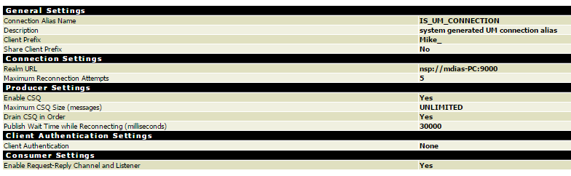

myDoc, IS document (UM channel), in sync with the messaging provider:
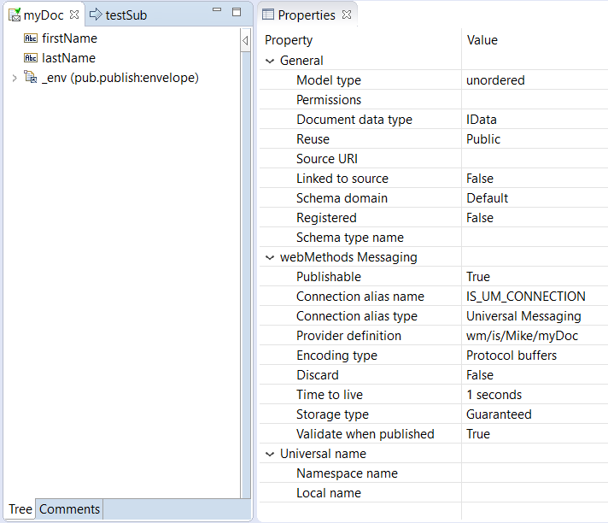
I can publish the document myDoc to my IS_UM_CONNECTION connection Alias, the document is published and subscribed successfully by the trigger… But I was trying to understand and test the ACL you can configure on a Channel with UM and see if I could make a document unpublishable from IS.

The ACL on the UM is configured for the channel myDoc in that way (tested various options..):
I’ve clicked click on the 'Apply' button.
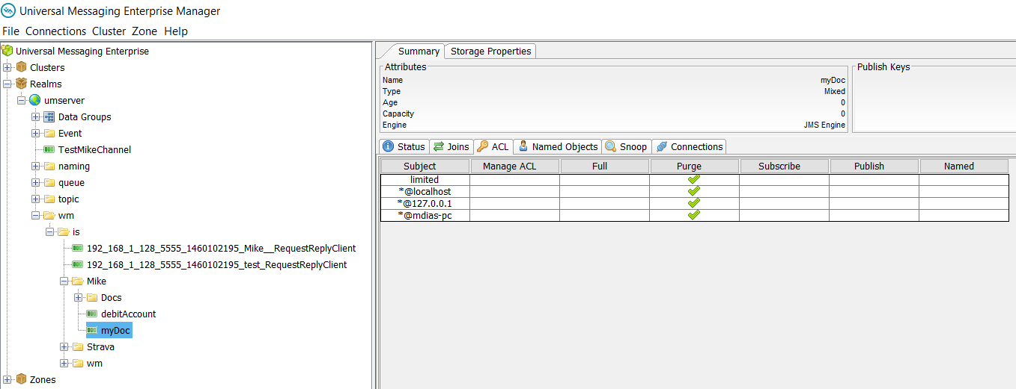

But the channel receives the published document: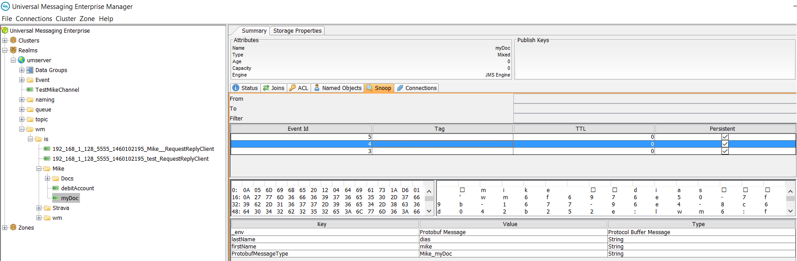

And the trigger can subscribe it as well:
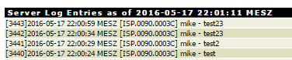

So I am doing something wrong here?

