**Step 1**: Under your “Get Process List”, make Auto Refresh as true. This helps in auto refreshing your webservice upfront and loads the results.

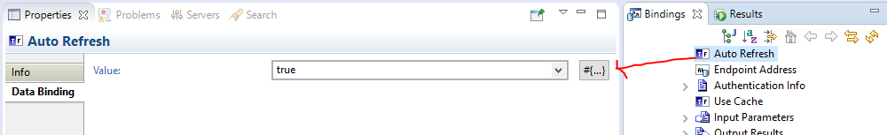

**Step 2:** Drag a dropdown on to Canvas, go to properties -> choices, click on + icon then Option Group.

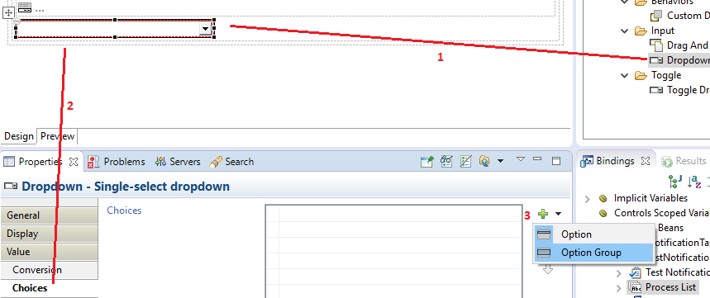

**Step 3:** Here you there are two choices, one is simple other advanced.

*Simple Approach –* Double click on Options group, go to value and click on “binding button (#{…})”

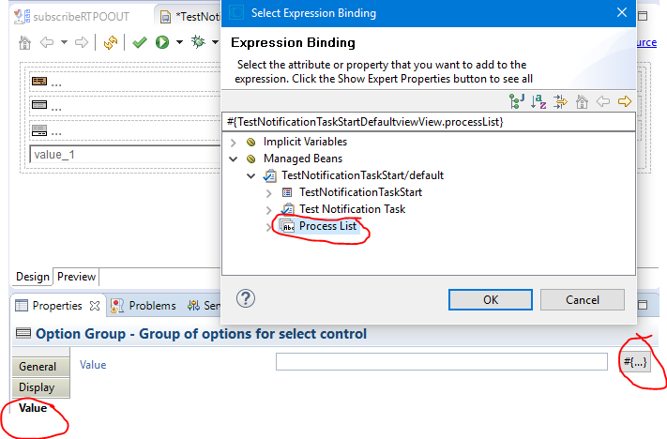

*Advanced Approach –* This is something similar to what I explained you in different post about “TableContentProvider”. We use, “ListProvider” in case of options. Approach is almost similar.

Right click on your String[] or ArrayList, then NEW -> Content Provider

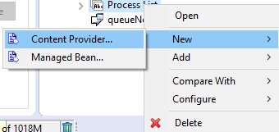

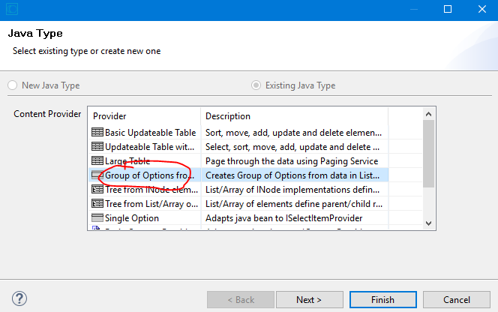

Click Next and then Finish.

Now, go to dropdown properties -> choices -> options group. Double click on Options group, go to value and click on “binding button (#{…})”

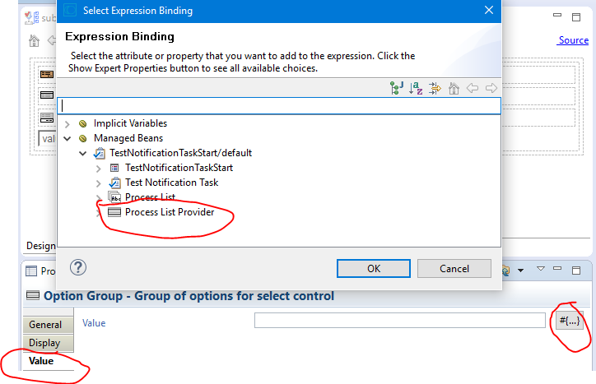

THE ADVANTAGE OF GOING WITH SECOND APPROACH (PROVIDER APPROACH) IS, IT ALLOWS YOU TO SET LABELS, VALUES AND MANY OTHER SORT OPTIONS ETC WHICH YOU DO NOT GET WITH PLAIN STRING LIST