1. Create a flow service with two inputs.
2. binField

ensure that the properties for the above field is as such:

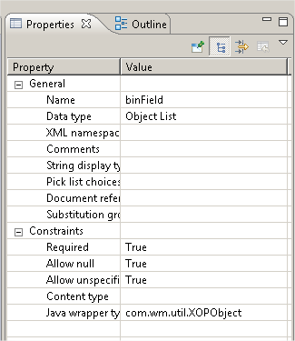

1. attachmentNames – string list
2. First step in your flow service initialize index to ‘zero’ this will ensure that we get the first attachment name which we will concatenate with the path we are willing to save our files.

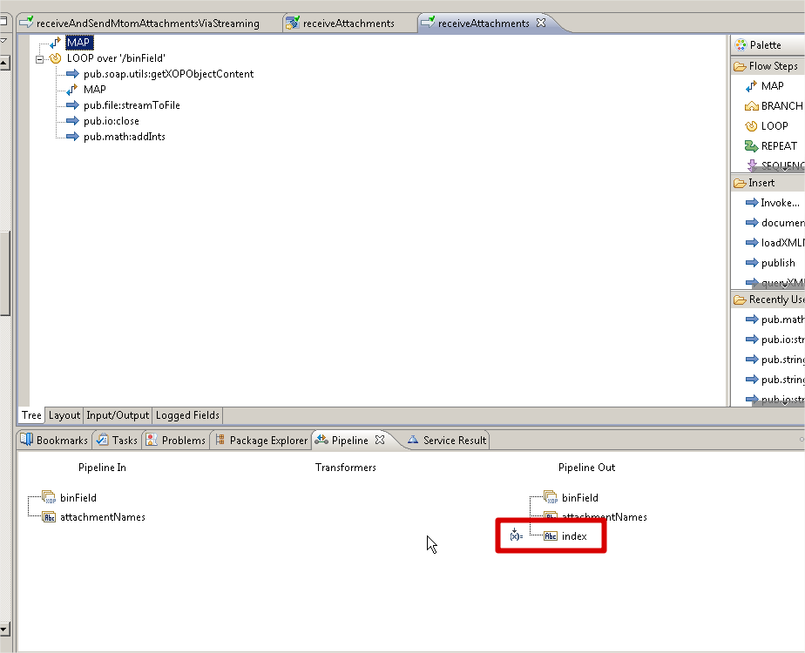

1. Loop over the binField to get the attachment as such

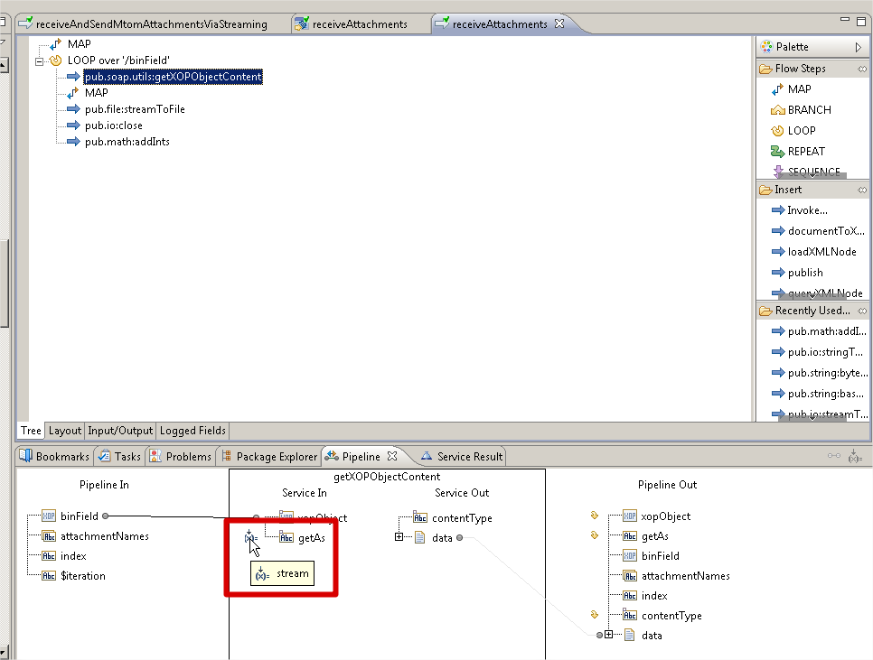

1. See how I am getting the attachment name from the input using indices

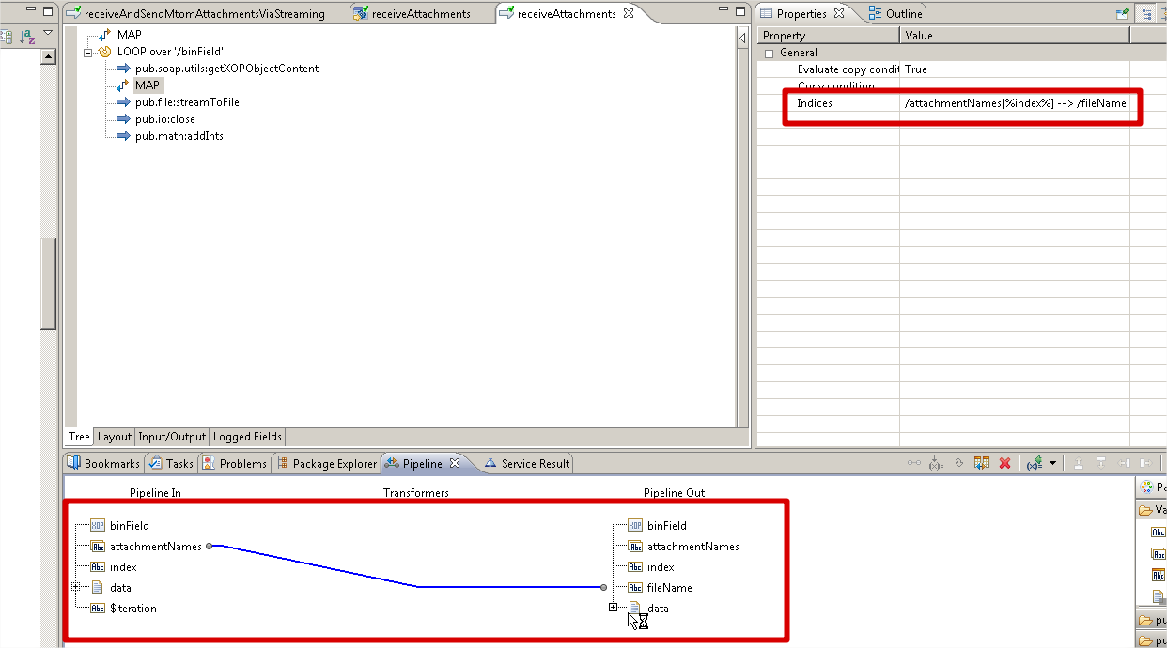

1. Now saving the file to the path as shown in below screen shot

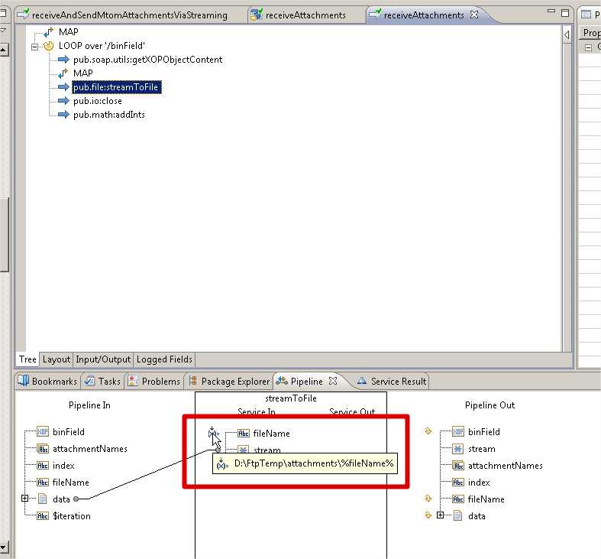

Then I create a provider wsd in designer and set the permission to Anonymous for testing.

Load the wsdl in soapui as shown below and set the input as such. When run the request

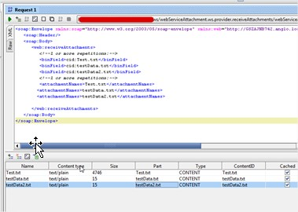

I get the below output and also the files have been transferred from my local pc to the IS server which is somewhere else on another network.

