Step 1->Created one new Role as ‘testRole’ in user Management->Roles.

Step 2->From permission management Select resource type as ‘My webMethods Application’

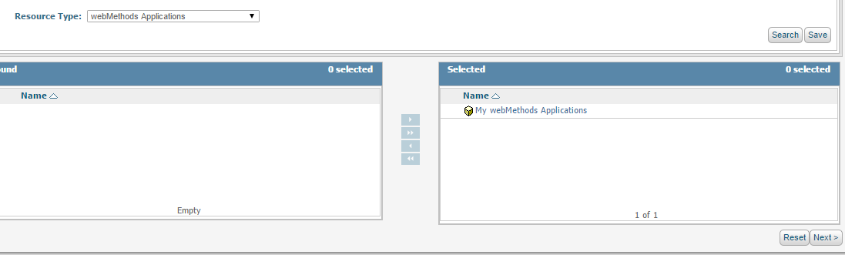

Step 3->Provide access to ‘testRole’ in Monitoring->Business->Tasks->My Inbox.

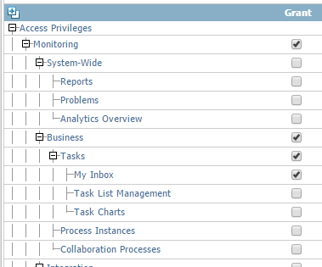

Step 4->Then select Resource Type as ‘Tasks’

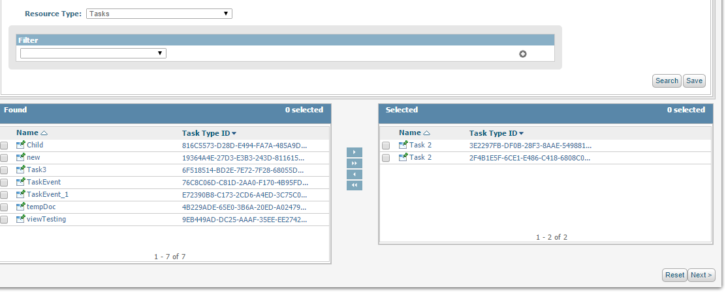

Step 5->Provide access to ‘testRole’ to Task Application Root Page->Task Inbox Page and other component as per requirment.

