We have came across two problems when we tried to create a virtual service in CentraSite. And those can be reproduced on different computers.

System environment:
OS: MS Windows Server 2008 x64 R2 6.1 SP1

CentraSite Version:
CentraSite Active SOA 8.2
Control Full Version 8.2.1.0-397
Registry/Repository Version 8.2.1.0.148

Plugins installed
CentraSite Conrol: 8.2.1.0 - 397
Pbluggable UI: 8.2.1.0 - 14

1 Servlet Error
HTTP Status 404 - /PluggableUI/servlet/keyword_search.html at 'Search for Endpoint'
When we tried to create a new Virtual Service, we have to fill the madatory field 'Defaul to' located at:
Register Processing Steps -> Navigation Menu Routing Protocols -> section Routing Rules (screenshot 1)
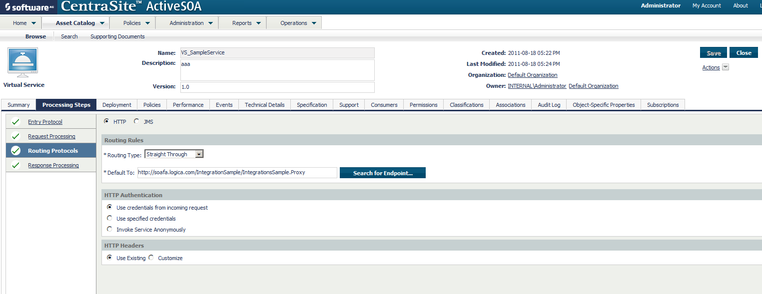
After clicking the button, the servlet error appears in the pop window.
"HTTP Status 404 - /PluggableUI/servlet/keyword_search.html":
(screenshot 2)
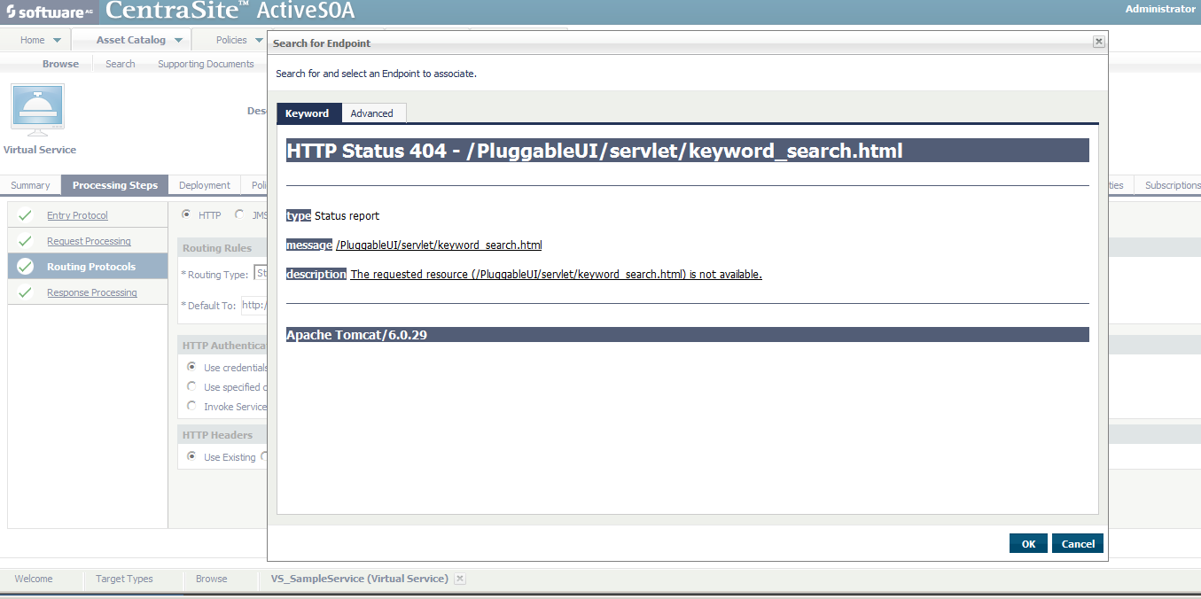
In order to create a new virtual service, we have to fill the endpoint field manually.

2. Access URI gets lost after after saving the virtual service:
The second error appears at
Register Summary -> Section Endpoints -> Column Access URI (see screenshot 3)
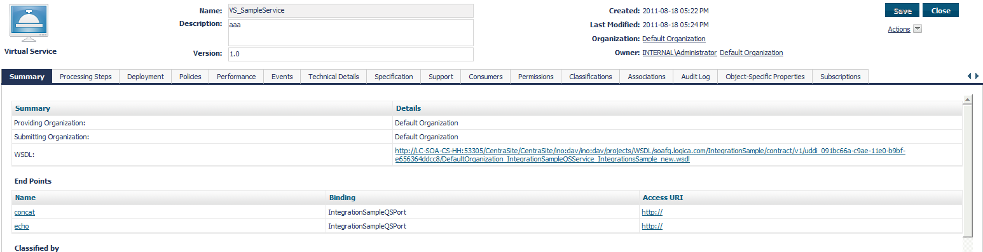

After attaching a WSDL successfully, the URI fields were filled with the right information, however, whenever you try to save the virtual service by clicking the save button upper right, the URI get lost.


We have tried to installed CentraSite on different computers and the problems remain the same,
Can anybody help with that? Thanks so much!
Hao

