HI All,
I am trying to build the Continuous Deployment in Web Methods using Jenkins and used below stack.
- Groovy Script <Jenkins Pipeline>
- Jenkins for CD
- Web Methods as service
- Git Hub -Repository

And I have configure the GitHub repository.
Git Repo
https://github.com/Pradeen/webmethods-sample-project-layout.git

Step 1 :
Create Service in the Web methods

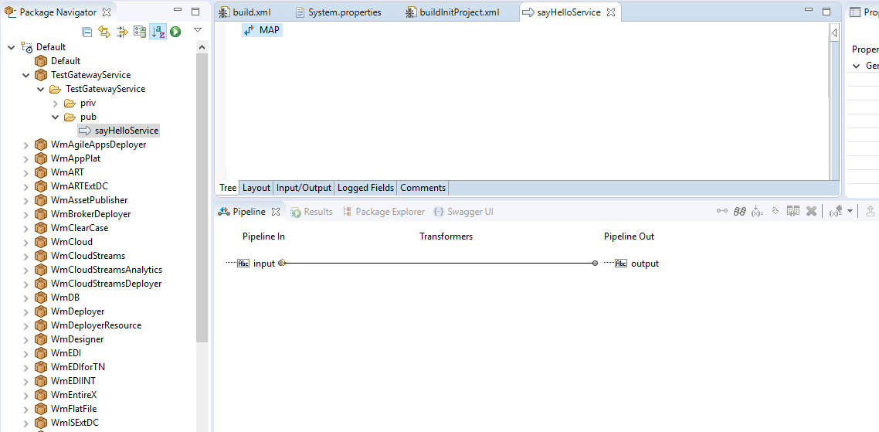

Step :2 Check in the code in GitHub Repo using the create Local Service Development

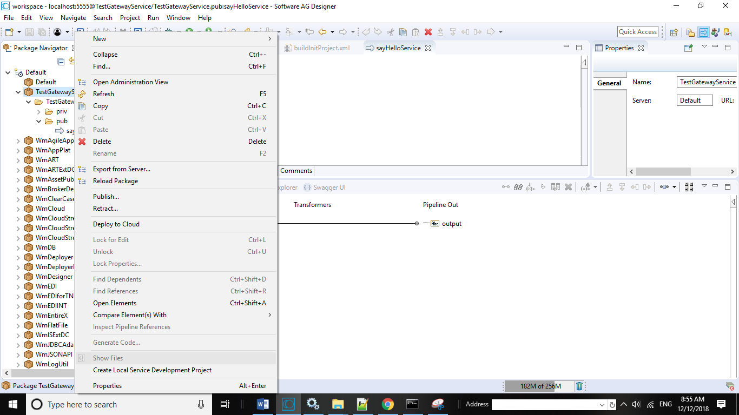

Check in code

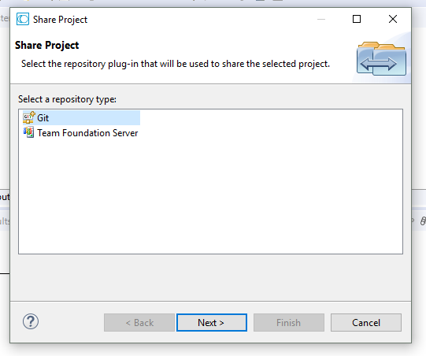
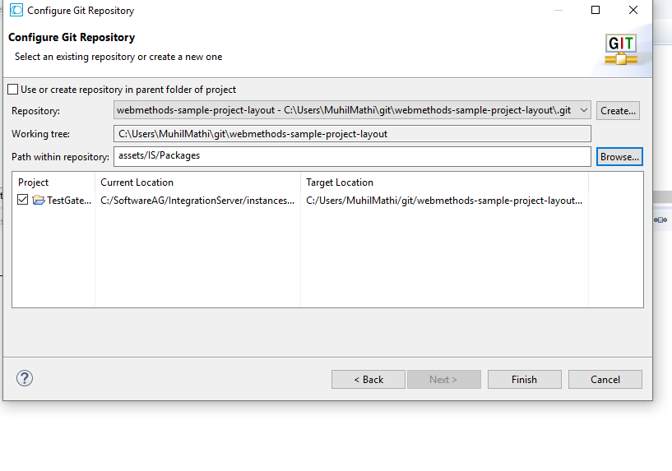
Now HelloService move into the packages

Step 4:
I moved code from the local repository into Git Hub Repo.

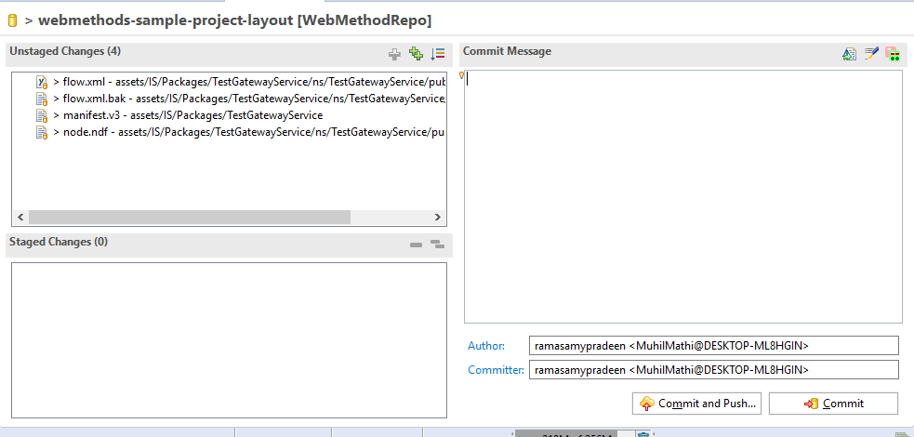

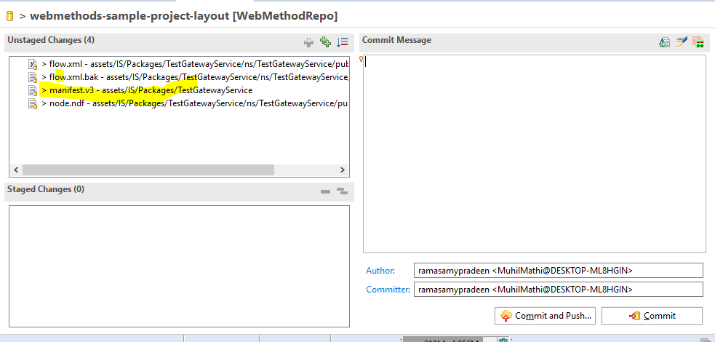

Step 5 : validate code is moved in to Git Hub Repo

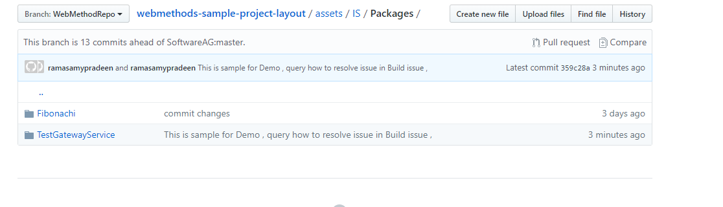

Step 6 : run the Pipeline script .

Groovy Pipeline is

pipeline {
agent any
stages {
stage('Build'){
steps {
echo "${env.SAG_HOME}"
bat "${env.SAG_HOME}/common/lib/ant/bin/ant -DSAGHome=${env.SAG_HOME} -DSAG_CI_HOME=${env.SAG_CI_HOME} -DprojectName=${env.JOB_NAME} build"
}
}
stage('Deploy') {
steps {
bat "${env.SAG_HOME}/common/lib/ant/bin/ant -DSAGHome=${env.SAG_HOME} -DSAG_CI_HOME=${env.SAG_CI_HOME} -DprojectName=${env.JOB_NAME} deploy"
}
}
}
}

But it’s got failed. I have attached the logs
And also attached the audit Report

Step 7 : Jenkins Build Status is failed

Build is successful

Logs

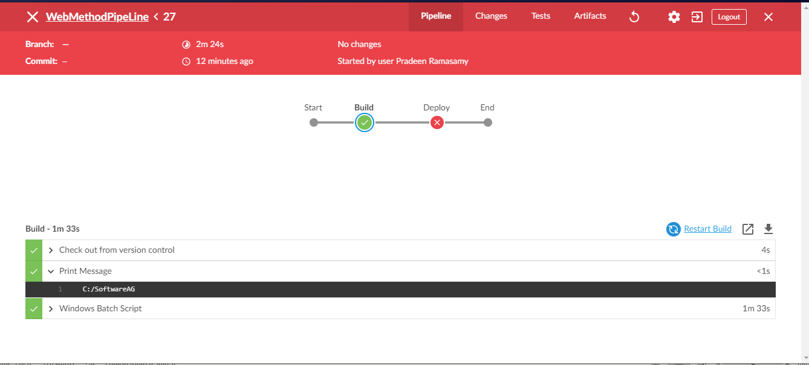

Deployment is failed

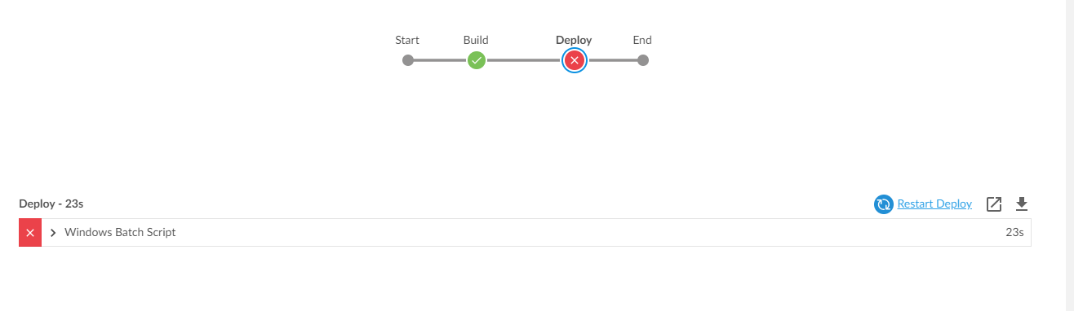

Deployment log

