**MTOM Demo**

I followed these steps to prepare a MTOM demo. This demo is OK, but not what I expected. What I want is that make a MTOM attachment case. Attach files into MTOM attachment instead of SOAP message body. How could I make this kind of case?

1. Configure the following parameters:
   1. watt.server.soap.MTOMStreamiong.enable=true
   2. watt.server.SOAP.MTOMStreaming.cachedFiles.location = leave it to the default location
   3. watt.server.SOAP.MTOMStreaming.threshold = leave it to the default value
2. Prepare web service

I created a very simple service flow which getXOPObjectContent and streamTofile. The input parameter are binObject(type: XOPobject) and flag(type: String).

For detail, please refer to the WSDL:



1. Test the webservice
   1. Use Axis2 to write client code, and calls service successfully.

The request the client send is as:



* 1. Use SOAPUI to test service, only success when set property “Enable Inline Files” to “true”. For detail, please refer to the belowing screenshot:

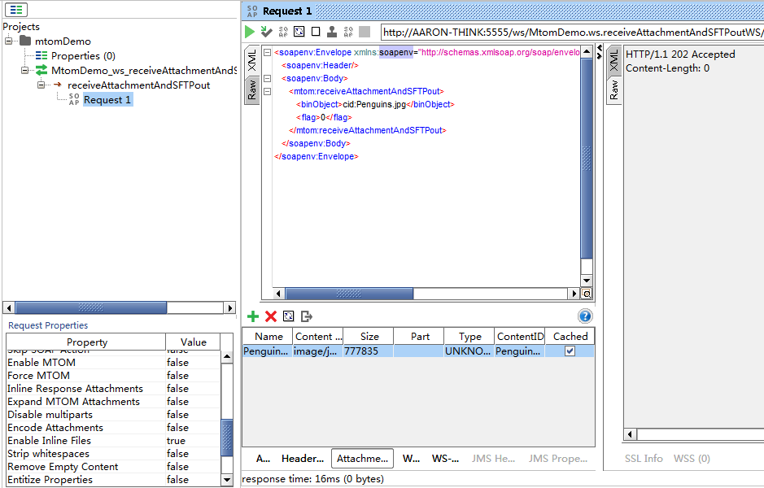

## Questions

What I want is that make a MTOM attachment case. Attach files into MTOM attachment instead of SOAP message body. How could I make this kind of case?