We have problem with Title for Auto Complete Text Input CAF component.

For an Auto Complete Text Input I have set the Elemen Rytle & Value
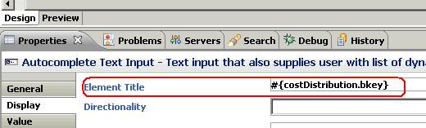
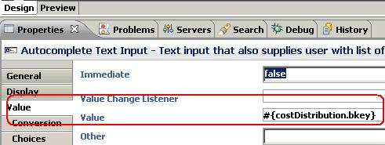
And it works fine

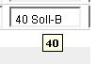
But when I selected other value from Auto Complete Text Input the element title is not updated .
