Value Change Listener in webMethods Designer

Document Overview
The artifact explains the technique to implement a business requirement involving populating one dropdown based on other dropdown using value change listener. This document also provides the sample code and its usage description.

Pre requisite
Knowledge of webMethods designer and MyWebMethods Server.

Scenario

Let’s take an example of filling a form where we need to provide our address. In the form we have state dropdown and city dropdown. When we select a state from state dropdown, the city dropdown should automatically show the cities for the selected state. This can be achieved by using a value change listener, invoke script, async hidden command and a hideable panel.

Steps involved

Variable Declaration
Declaring variables for city, state and city list for state A say ‘cityListA’, city list for state B say ‘cityListB’.
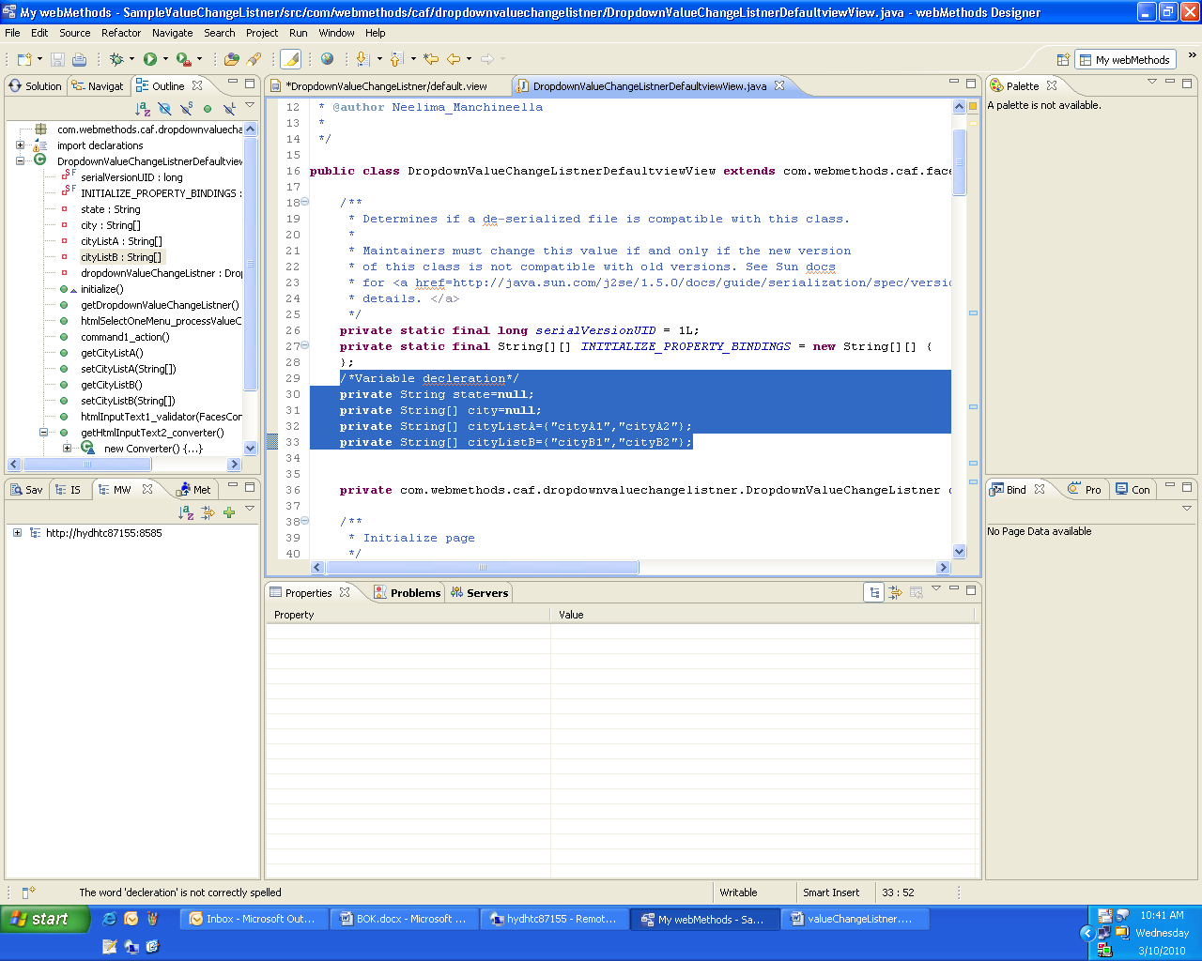

Adding Value Change Listener
Place a dropdown for state and right click on the dropdown, in lifecycle option select value change listener.
The immediate property of the dropdown should be set to “true”. This is to hold the value of the dropdown when dropdown value is changed.

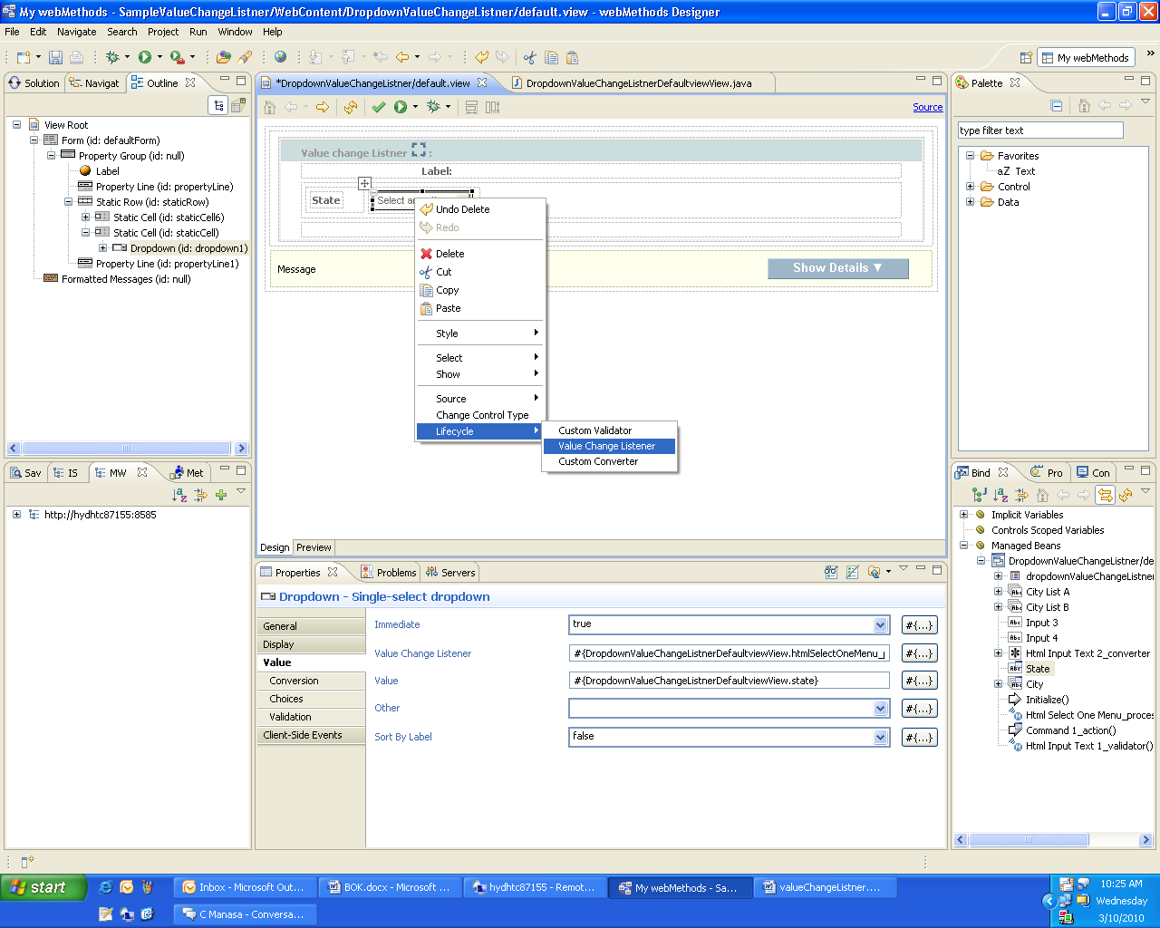
When we select the value change listener, It automatically creates a method in the java file.
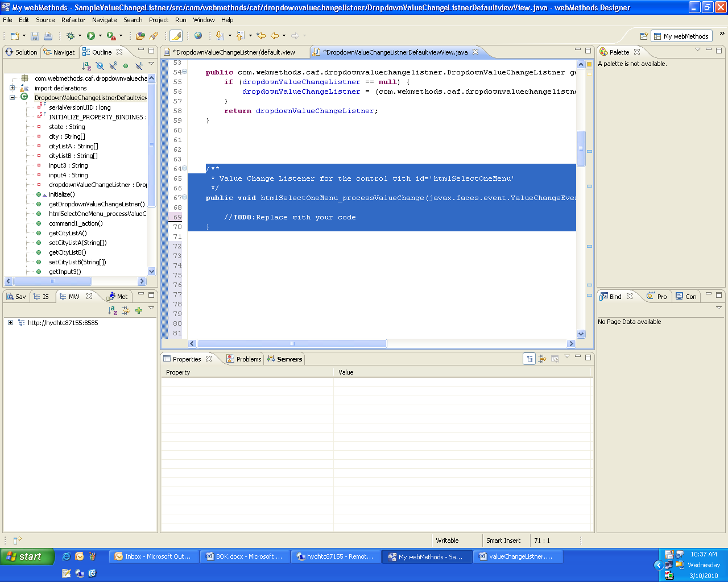

Obtaining Value of the Dropdown

The changed value of the dropdown is obtained by - event.getNewValue() ,where event.getNewValue() gives an object and it is converted to string and set to the state variable.

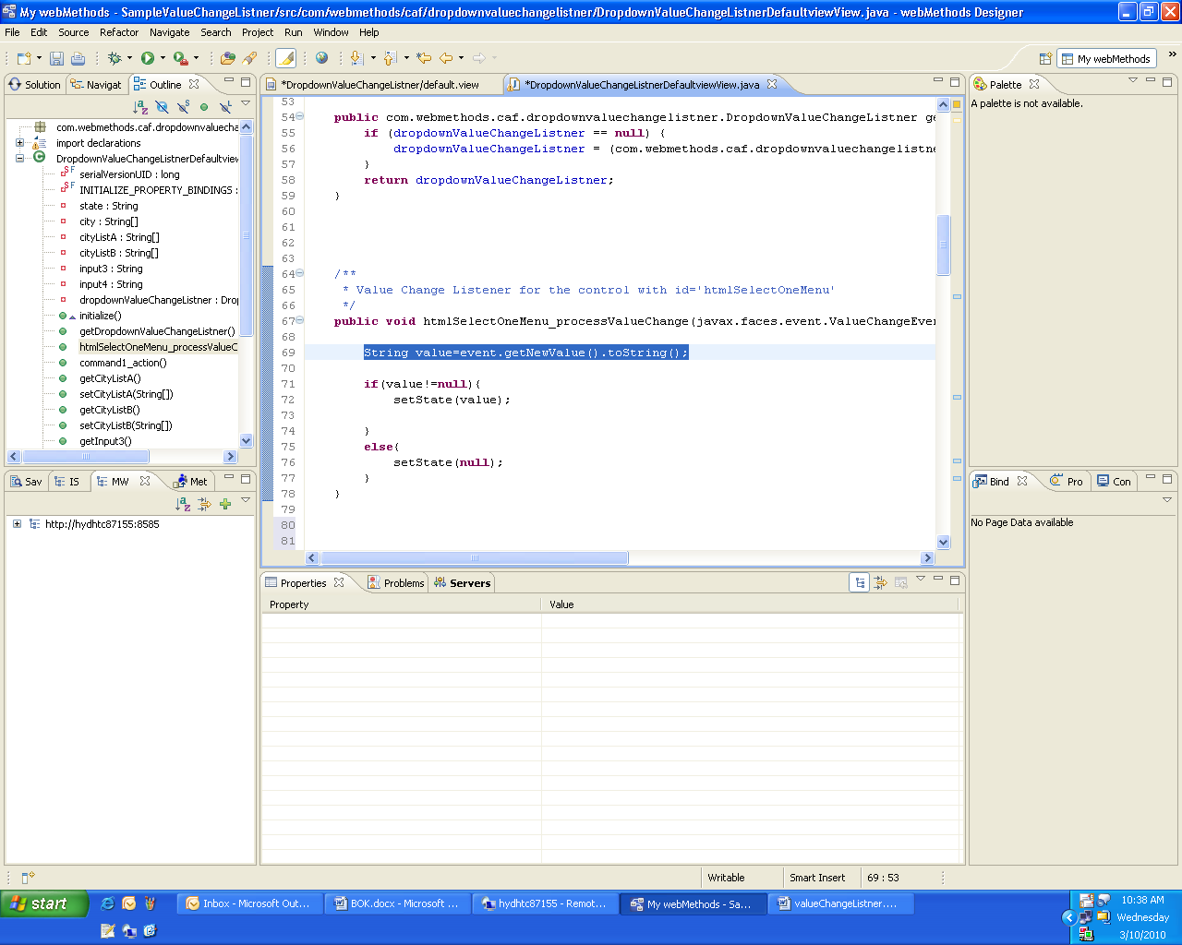

Adding Hideable Panel
The city dropdown should be placed in a hideable panel because every time when we change the state value, the city dropdown should be refreshed.
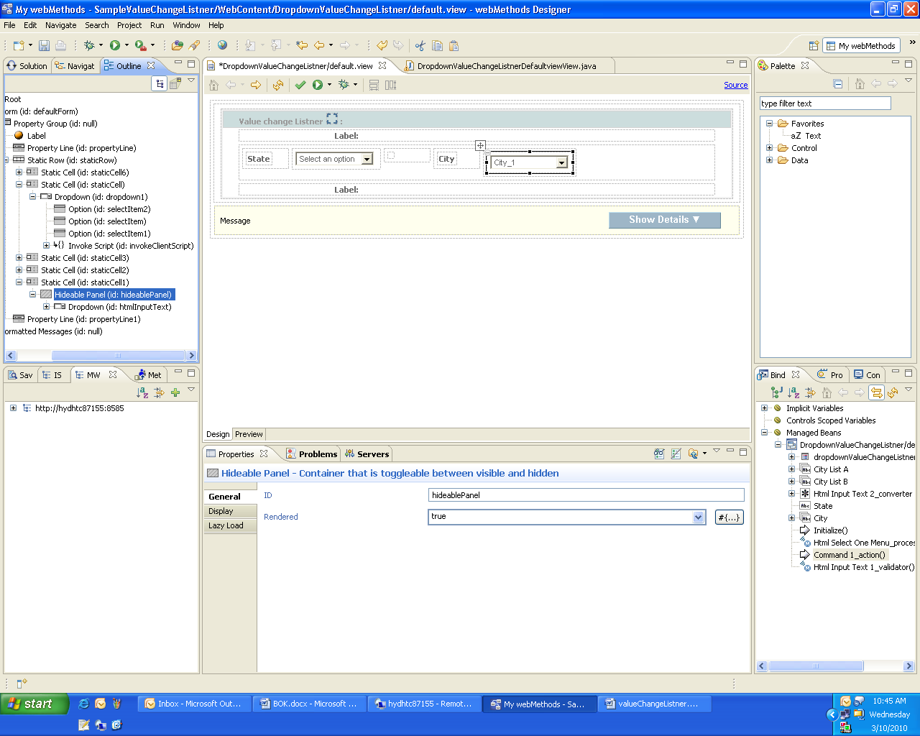
The option group of the city dropdown should be set to city string list with is set to either cityListA or cityListB based on the selected state.
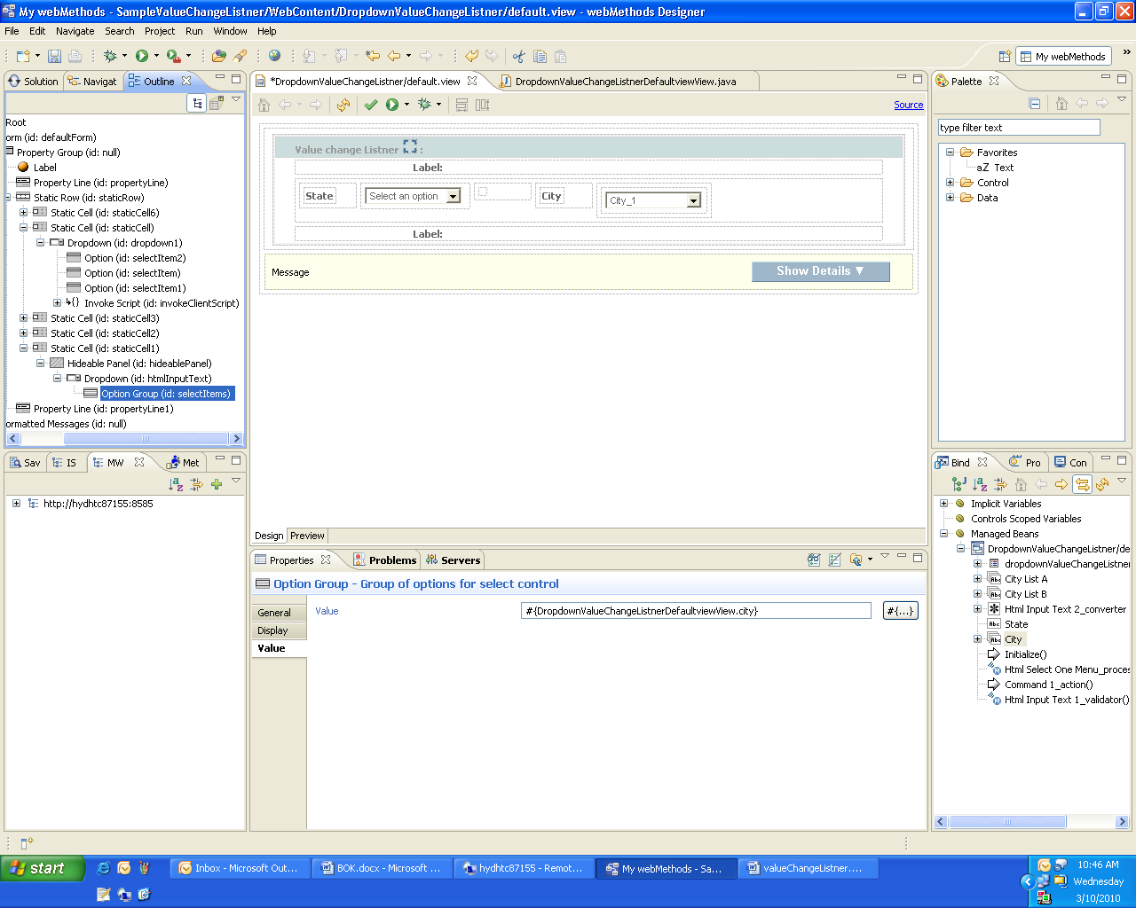

Adding Async Hidden Command

Drag and drop an async hidden command on to the canvas. This command is added to refresh the hideable panel in which the city dropdown is placed. This is achieved by giving hideable id in refresh property.
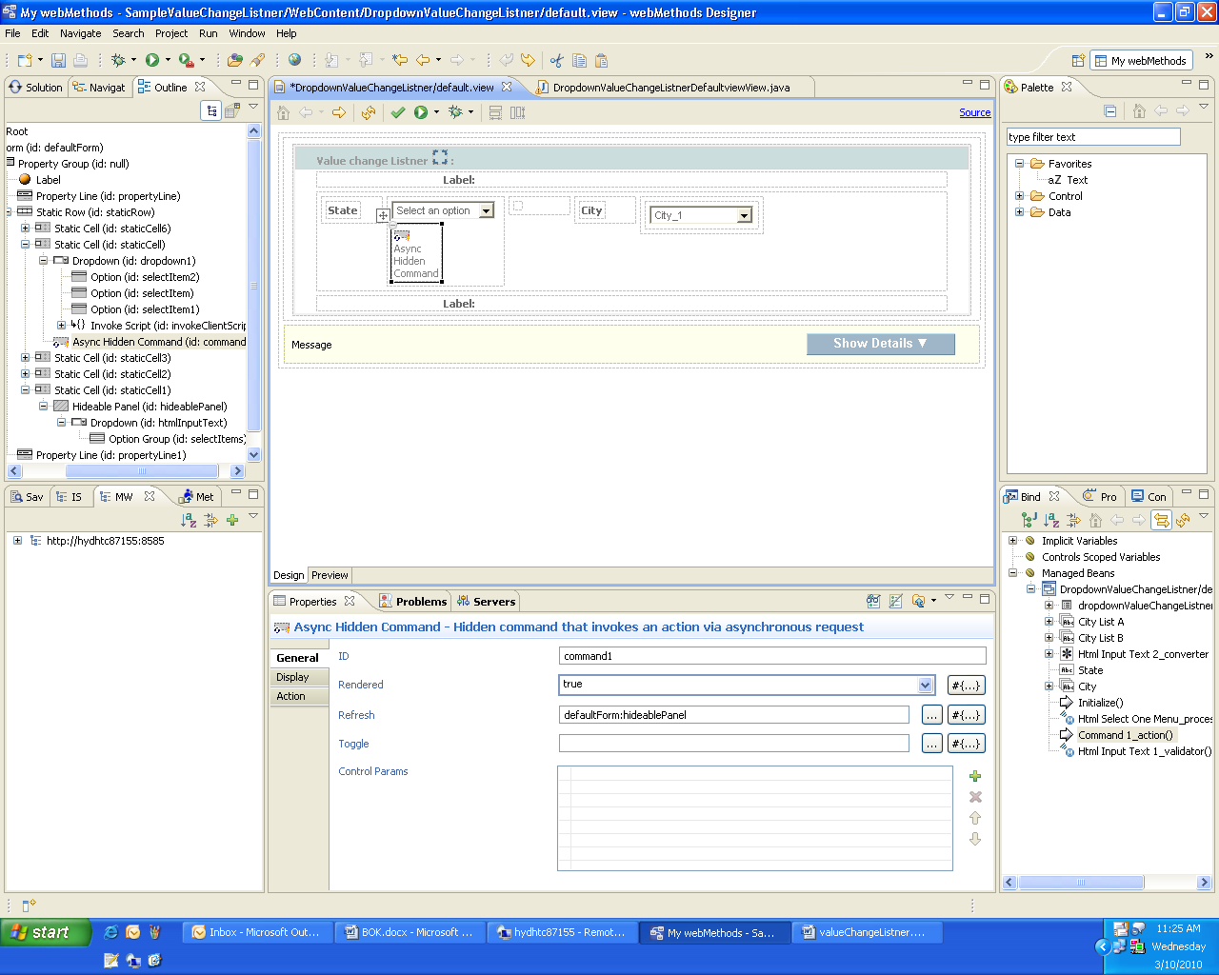
Add the logic which needs to be executed when the dropdown value is changed in the method which is binded to the async hidden command.
In the current scenario when state A is selected, city is set with cityListA which contains cities present in state A and when state B is selected, city is set with cityListB which contains cities present in state B.

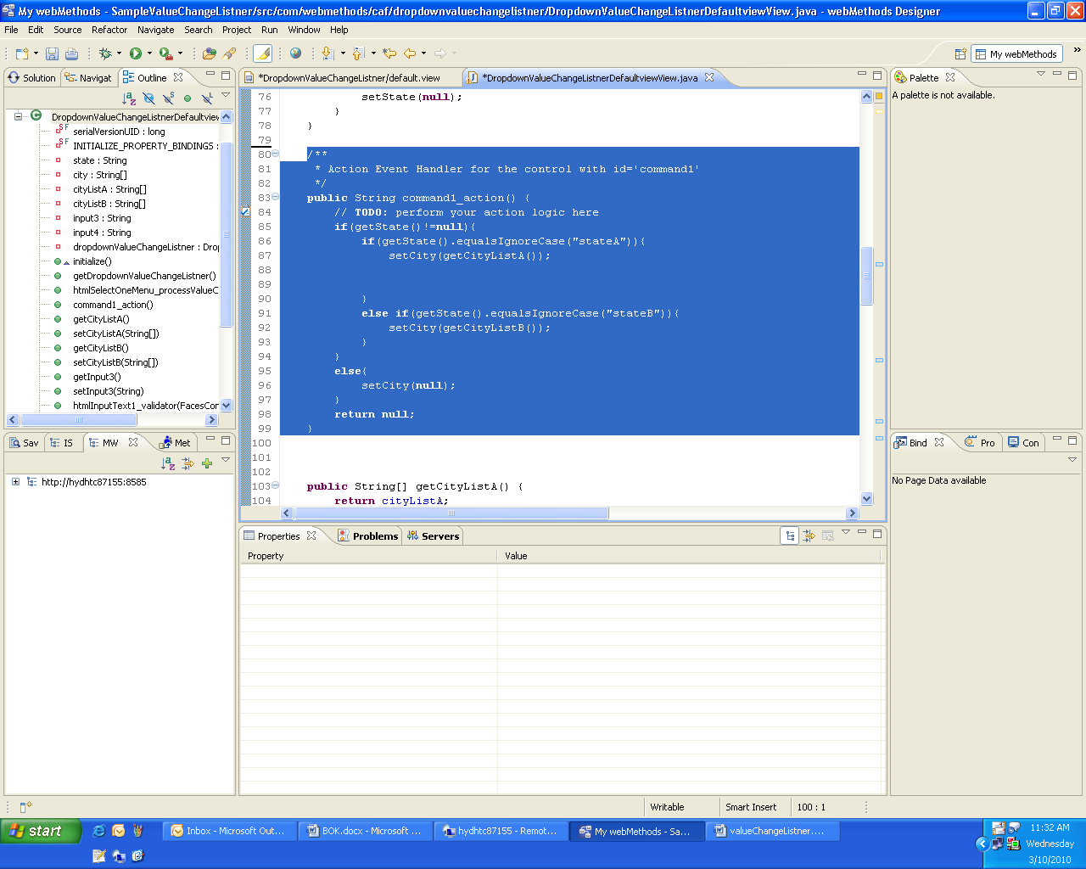

Adding Invoke Script

Add an Invoke script in dropdown and set its properties as
Event : onchange
Action : raise
Control: id of the async hidden command placed in step5
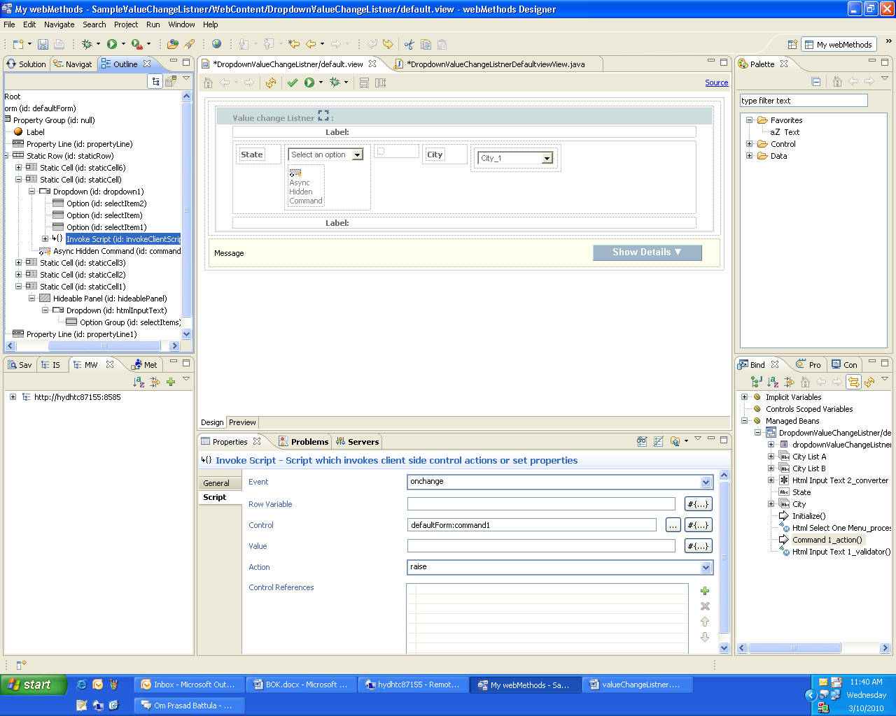

Output

When state A is selected city dropdown is refreshed and corresponding city list (cityListA) is populated.
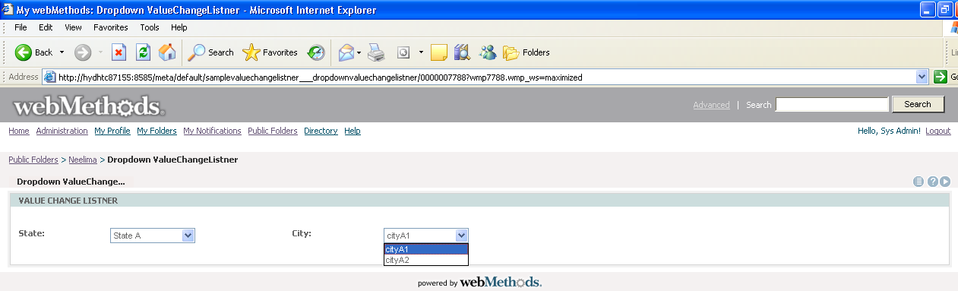

When state B is selected city dropdown is refreshed and corresponding city list (cityListB) is populated.
