Request coming from web service,

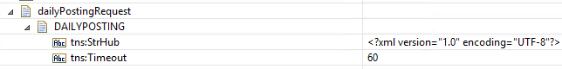

Actual Input

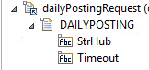

Simillarly , the WS is returning the output properly , but the SOAP handler is not able to parse the response.

