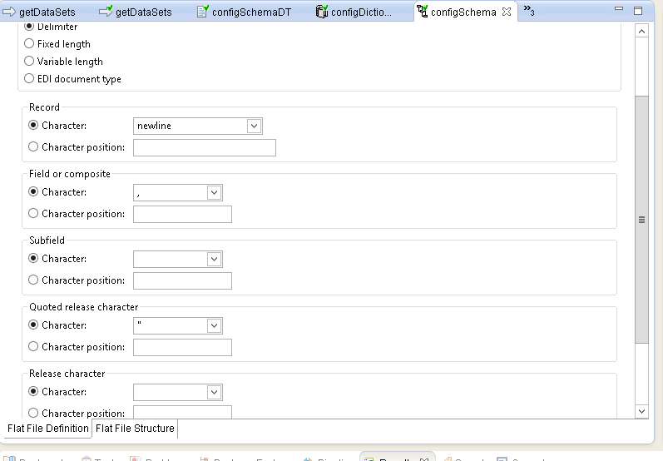

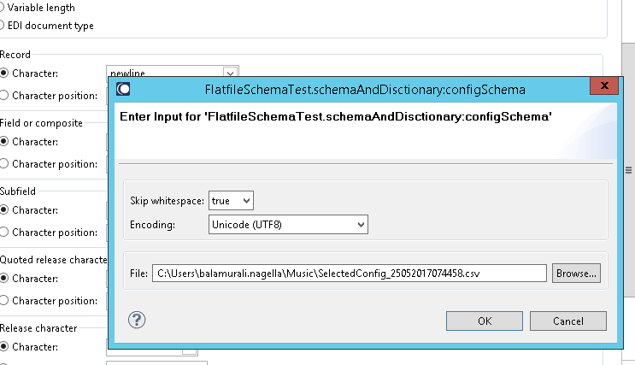

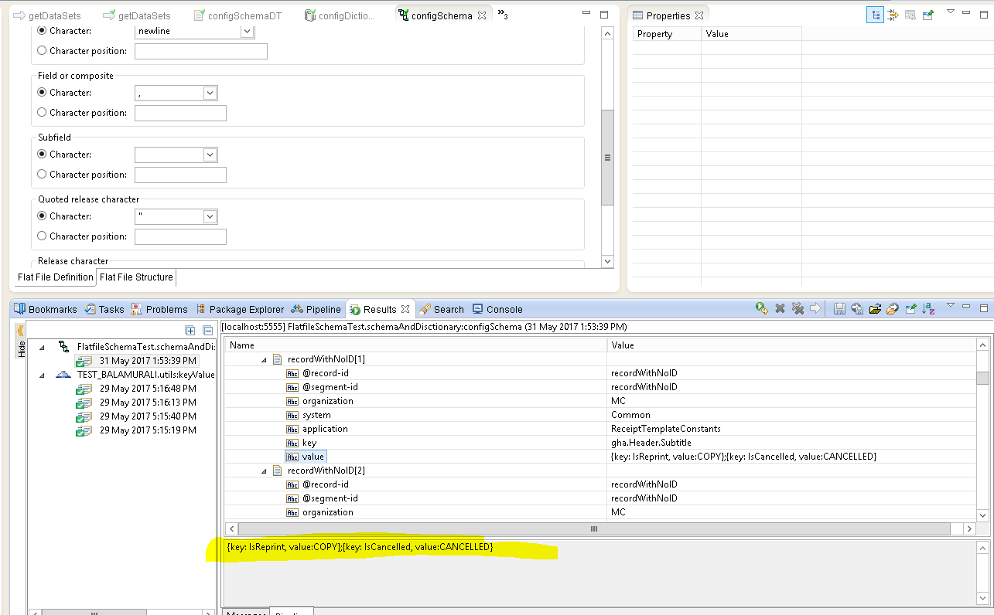

In above highlighted in Yelllow,,double quotes are missing for Key Value pairs ….

Actual data looks like below from CSV

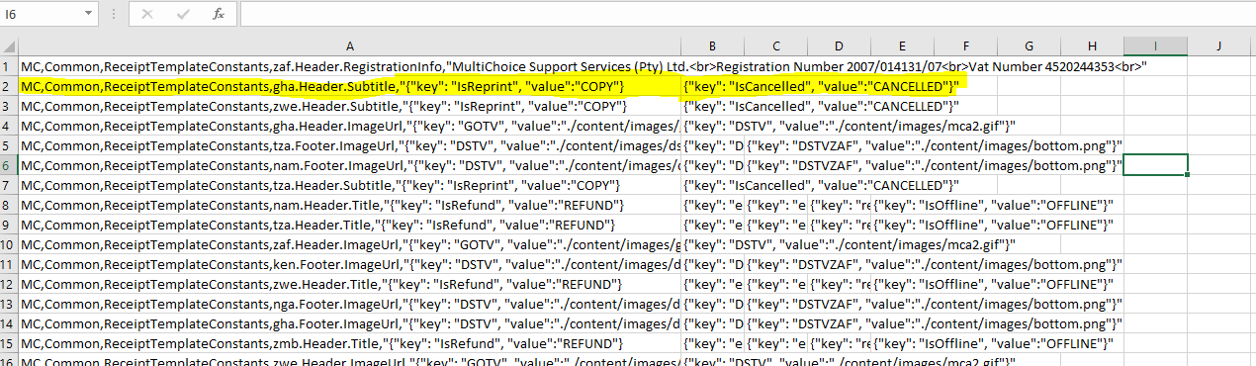

I want the quotes for key values data …

Current Output : {key: IsReprint, value:COPY};{key: IsCancelled, value:CANCELLED}

expected output should be : {“key”: “IsReprint”, “value:COPY”};{“key”: “IsCancelled”, “value”:”CANCELLED”}