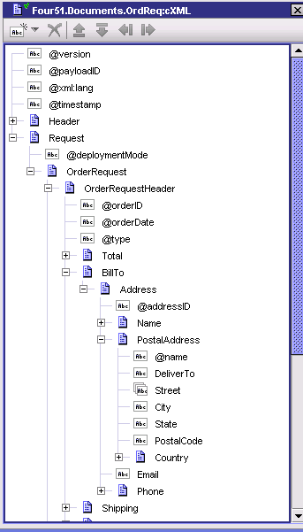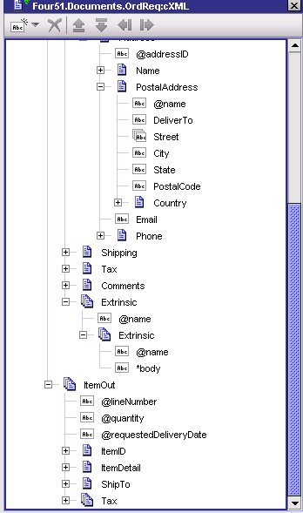
Document cXML (used as documentTypeName in XMLnodeToDocument) Note the arrays for Street, Extrinsic, ItemOut and Tax
This document was actually created by uploading the XML of a sample order when creating the document.
Below now look how the order is being brought in… the arrays are identified as arrays but only the last record of each array is displayed as record 0. In the case of the street there should have been two but only the second street record is shown as record 0. The same for item out. Of the 3 items only the last item is shown.
