1. Response in document format:

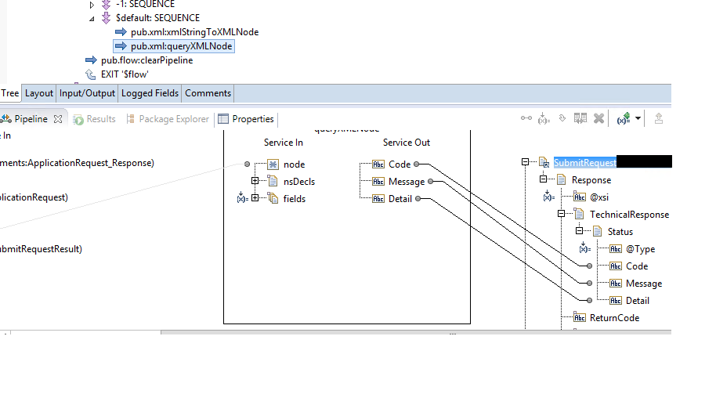

Here I am sending the response in SubmitRequest document and below is the raw format captured from soapUI.

HTTP/1.1 200 OK

Content-Type: text/xml; charset=UTF-8

Content-Encoding: gzip

Content-Length: 313

<?xml version='1.0' encoding='UTF-8'?>

<soapenv:Envelope xmlns:soapenv="http://schemas.xmlsoap.org/soap/envelope/">

<soapenv:Body>

<ser-root:SubmitRequestResponse xmlns:ser-root="http://example" xmlns:xsi="http://www.w3.org/2001/XMLSchema-instance">

<SubmitReques>

<Response xsi="http://www.w3.org/2001/XMLSchema-instance">

<TechnicalResponse>

<Status Type="Error">

<Code>2</Code>

<Message>Invalid XML</Message>

<Detail/>

</Status>

</TechnicalResponse>

</Response>

</SubmitRequest>

</ser-root:SubmitRequestResponse>

</soapenv:Body>

</soapenv:Envelope>

1. Response in string:

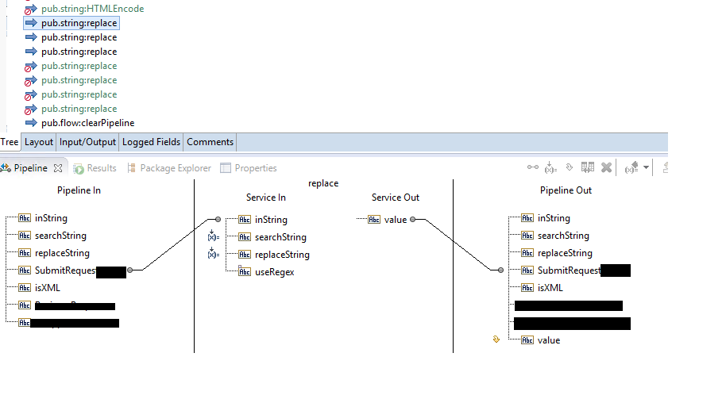

Here I am replacing with < and > signs with &lt; and &gt; and raw format captured from SoapUI is

HTTP/1.1 200 OK

Content-Type: text/xml; charset=UTF-8

Content-Encoding: gzip

Content-Length: 313

<?xml version='1.0' encoding='UTF-8'?>

<soapenv:Envelope xmlns:soapenv="http://schemas.xmlsoap.org/soap/envelope/">

<soapenv:Body>

<ser-root:SubmitRequestResponse xmlns:ser-root="http://example" xmlns:xsi="http://www.w3.org/2001/XMLSchema-instance">

<SubmitRequest>

&amp;lt;Response xsi="http://www.w3.org/2001/XMLSchema-instance"&amp;gt;

&amp;lt;TechnicalResponse&amp;gt;

&amp;lt;Status Type="Error"&amp;gt;

&amp;lt;Code&amp;gt;2&amp;lt;/Code&amp;gt;

&amp;lt;Message&amp;gt;Invalid XML&amp;lt;/Message&amp;gt;

&amp;lt;Detail/&amp;gt;

&amp;lt;/Status&amp;gt;

&amp;lt;/TechnicalResponse&amp;gt;

&amp;lt;/Response&amp;gt;

</SubmitRequest>

</ser-root:SubmitRequestResponse>

</soapenv:Body>

</soapenv:Envelope>

I have tried to wrap the response in CDATA tag.

Then I have got response in below format.

HTTP/1.1 200 OK

Content-Type: text/xml; charset=UTF-8

Content-Encoding: gzip

Content-Length: 313

<?xml version='1.0' encoding='UTF-8'?>

<soapenv:Envelope xmlns:soapenv="http://schemas.xmlsoap.org/soap/envelope/">

<soapenv:Body>

<ser-root:SubmitRequestResponse xmlns:ser-root="http://example" xmlns:xsi="http://www.w3.org/2001/XMLSchema-instance">

<SubmitRequest>

<![CDATA[&lt;Response xsi="http://www.w3.org/2001/XMLSchema-instance"&gt;

&lt;TechnicalResponse&gt;

&lt;Status Type="Error"&gt;

&lt;Code&gt;2&lt;/Code&gt;

&lt;Message&gt;Invalid XML&lt;/Message&gt;

&lt;Detail/&gt;

&lt;/Status&gt;

&lt;/TechnicalResponse&gt;

&lt;/Response&gt;]]>

</SubmitRequest>

</ser-root:SubmitRequestResponse>

</soapenv:Body>

</soapenv:Envelope>

But when reaches to client response format will be changing as above format(response without CDATA tag)