Creating consumer wsd from below wsdl hosted over internet

<https://host:port/svcname?wsdl>

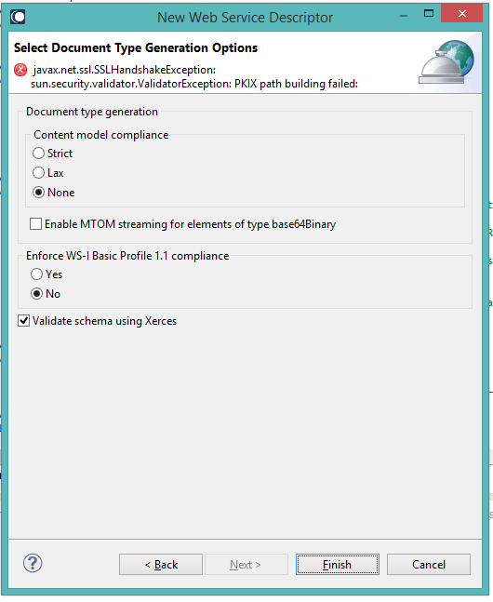

Figure Before adding the SSL configuration lines

After adding the below lines to designer’s eclipse config.ini, please check the error screenshot

javax.net.ssl.trustStore=C\:\\temp\\oct26\\cacertsfordesigner\\designerTrustStore.jks

javax.net.ssl.trustStoreType=JKS

javax.net.ssl.trustStorePassword=changeit

javax.net.debug=ssl

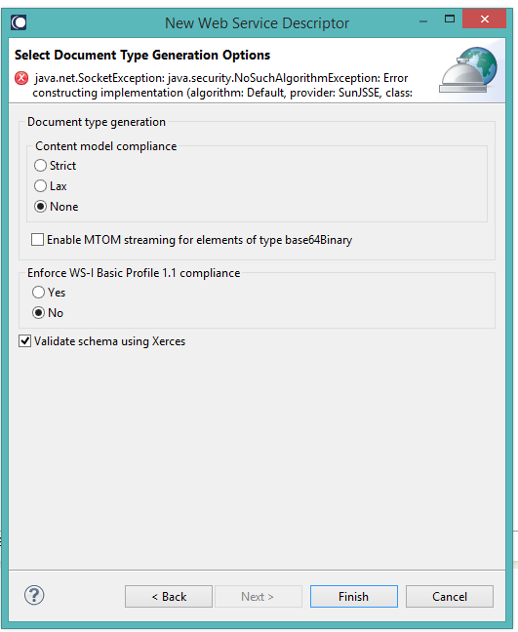

Figure After adding the SSL configuration lines