1. First publishing where type =’A’

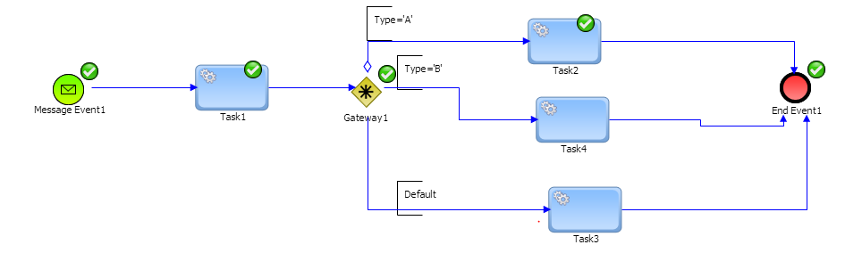

1. Publishing where type =’hbjbsa’

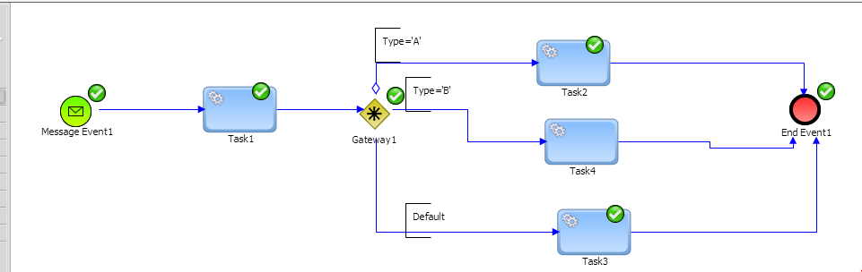

1. Again publishing for same instance where type=’B’

