CSV

Mike,Hussey,1,2023-06-04T20:27:24

David,Warner,2,2023-06-04T20:27:25

Glenn,Max,3,NULL

Stephen,Jard,4,2023-06-04T20:27:26

Peter,Max,5,NULL

In the first map step hard coded 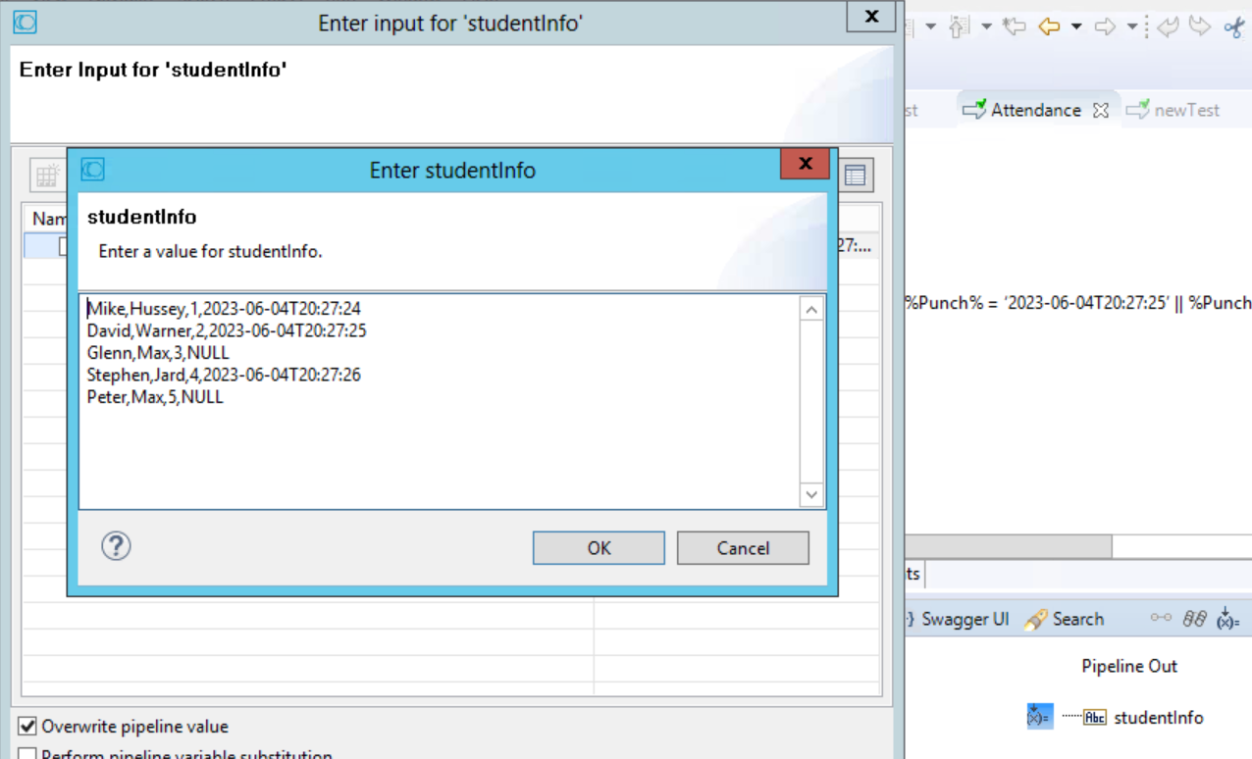

FF Dictionary

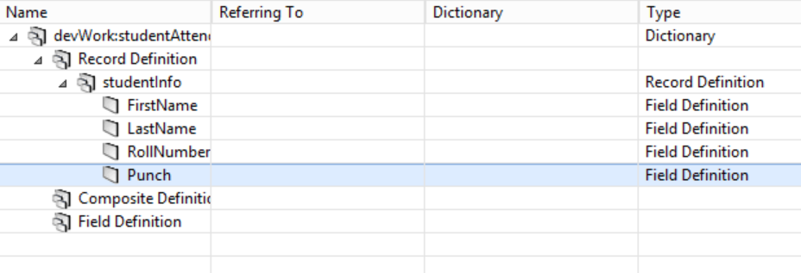

Schema Definition

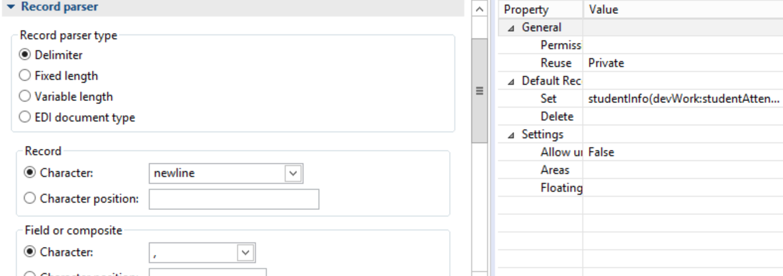

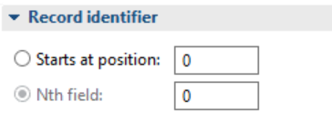

Structure

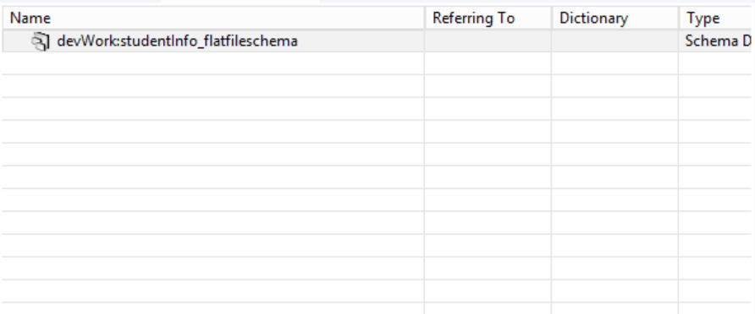

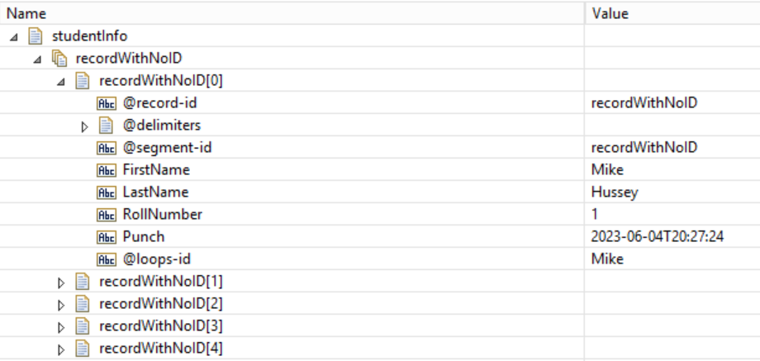

Within loop

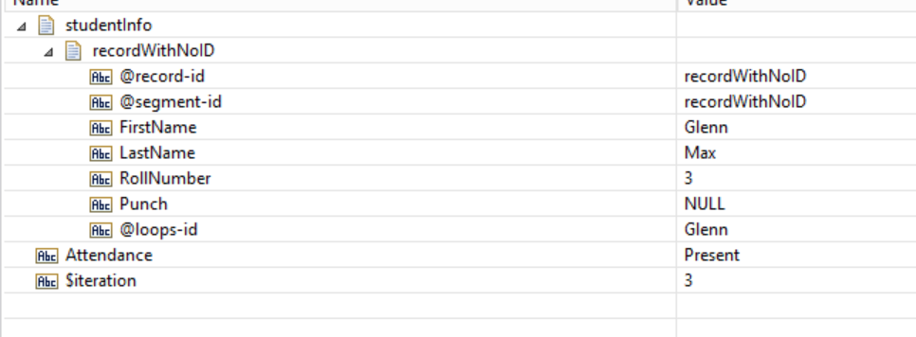

Code:

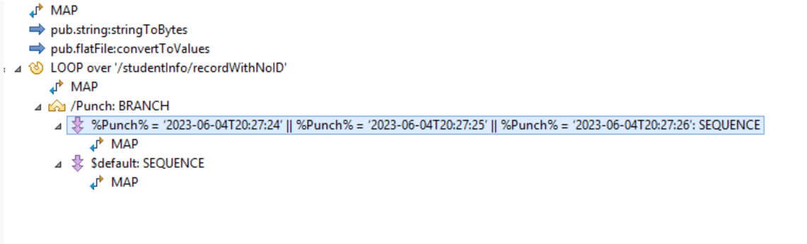

Branch Label

