CAF Web Service Connector Configuration Best Practices

CAF/MWS version 8.2

Sergei Pogrebnyak
webMethods BPMS

April 2010

1.1 Individual Web Service Connector 3
1.1.1 Default Value 3
1.1.2 Recommended value 3
1.1.3 Fall Back 3
1.2 Web Application Runtime Configuration 4
1.2.1 Default Value 4
1.2.2 Recommended value 4
1.2.3 Fall Back 5
1.3 Global Defaults for Web Application Runtime Configuration 6
1.3.1 Default Value 6
1.3.2 Recommended value 6
1.3.3 Fall Back 6
1.3.4 Applying Global Default Value Change 6
1.4 Design-Time Web Application Environment Variable 8
1.4.1 Default Value 8
1.4.2 Recommended value 9
1.4.3 Fall Back 9
2 Hardcoded Default Timeout Value 10
2.1 Default Value 10
3 Irrelevant Timeout Configurations 11
3.1 Glue Configuration Timeout 11
3.2 Java Socket Timeout 11
4 Considerations for Web Service Client Authentication Configuration 12
5 Considerations for Web Service Client Endpoint Configuration 13
5.1 Configuring Web Service Endpoint for Integration Server 6.x SOAP Stack Clients 13
5.2 Configuring Web Service Endpoint for Integration Server 7.x SOAP Stack Clients 13
5.3 Configuring Web Service Endpoint for Various Clients using the Same Service Provider 14
5.4 Configuring Web Service Endpoint for Various Clients using the Various Service Providers 14

Considerations for Web Service Client Timeouts

Individual Web Service Connector
Specifying timeout at the individual web service connector level using Socket Timeout property overwrites any other timeout value.

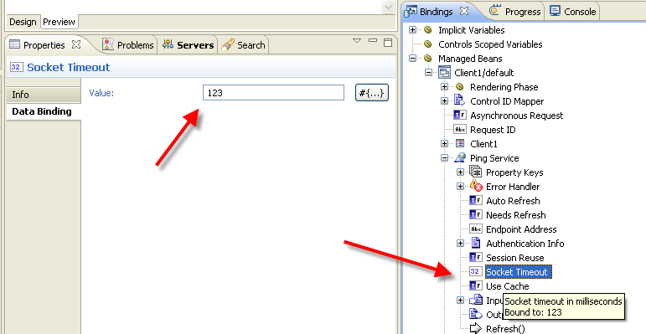

Default Value
Empty

Recommended value
Empty

Specifying non-empty value generally should be avoided because it does not allow the administrator to change the value at runtime. It can only be used if the web service connector timeout value is bound to an alternative ‘run-time configurable parameter’, like another environment variable or portlet preference or some other API that provides run-time configuration mechanics. This is NOT recommended, but can be used to solve individual service timeout requirements. Ideally, the problem has to be resolved by addressing the service implementation to NOT require long timeout values.

Fall Back
Web Application Runtime Configuration wsclient-socketTimeout environment variable value

Web Application Runtime Configuration
Specifying timeout at the Web Application Runtime Configuration level using wsclient-timeout environment variable overwrites any other timeout defined somewhere else, except individual web service connector level Socket Timeout property.

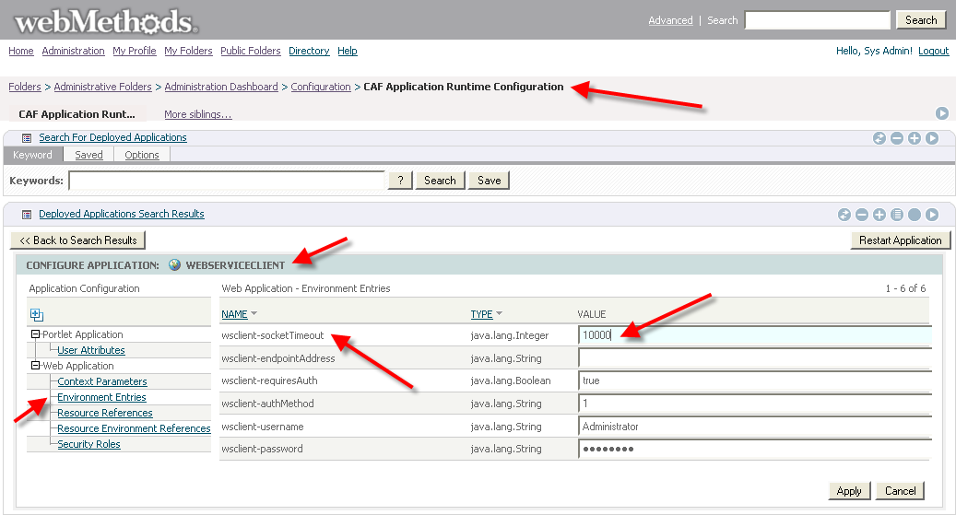

Default Value
10000 (milliseconds)

The default comes from application WEB-INF/web.xml (see below for details why it is not empty).

Recommended value
Empty

Empty value is recommended to make it fall back to the Global Defaults (see below).

Specifying non-empty is recommended if there are several applications deployed to MWS and they have different timeout requirements for their web service clients.

For example, one application calls local Integration Server services and requires short timeout value. The other application calls remote web services from the third-party provider over the internet and requires longer timeouts.

Fall Back
When empty value is specified at this level, MWS will fall back to Global Defaults wsclient-socketTimeout environment variable value (see below).

Global Defaults for Web Application Runtime Configuration
Specifying default timeout at the Global Defaults level using wsclient-timeout environment variable provides a fall back value when empty wsclient-timeout value is specified at the Web Application Runtime Configuration level for a given application.

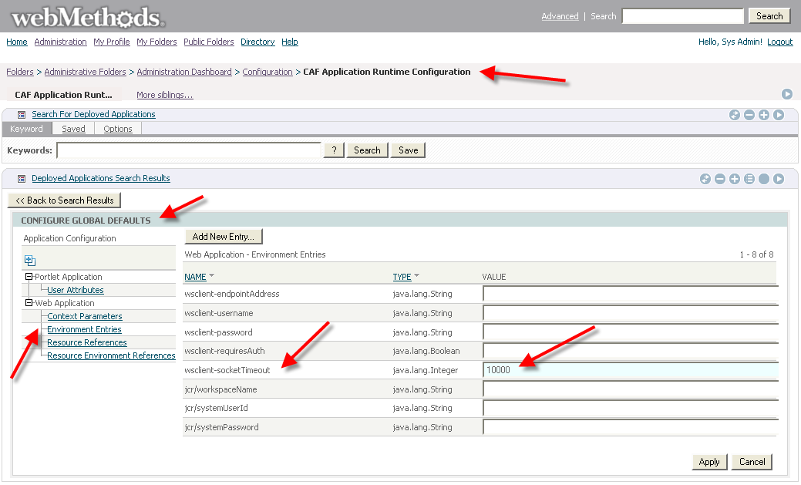

Default Value
Empty

Recommended value
10000 or any other suitable timeout value in milliseconds

Fall Back
When empty value is specified at this level MWS will fall it back to wsclient-socketTimeout environment variable value defined at design-time in the application WEB-INF/web.xml (see below)

Applying Global Default Value Change
If you change the value at this level and expect all web applications to default to it:
- Make sure applications do NOT have timeout value specified as Runtime Configuration
- Restart individual applications using Restart Application button OR restart MWS

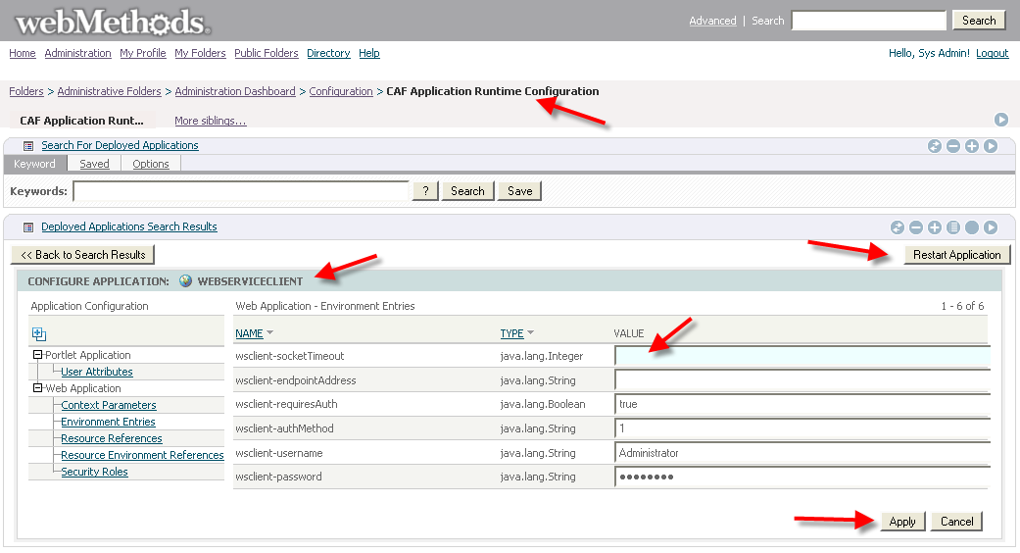

Design-Time Web Application Environment Variable
Specifying default timeout using wsclient-timeout environment variable in web.xml file provides both default value for Runtime Web Application Runtime Configuration as well as fall back value when no value is provided in the Global Defaults on MWS.

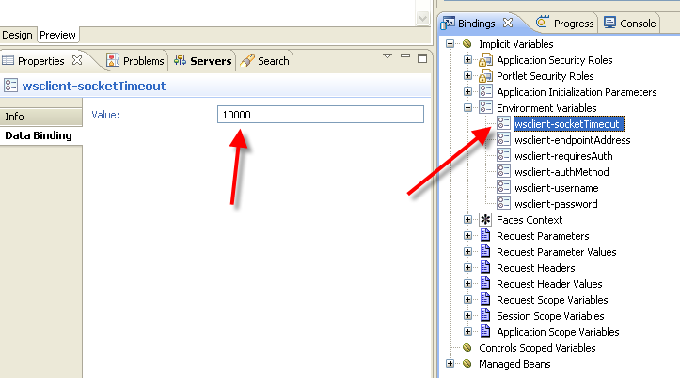

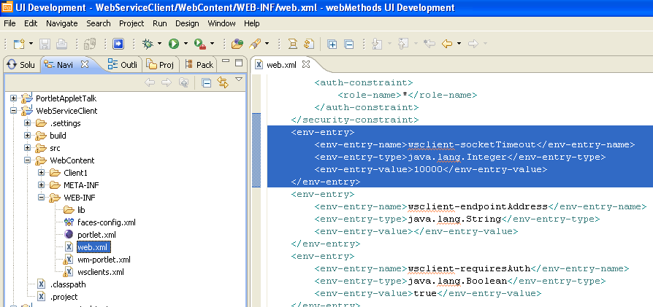

Default Value
10000

Recommended value
10000 – to keep the application functional when deployed to a 3-rd party runtime OR on MWS when no Global Default value is configured
Empty – for MWS deployment only when Global Default is guaranteed to be provided

Fall Back
When empty value is specified it will default to Global Default on MWS.

Hardcoded Default Timeout Value

Default Value
60000 = 1 minute

When no run-time or design-time timeout value is provided both CAF Web Service Connector (from wm-caf-ws-glue.jar) and Web Service Client API (from wm-wsclient.jar) use hardcoded value of 1 minute.

Irrelevant Timeout Configurations

Glue Configuration Timeout
Glue default timeout value specified in _install_/common/lib/glue.jar/glue-default-config.xml file has NO effect on CAF Web Service Connector of WS Client API timeouts.

<!--timeout in milliseconds for a client reading a response, 0 => infinite-->
<clientReadTimeout>0</clientReadTimeout>

IMPORTANT: This timeout value MAY have effect on Glue web service clients that by pass CAF or WSClient API layer and work with Glue proxies directly.

Java Socket Timeout
Default java socket timeout system properties which can be defined in portal.properties configuration file or set programmatically do NOT have any effect on the CAF Web Service Connector or WS Client API timeouts.

See complete description of Sun JRE networking properties description here:
http://java.sun.com/j2se/1.4.2/docs/guide/net/properties.html

Considerations for Web Service Client Authentication Configuration
CAF Web Service Clients should follow the same configuration pattern for authentication information. The following properties implement the same fall back behavior as Socket Timeout:
- wsclient-requiresAuth
- wsclient-authMethod
- wsclient-username
- wsclient-password

It is recommended to default these values to the highest possible level of runtime configuration:
- Using Global Defaults is only feasible if all deployed applications work with the same web service provider, for example the same Integration Server.
- If that is not the case then Application Runtime Configuration level should be used instead
- No hardcoded values should be used by application developers

Considerations for Web Service Client Endpoint Configuration
Externalizing web service endpoint address is more difficult to achieve because the CAF Designer does not do it automatically.

The same general criteria apply here as in the authentication information configuration but with a few differences.

It is possible that even a single application consumes web services that that come from different service providers and thus use different endpoints. Let’s review a few specific use cases.

Configuring Web Service Endpoint for Integration Server 6.x SOAP Stack Clients
If the application uses only Flow and Java services (6.x IS SOAP stack) from the same Integration Server host then CAF Designer automatically creates necessary configuration for your application:
- No web service connectors use hardcoded endpoint address URL
- The default endpoint URL specified in web.xml as wsclient-endpointAddress environment variable points to the integration server that has been used for development, e.g. http://localhost:5555/soap/rpc
- If the deployed application needs to point to a different Integration Server instance, MWS administrator can use CAF Application Runtime Configuration UI to modify wsclient-endpointAddress environment value to point to another host:port, e.g. http://runtimeishost:port/soap/rpc
- If all applications on this MWS use the same Integration Server the value of wsclient-endpointAddress can be moved up to Global Defaults to allow a single place for endpoint configuration.

Configuring Web Service Endpoint for Integration Server 7.x SOAP Stack Clients
CAF Designer does NOT automatically populate wsclient-endpointAddress environment variable when the developer creates CAF Web Service Connectors for Integration Server WSD nodes (7.x+ IS SOAP stack). In this case, all CAF Web Service Connectors default to the endpoint defined in the WSDL file for each service, which by default points to the original Integration Server used for development.

If the application uses Integration Server WSD nodes from the same Integration Server host then the developer needs:
- Put host:port portion into the wsclient-endpointAddress environment variable value in web.xml, e.g. http://localhost:5555
- Specify binding for each Web Service Connector Endpoint Address property as the following:
#{environment[“wsclient-endpointAddress”]}/package.folder.nsname
e.g. #{environment[“wsclient-endpointAddress”]}/mypackage.myfolder.myswsd

Configuring Web Service Endpoint for Various Clients using the Same Service Provider
If application uses web services from the same service provider, e.g. the same host:port then the procedure for manual configuration of endpoint address is similar to configuring clients for IS WSD nodes:
- Put host:port portion of the service provider endpoint URL into the wsclient-endpointAddress environment variable in web.xml, e.g. http://somehost:someport
- Open each web service client WSDL file and lookup default endpoint URL specified in the WSDL, e.g.
<soap:address location="http://somehost:someport/context/service"/>
- Specify binding for each Web Service Connector Endpoint Address property as the following:
#{environment[“wsclient-endpointAddress”]}/endpointPath
e.g. #{environment[“wsclient-endpointAddress”]}/context.service

Configuring Web Service Endpoint for Various Clients using the Various Service Providers
If the application uses web services from a variety of service providers and the endpoint addresses for those provides must be configurable then the developer should
- Introduce new environment variables for configuring endpoint, authentication information and timeouts for each service provider, e.g.
  - provider1-endpointAddress
  - provider1-username
  - provider1-password
  - provider1-socketTimeout
- Follow the same procedures identified above for binding endpoint address and other properties of the Web Service Connectors, e.g.
  - Endpoint Address = #{environment[“provider1-endpointAddress”]}/endpointPath

MWS Version considerations

Global Defaults
CAF Application Runtime Configuration Global Defaults feature was introduces only in MWS 8.0. On MWS 7.x the configuration can only be provided at the individual application level.

