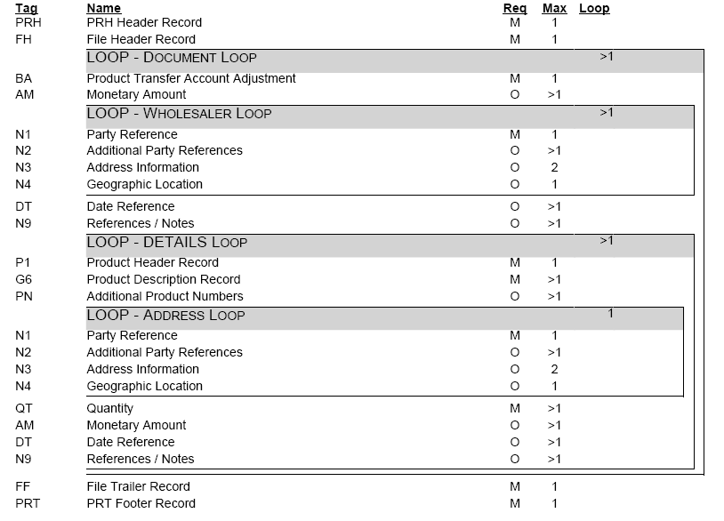

Comments
We understand that many of the clients that receive flat file transactions develop custom software applications to
process, and load data. For these customers, looping and repeating segments present additional complexity. In
order to simplify the coding most segments have the first three (3) characters, following the segment identifier,
reserved as a qualifier field which identifies the type of loop, or in the case of a repeating segment - record type.
If a qualifier is not applicable, the first three characters are left blank, and appear in this specification as FILLER.
Here is an example of how this approach can be used to find the city of a depositor located in the 'N4' segment
of an address loop. Using a traditional approach to looping the developer would usually need to find the first
record in the loop, in this example 'N1', find out if the loop is for the party of interest (N1-01 = 'DE'); then, if it is,
go through the following segments of the loop until the needed segment ('N4') is found. In this example 'N4'
segment is an optional segment and may not exist in the loop, which means that an additional effort is required
to ensure that the search is limited to the correct instance of the loop. By taking advantage of the first three
characters in the segment, the process can be simplified by treating the first FIVE characters ('N4DE '), as
opposed to the first two, as a segment identifier. Using this approach there is no need to be concerned with
looping at all.
The sample method works with repeating segments, for example the reference segment, in a similar way. Of
course, the use of this method is fully optional.

