This document describes the installation of the Tamino filter in the two supported Web Server environments; Microsoft Internet Information Server (IIS) and Apache. The purpose of the filter is to pass http requests that contain “/tamino” to the Tamino database server. The appropriate filter is normally installed automatically by the Tamino installation process, but for various reasons it may be necessary to install the filter by hand (for example, if the active web server type is changed, or if two servers are required to listen on different ports).

Internet Information Server

Make the filter available:
Copy the filter “modiis.dll” from the <Tamino root>/X-Port directory to the IIS Scripts directory (normally C:\INETPUB\Scripts. Ensure that this scripts directory is available to your web server and has execute permission set.

Configure the server to use the filter:
Use the Microsoft Management Console (Windows NT) or the Control Panel, Administrative Tools, Internet Services Manager icon (Windows 2000) to set up IIS as follows:
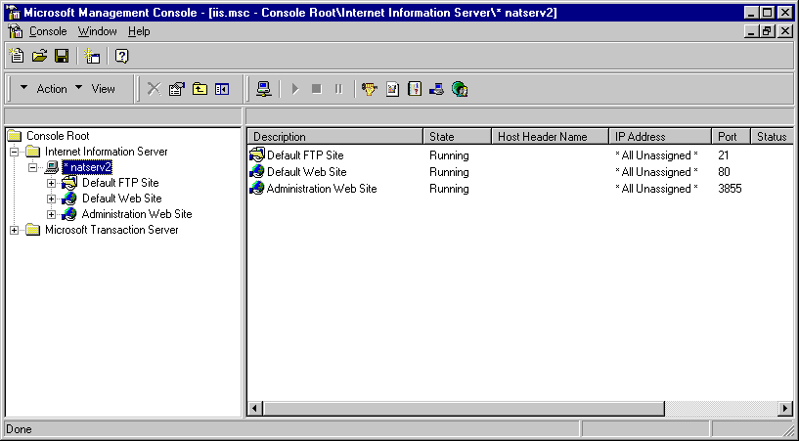
Select the machine name node (not an individual web site )
Right-click on the machine name node and select Properties…
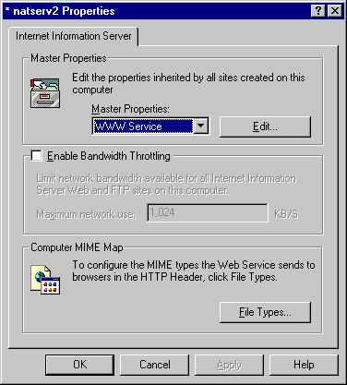
Edit the WWW Service Master Properties…
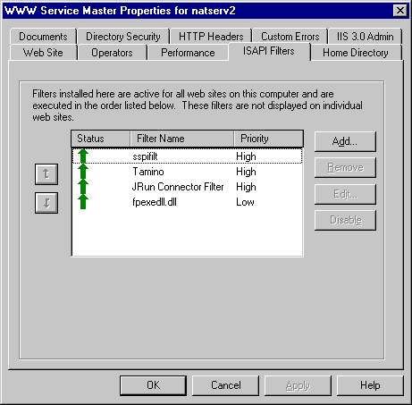
If the Tamino filter does not appear in the list of ISAPI Filters as shown, add it. Press add….
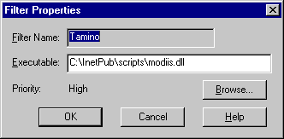
…and add the filter attributes. The most reliable way to ensure the filter will work after making these changes is to re-boot the machine. When the filter is correctly installed, it should display as a green upward-pointing arrow as shown above. It should be possible to get an xml response from Tamino by referring to URL
http://<machinename>/tamino/non-existentdbname
in a web browser. Tamino should respond with “Tamino database unknown” in XML format.

Apache V1.3.x
Adding the filter to Apache is a non-Gui process and involves making changes to text files only.

Make the filter available:
Copy the file “ApacheModuleIno.v1.3.6.dll” from the <Tamino root>/X-Port directory to the <Apache root>/modules directory. Rename it to ApacheModuleIno.dll.

NB: This instruction assumes you are using Apache 1.3.6 or later. Earlier versions of the filter are available for earlier versions of Apache – make sure you use an appropriate filter version.

Configure the server to use the filter:
Edit the file httpd.conf in the <Apache Root>/conf directory.
If the following four lines are not already present, add them:

LoadModule ino_module modules/ApacheModuleIno.dll
<Location /tamino>
SetHandler ino
</Location>

Start Apache (no need to re-boot) and test the filter by addressing URL
http://<machinename>/tamino/non-existentdbname
in a web browser. Tamino should respond with “Tamino database unknown” in XML format.

