Creating a Task With an Updatable Table

Below is the data structure we will use for the table

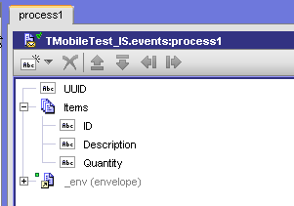

Create new content provider from array in business data

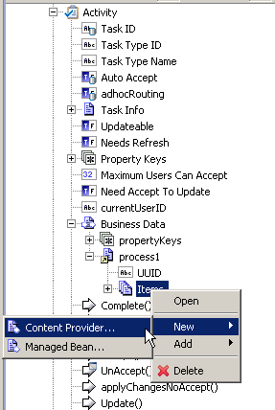

Select marked type

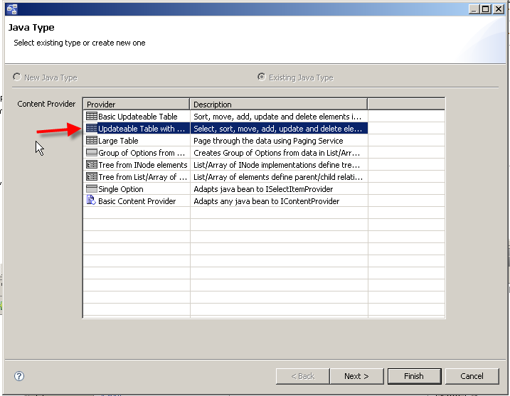

Insert Async table into form

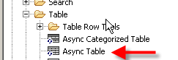

And place content provider into async table (drag and drop)
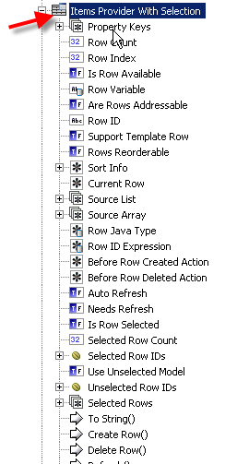

Clean the Source Array Data Binding (you will map it manually, the automatic mapping causes problems)

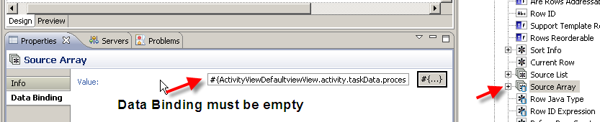

After that the fields in the table will be marked as error, you can ignore this

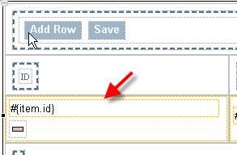

You must now manually populate this field in the initialize data flow

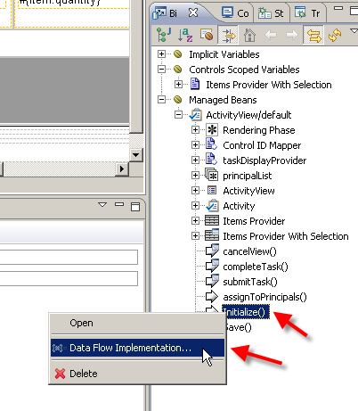

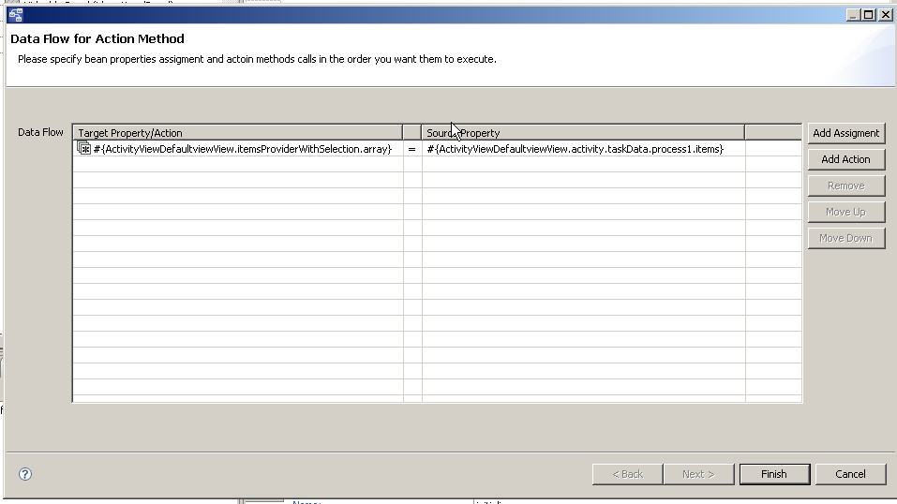

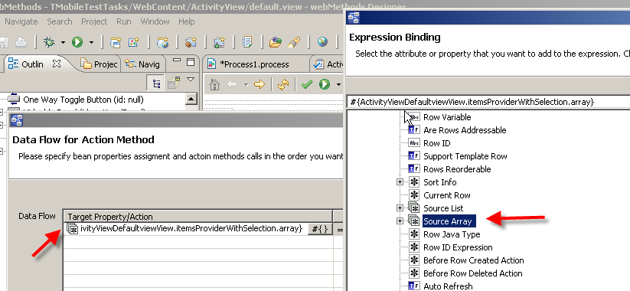

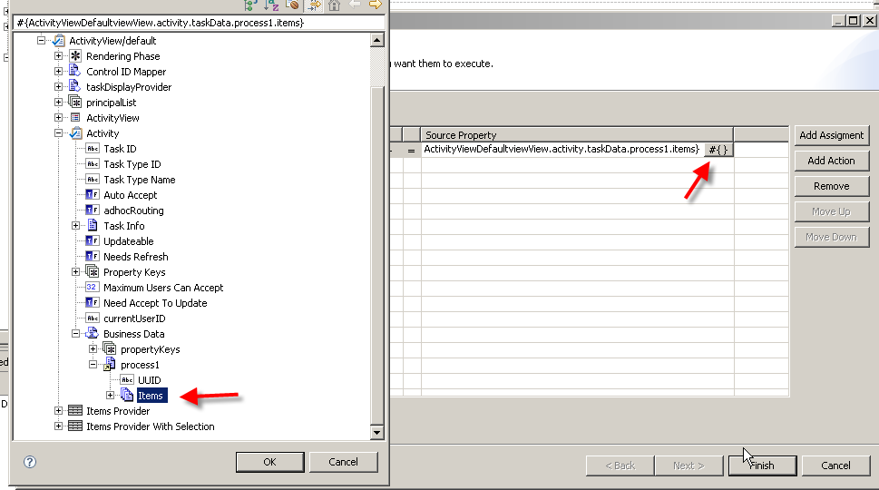

Add remove row link into table

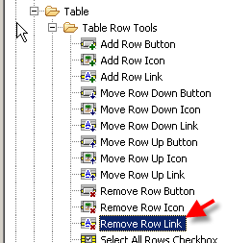

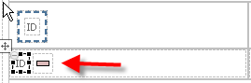

Sometimes the type of the fields is just output. In this case change the type to Text Input

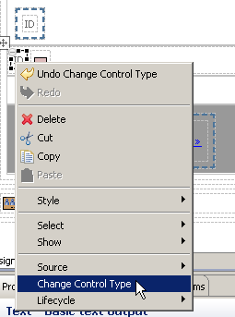

And repeat this for all fields

At the top of the table you need to replace the default text with a block panel (or something similar. So first delete the text …

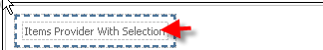

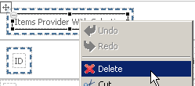

… and then place a block panel in there.

Insert Add row button into this block panel

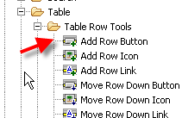

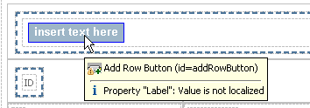

And name it appropriately

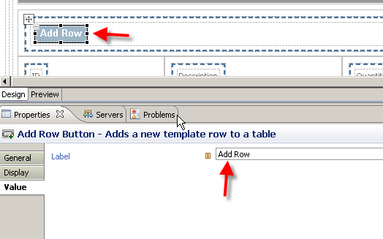

Now we need to reverse the mapping from Source Array into the task business data. Add a new action …

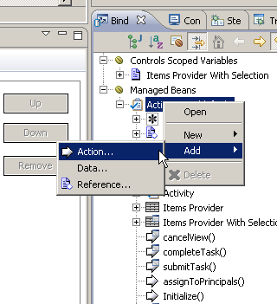

…. and make it a Data Flow, call it “Save”

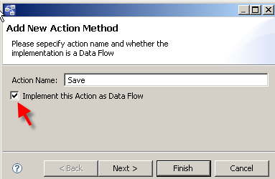

The mapping is the reverse from what you did when you changed the “Initialize” data flow

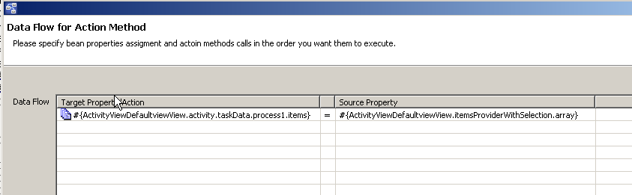

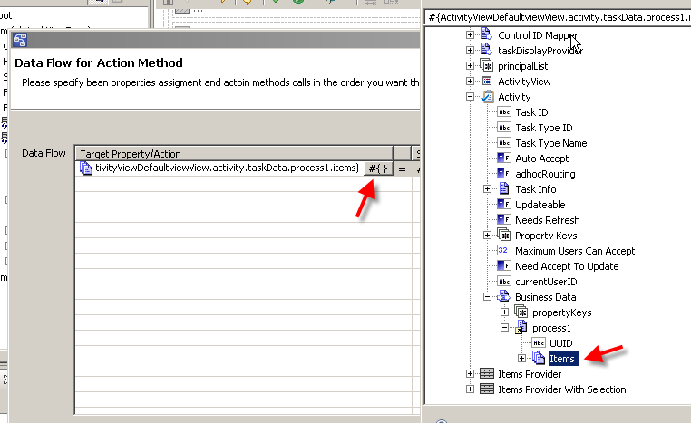

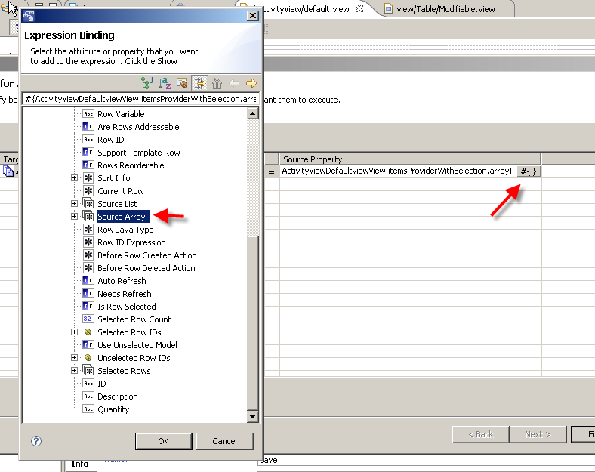

Place a command button (NOT async command button) next to the “Add Row” button

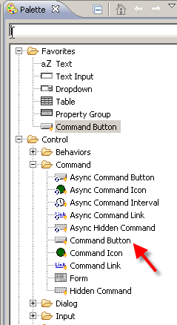

The result looks like this

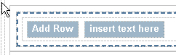

Then drag and drop the “Save” Data Flow Action onto this button, they appearance will change to this

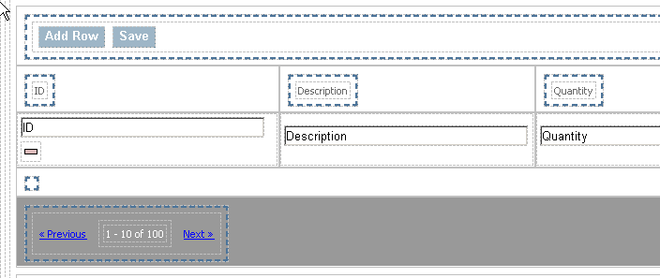
The resulting task looks like this

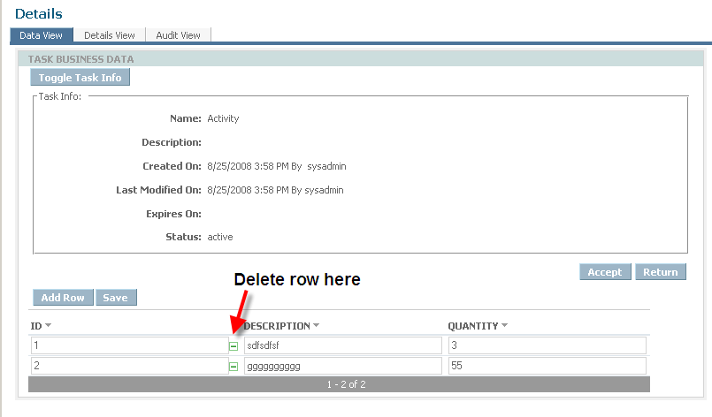

Check in the output logged fields in your process model that it works

