**Product:** webMethods Integration Server

**Version :** 8.0.1.0

**Issue:** wM version 8.0 is not generating WSDL with proper prefix. It is incorrectly putting prefix at wrong places.

**WSDL example in 8.0**

<soapenv:Envelope xmlns:soapenv="http://schemas.xmlsoap.org/soap/envelope/" xmlns:inb="https://partner.access.nsn.com/NSN_EAI_RESOLVE_COMMON/webservices/inboundFromVINE" xmlns:tro="http://java.sun.com/products/oss/xml/TroubleTicket" xmlns:tro1="http://www.vodafone.com/oss/xml/TroubleTicket" xmlns:com="http://java.sun.com/products/oss/xml/Common" xmlns:mon="http://java.sun.com/products/oss/xml/QualityOfService/FM/Monitor" xmlns:thr="http://java.sun.com/products/oss/xml/QualityOfService/PM/Threshold" xmlns:meas="http://java.sun.com/products/oss/xml/QualityOfService/PM/Measurement">

<soapenv:Header/>

<soapenv:Body>

<inb:createTroubleTicketByValueRequest>

<tro:troubleTicketValue>

<!--Optional:-->

<tro1:lastUpdateVersionNumber>?</tro1:lastUpdateVersionNumber>

<!--Optional:-->

<tro1:troubleTicketKey>

<!--Optional:-->

<tro:applicationContext>

<com:factoryClass>?</com:factoryClass>

<com:url>?</com:url>

<com:systemProperties>

<!--Zero or more repetitions:-->

<com:property>

<com:name>?</com:name>

<com:value>?</com:value>

</com:property>

</com:systemProperties>

</tro:applicationContext>

<!--Optional:-->

<tro:applicationDN>?</tro:applicationDN>

<tro:type>?</tro:type>

<tro:primaryKey>?</tro:primaryKey>

</tro1:troubleTicketKey>

<!--Optional:-->

<tro1:accountOwner>

Tag Expected Prefix Resulting Prefix

lastUpdateVersionNumber com tro1

troubleTicketKey tro tro1

accountOwner tro tro1

applicationContext com tro1

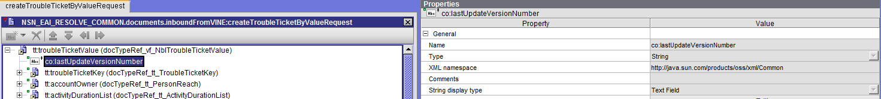

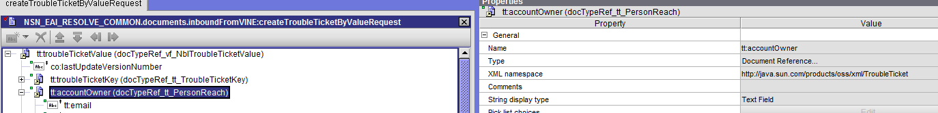

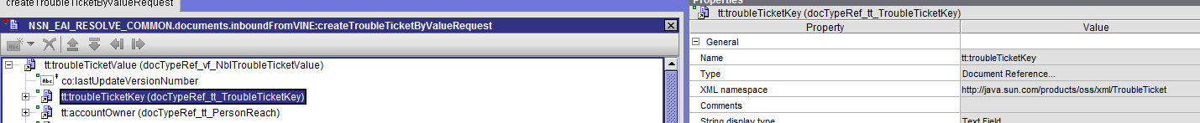

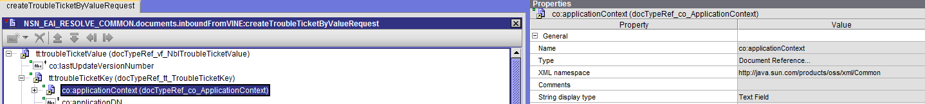

Please find attached generated WSDL on IS 8.0



For wM version 8.2, we are getting prefixes as expected,

**WSDL example in 8.2**

<soapenv:Envelope xmlns:soapenv="http://schemas.xmlsoap.org/soap/envelope/"

xmlns:inb="https://partner.access.nsn.com/NSN_EAI_RESOLVE_COMMON/webservices/inboundFromVINE"

xmlns:tro="http://java.sun.com/products/oss/xml/TroubleTicket"

xmlns:com="http://java.sun.com/products/oss/xml/Common"

xmlns:mon="http://java.sun.com/products/oss/xml/QualityOfService/FM/Monitor"

xmlns:thr="http://java.sun.com/products/oss/xml/QualityOfService/PM/Threshold"

xmlns:meas="http://java.sun.com/products/oss/xml/QualityOfService/PM/Measurement"

xmlns:tro1="http://www.vodafone.com/oss/xml/TroubleTicket">

<soapenv:Header/>

<soapenv:Body>

<inb:createTroubleTicketByValueRequest>

<tro:troubleTicketValue>

<!--Optional:-->

<com:lastUpdateVersionNumber>?</com:lastUpdateVersionNumber>

<!--Optional:-->

<tro:troubleTicketKey>

<!--Optional:-->

<com:applicationContext>

<com:factoryClass>?</com:factoryClass>

<com:url>?</com:url>

<com:systemProperties>

<!--Zero or more repetitions:-->

<com:property>

<com:name>?</com:name>

<com:value>?</com:value>

</com:property>

</com:systemProperties>

</com:applicationContext>

<!--Optional:-->

<com:applicationDN>?</com:applicationDN>

<com:type>?</com:type>

<tro:primaryKey>?</tro:primaryKey>

</tro:troubleTicketKey>

<!--Optional:-->

<tro:accountOwner>

Tag Expected Prefix Resulting Prefix

lastUpdateVersionNumber com com

troubleTicketKey tro tro

accountOwner tro tro

applicationContext com com

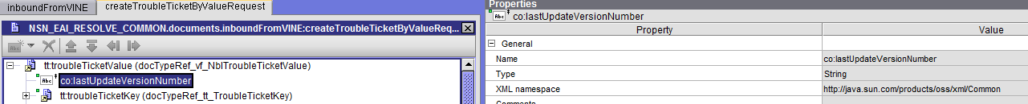

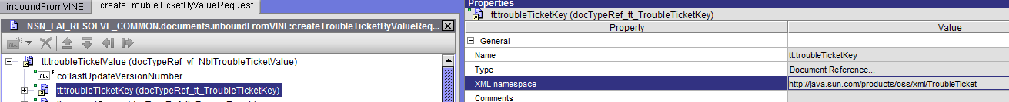

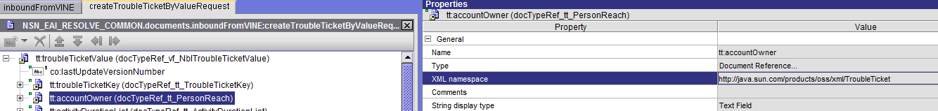

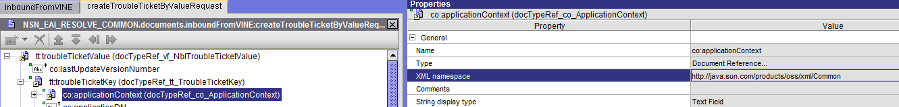

Please find attached generated WSDL on IS 8.2



**Here is the webService stack versions on both IS’s,**

|  |  |  |
| --- | --- | --- |
| IS Version | WS Stack version | Build Number |
| 8.0.1.0 | 8.0.5.0 | 146 |
| 8.2.2.0 | 8.2.2.0 | 234 |

**Fixes applied:**

