When the number of item in document list > 1
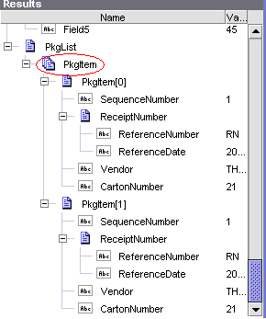
It is OK

When the number of item in document list = 1
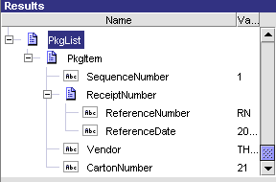
The loop does not understand PkgItem as a list so it does not work

