File Poller port configuration in the IS :
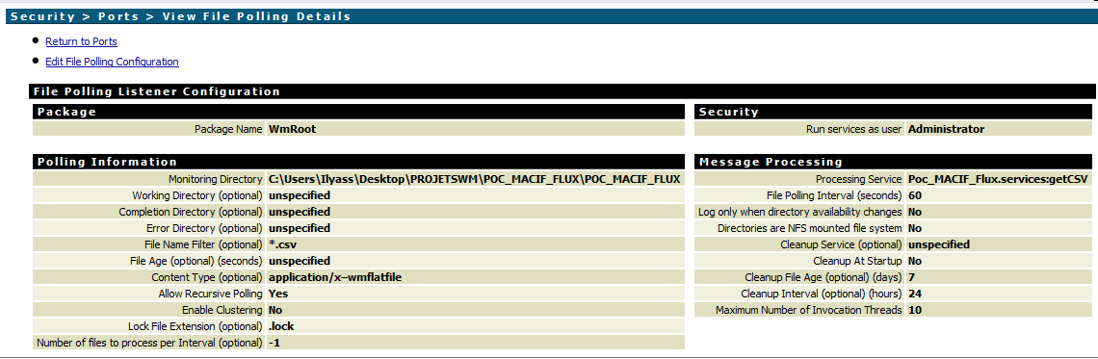

Configuration of getTransportInfo based on this site :
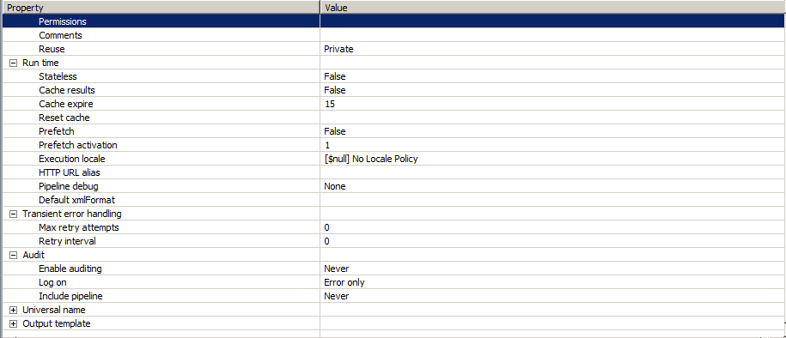
The Pipeline output when the getTransportInfo is run as a Flow Service :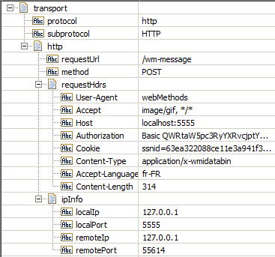
The pipeline mapping for the flow service pub.file:getFile :
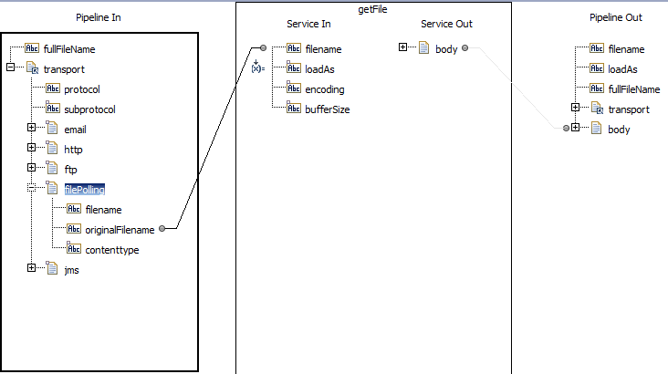
Parameter ServiceIn:loadAs is set at Bytes, which is ok for what is done after.

