Cloud Pak for Data integration AWS SimpleAD

Introduction:

This document outlines the steps to integrate AWS Simple active directory(SimpleAD) with cloud pak for data.

Documentation Link:

For better understanding of AWS SimpleAD please refer to the below link:
https://docs.aws.amazon.com/directoryservice/latest/admin-guide/directory_simple_ad.html

Pre-requisites:

One must be having AWS account with its credentials(AWS access key and AWS secret access key)

Deploying IBM CPD 3.5 cluster on AWS using terraform:

Please refer to the link below to deploy CPD cluster using terraform scripts :
https://github.com/IBM/cp4d-deployment/tree/master/selfmanaged-openshift/aws

On completion make note down of following things which will be created:
- Amazon VPC in the region you have chosen.
- Private and public subnets which are created in that VPC.
- The bootnode instance details which will be created in EC2 instances dashboard.
- If you don’t have an existing DNS domain for use with LDAP, create a private hosted zone and associate it with your VPC. The hosted zone name should be consistent with your Simple AD (for example, corp.example.com).

Configure an LDAPS endpoint for Simple AD:

Solution:

- The LDAP client sends an LDAPS request to the NLB on TCP port 636.
- The NLB terminates the SSL/TLS session and decrypts the traffic using a certificate. The NLB sends the decrypted LDAP traffic to Simple AD on TCP port 389.
- The Simple AD servers send an LDAP response to the NLB. The NLB encrypts the response and sends it to the client.
The following diagram illustrates how the solution works:
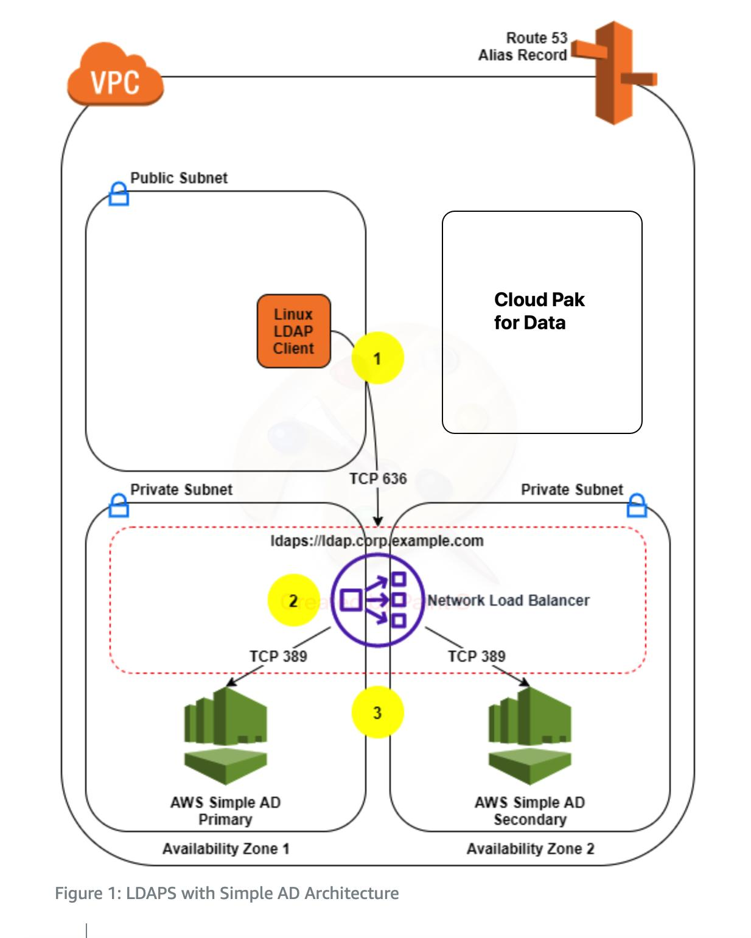
Please refer to the link below to configure LDAPs for SimpleAD :
https://aws.amazon.com/blogs/security/how-to-configure-ldaps-endpoint-for-simple-ad/

Perform all steps as mentioned from Point 1(Create a Simple Active Directory) till Point 4(Create a Route 53 Record).

Test LDAPS access:

SSH to the bootnode created after running terraform scripts and execute following steps:
- Install the openldap-clients package and any required dependencies:
sudo yum install -y openldap-clients
- Add the server.crt file to the /etc/openldap/certs/ directory so that the LDAPS client will trust your SSL/TLS certificate. You can download the file directly from the NLB the certificate and save it in the proper format, or copy the file using Secure Copy or create it using a text editor:
openssl s_client -connect <LDAPSURL>:636 -showcerts </dev/null 2>/dev/null | openssl x509 -outform PEM > server.crt
Replace <LDAPSURL> with the FQDN of your NLB, the address can be found in the Outputs section of the stack created in CloudFormation.
- Edit the /etc/openldap/ldap.conf file to define the environment variables:
- BASE: The Simple AD directory name.
- URI: Your DNS alias.
- TLS_CACERT: The path to your public certificate.
- TLSCACertificateFile: The path to your self-signed certificate authority.
Here’s an example of the file: 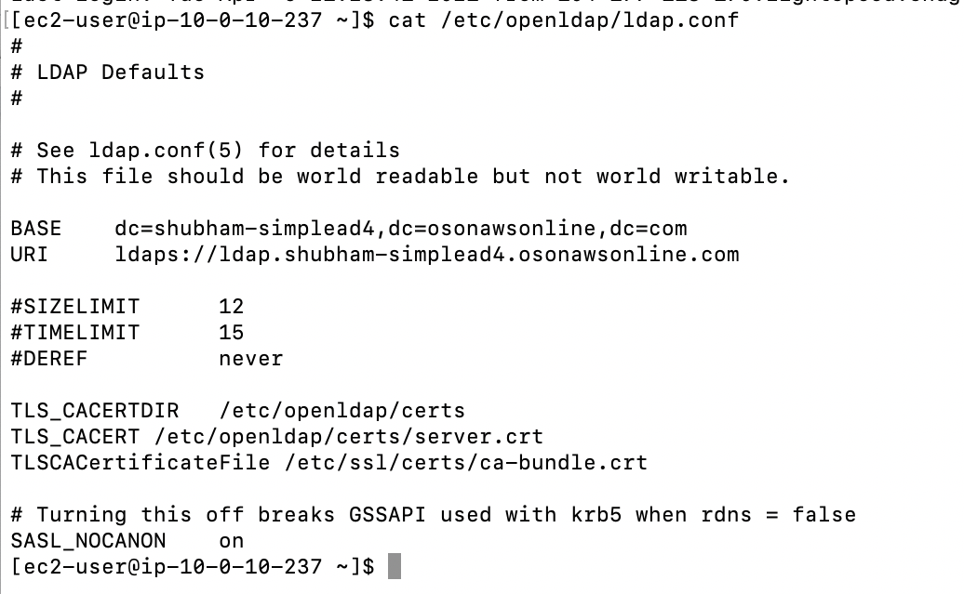
- To test the solution, query the directory through the LDAPS endpoint, as shown in the following command. Replace corp.example.com with your domain name and use the Administrator password that you configured while creating a Simple AD directory.
$ ldapsearch -D "Administrator@corp.example.com" -W sAMAccountName=Administrator
- The response will include the directory information in LDAP Data Interchange Format (LDIF) for the administrator distinguished name (DN) from your Simple AD LDAP server.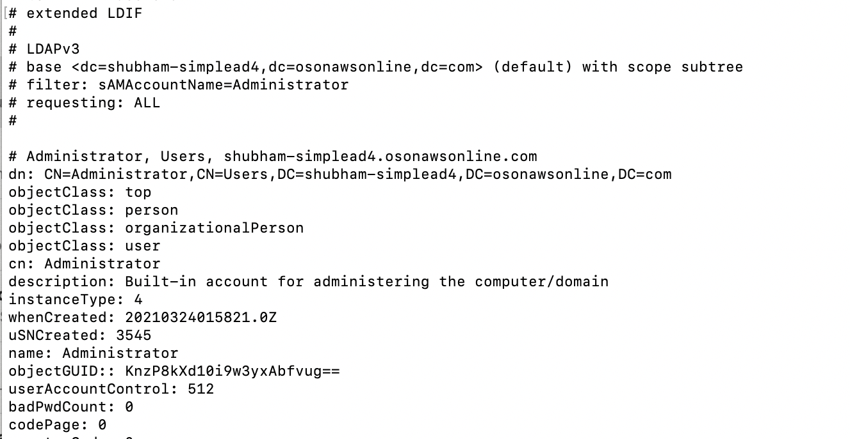
- You can now use the LDAPS endpoint for directory operations and authentication within your environment.

LDAP Configuration on CPD:

Log in to CPD web client by using default admin account, access the Manage users page by selecting menu Administration -> User management

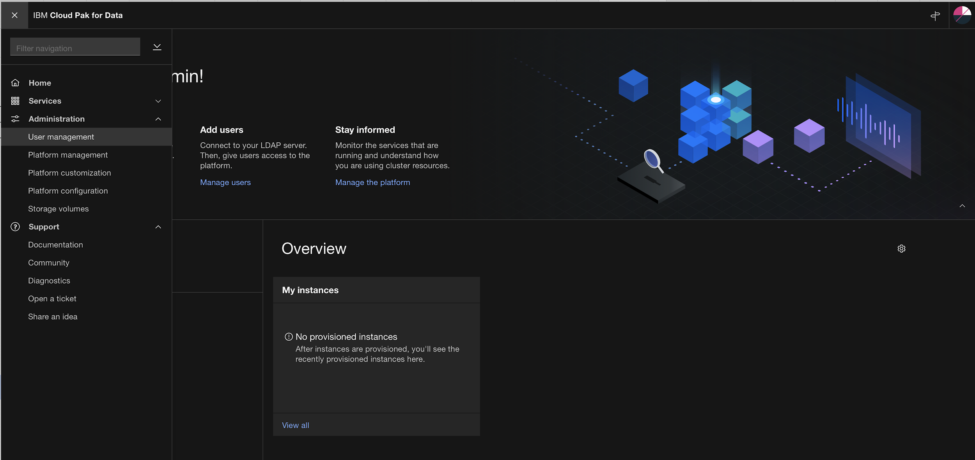

- Click the Configure LDAP link on the right top of User Management page

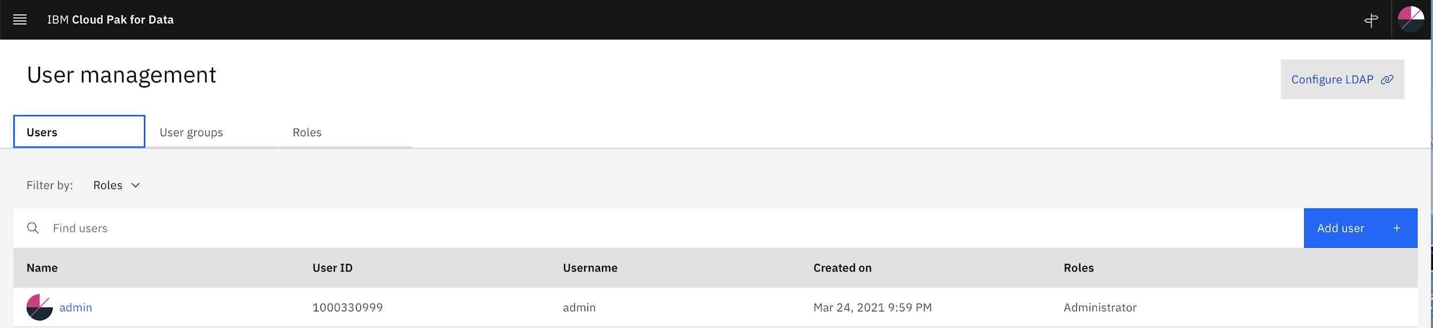

- On the Configure LDAP page, set the correct information for the connection to your SimpleAD

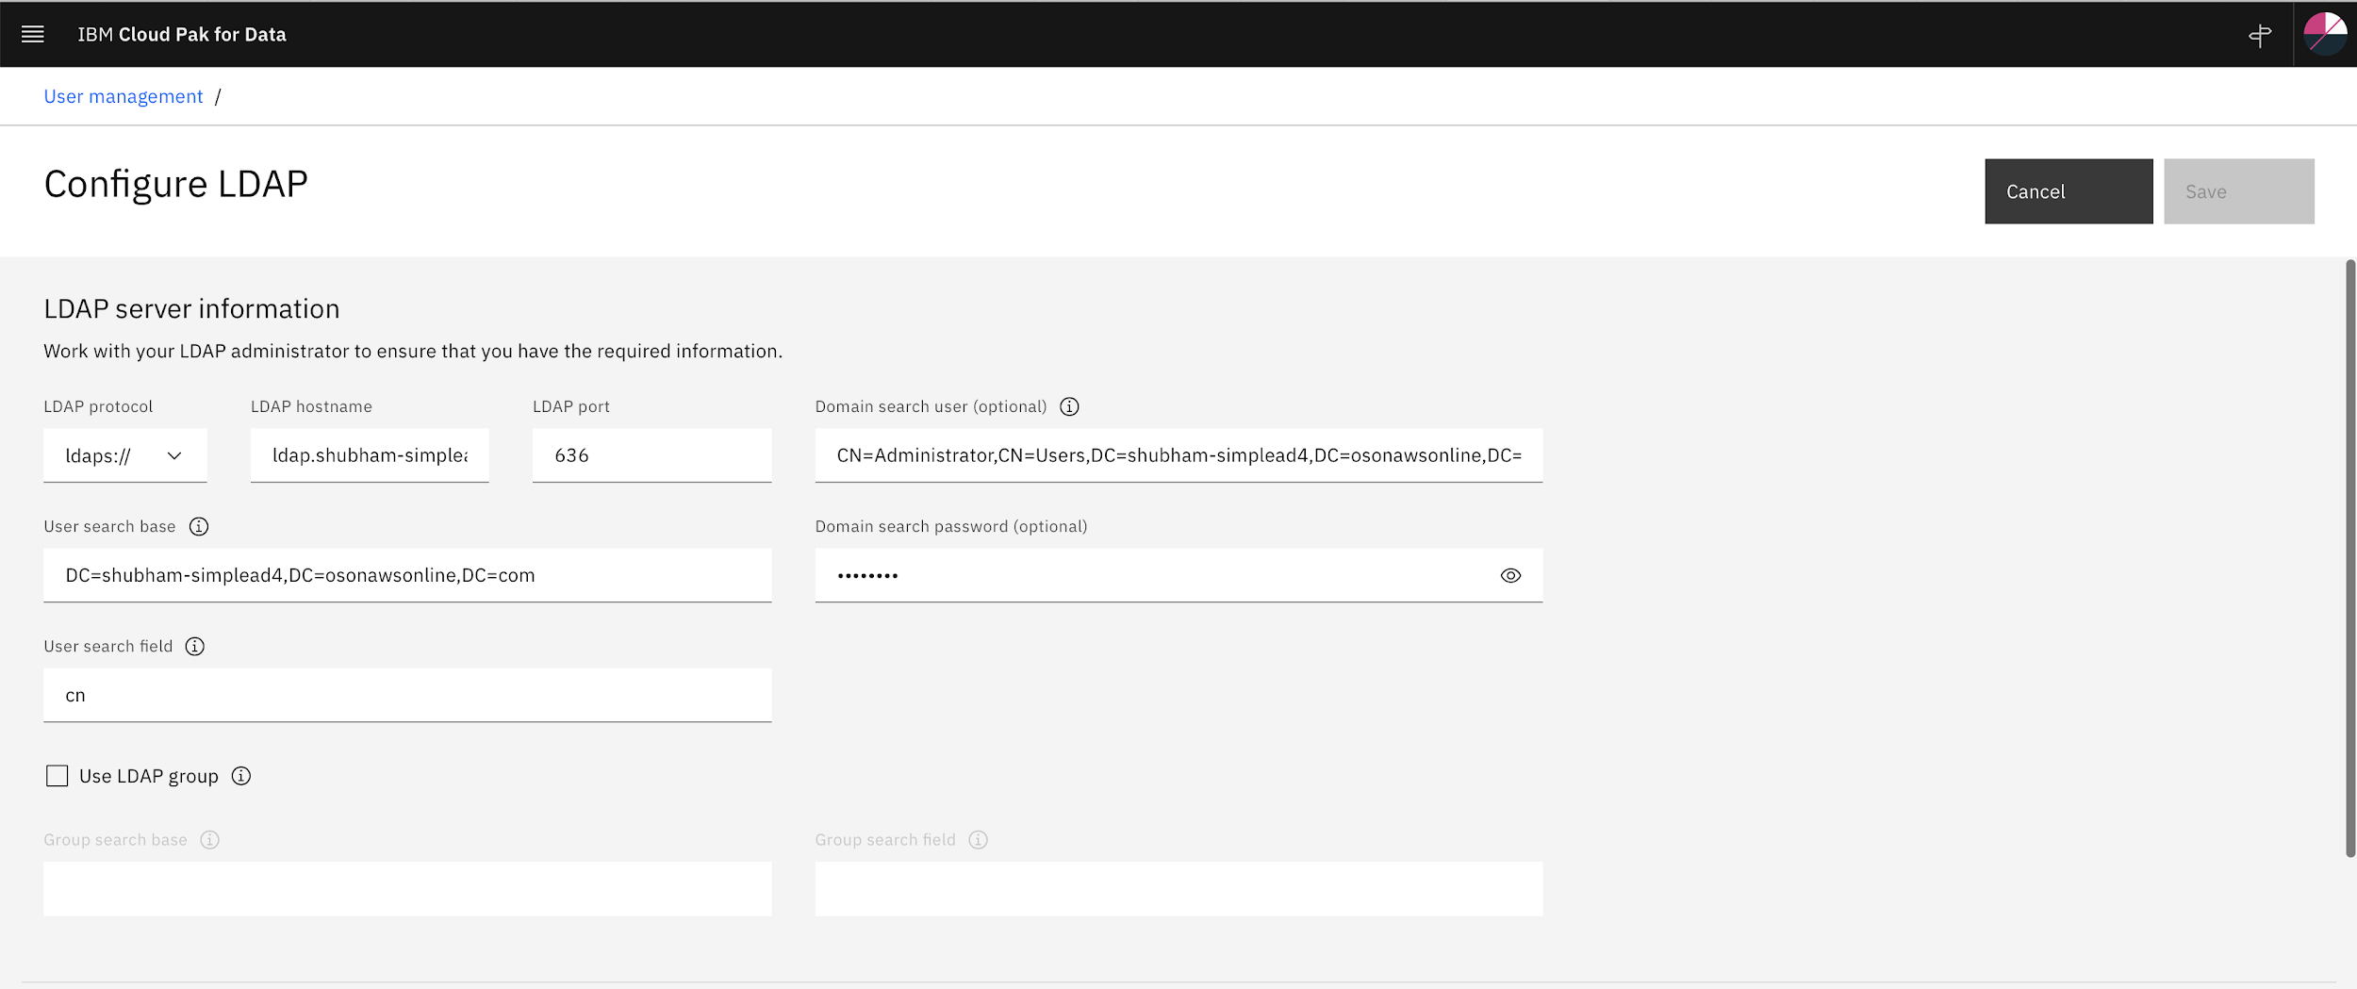

- Set the correct LDAP attribute-mapping .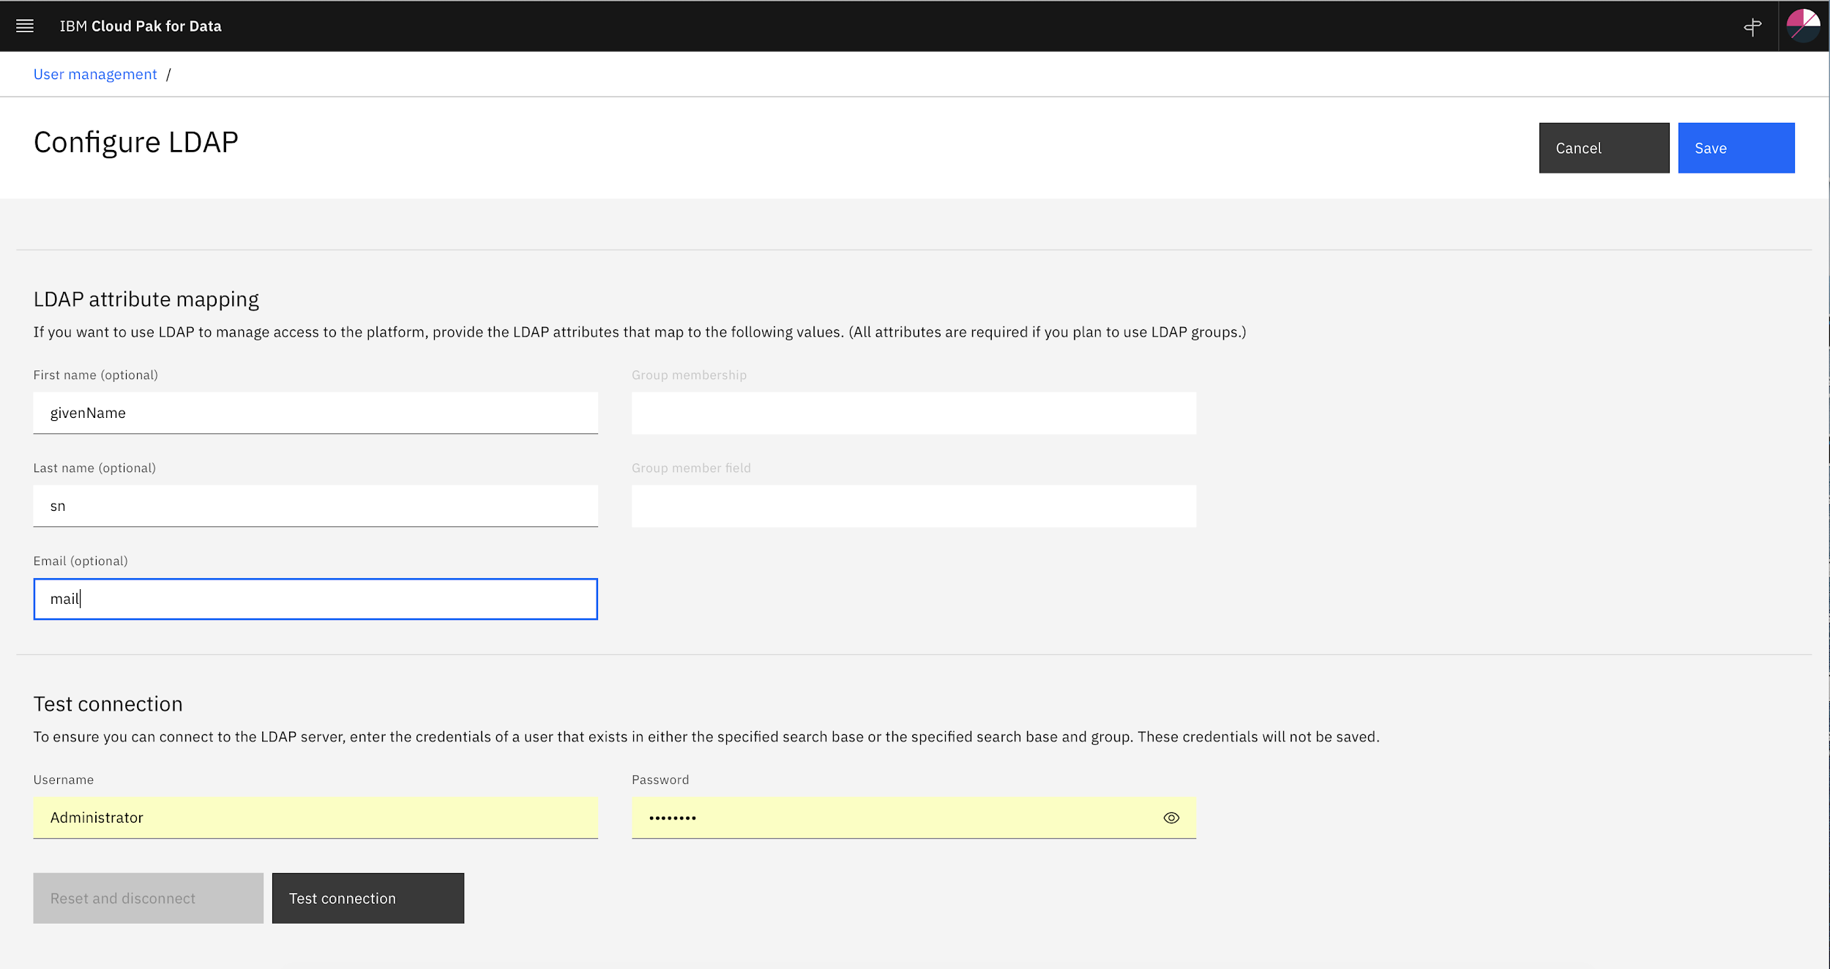

- Confirm the connection to SimpleAD by pressing Test Connection button and click Save

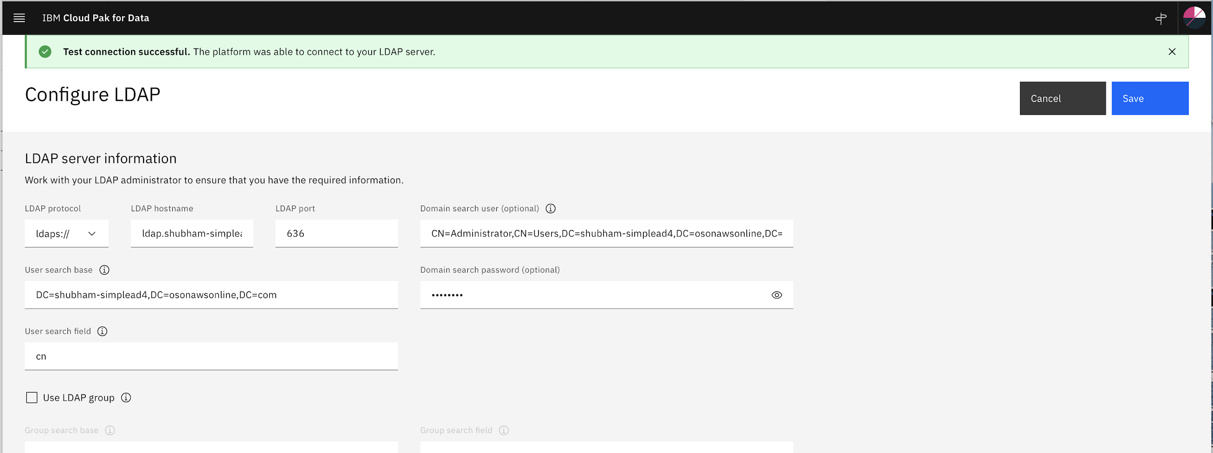

- Confirm you can log in to the CPD web client by using SimpleAD user.
