Cloud Pak for Data on Azure IAM SSO configuration

Introduction:

This document outlines the steps to configure Azure Active directory SAML/SSO configuration for cloud pak for data.

Documentation Link:

For better understanding of the SAML authentication in Azure please refer to the below link:
https://docs.microsoft.com/en-us/azure/active-directory/manage-apps/configure-saml-single-sign-on

Pre-requisites:

- The azure user id who would be performing this setup should have
  - One of the following roles:
    - Global Administrator.
    - Cloud Application Administrator.
    - Application Administrator.
- Should have the cloud Pak for data cluster ready.

Setting up Enterprise Application in Azure AD:

Please follow the below steps to setup the SAML identity provider (IdP) in AZURE.

- Login to the Azure portal.

- From the home page navigate to Azure Active Directory -> Enterprise Applications -> + New Application > Create your own application

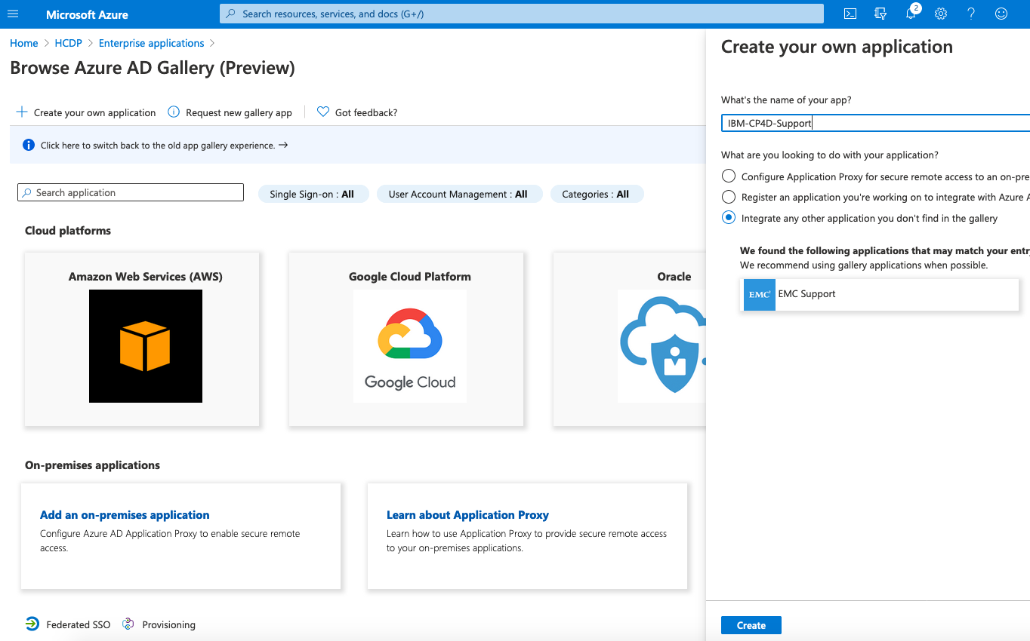

- Enter the application name (eg., IBM-CP4D-Support) and click create.

- Once it is saved, under Azure Active Directory > Enterprise Applications, it should show your new application. (eg., IBM-CP4D-Support)

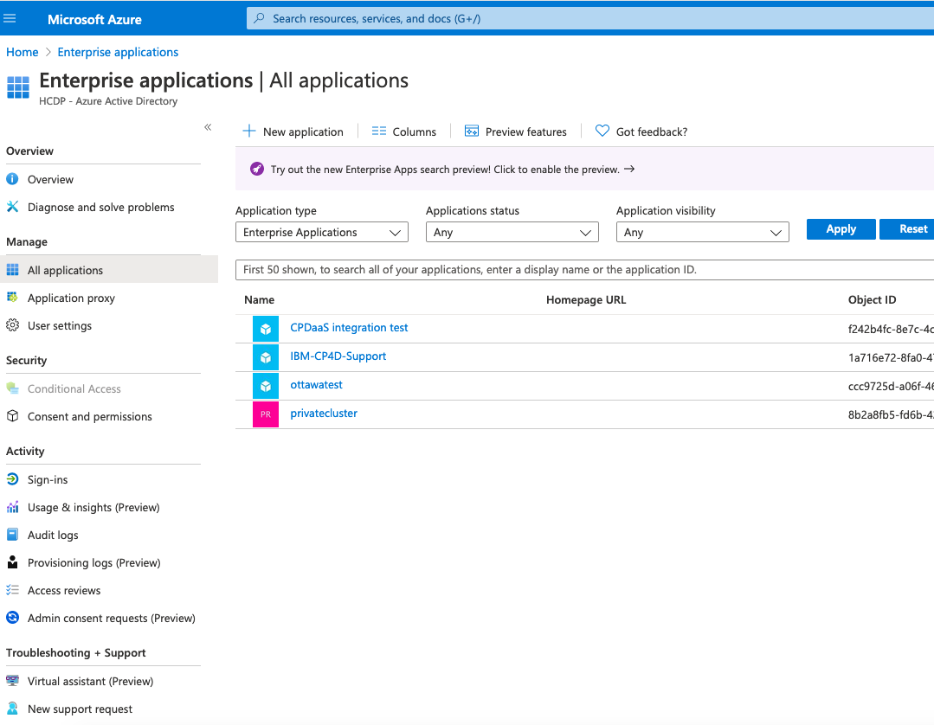

- Select the app you just created IBM-CP4D-Support and click on it.

- Click on 2. Set up single sign on
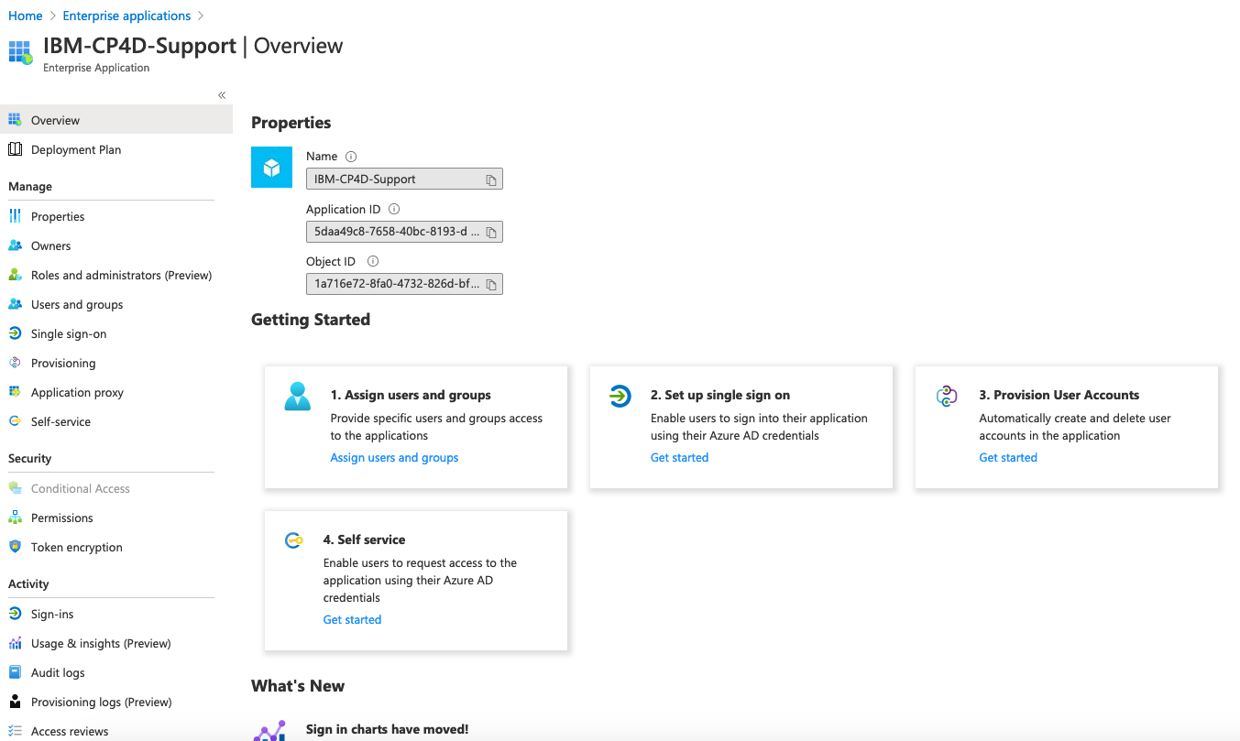

- On the Single Sign on page, please select SAML method.

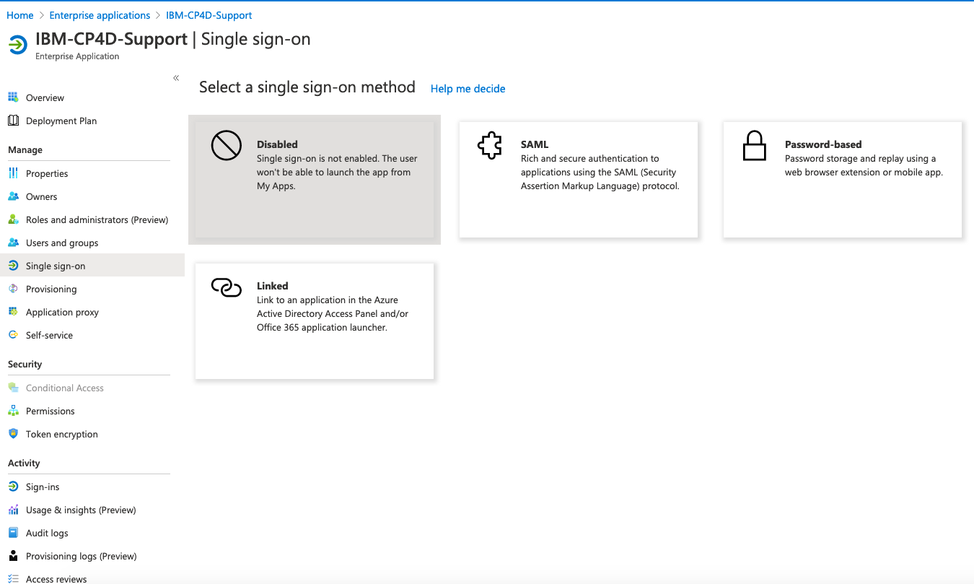

- In the “Set up Single Sign-on with SAML Page, please input the required values.

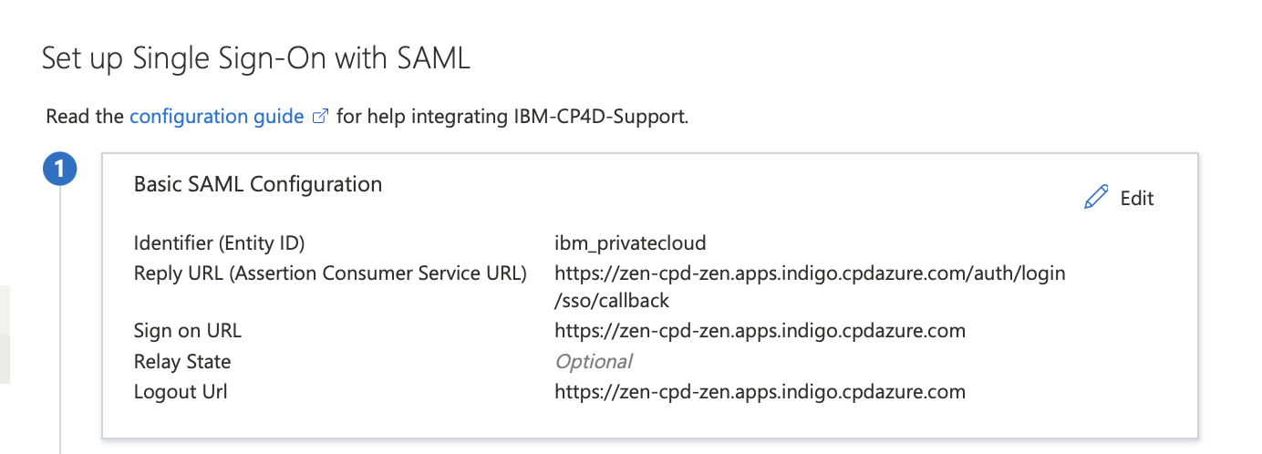

- In section 1. Basic SAML Configuration, please add the below values for the respective fields.
  - Identifier (Entity ID) – unique name to identify the application (default ibm_privatecloud). This entity id will be using the further steps while using samlConfig.json.
  - Reply URL – https://<cloudpak_web_URL>/auth/login/sso/callback
  - Sign on URL – https://<cloudpak_web_URL>
  - Relay State – optional.
  - Logout URL - https://<cloudpak_web_URL>

- In section 2. User Attributes and Claims, for Unique User Identifier field change the value as user.mail

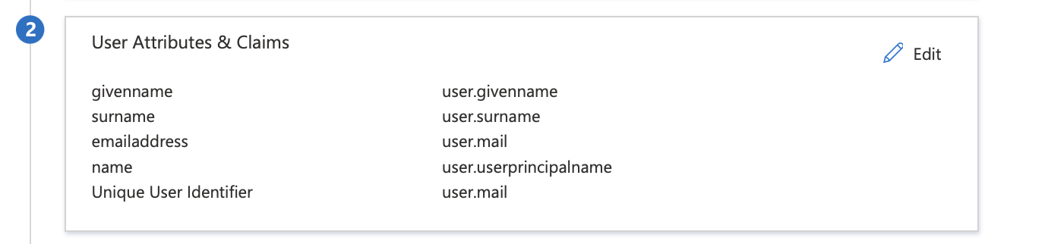

- In Section 3. SAML Signing certificate, download the base64 certificate and remove ‘---Begin Certificate ----’ and ‘--- End Certificate ---’ lines and also make sure to convert the multi line file into a single line using any editor and keep it. This will be used while setting up usrmgmt pod in CPD installed names space.

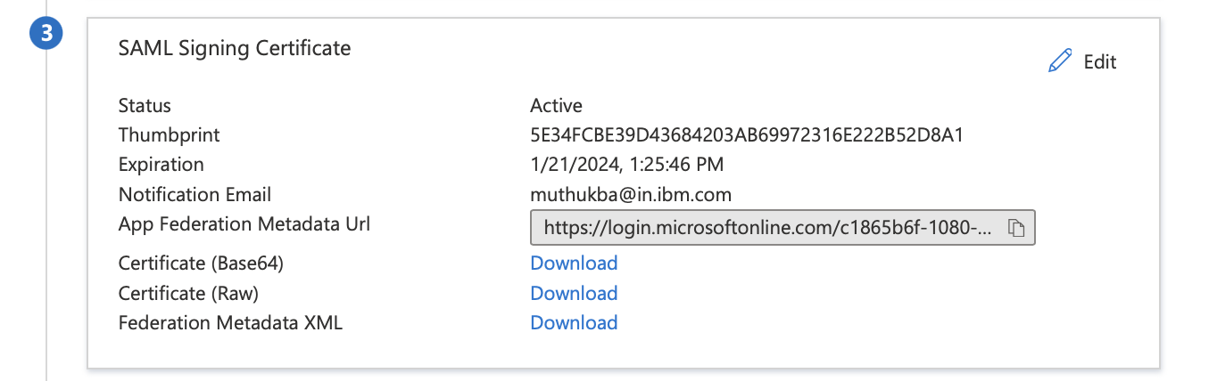

- Keep the default values in the section 4. The Logon URL will be used as entry point in the samlConfig.json file.

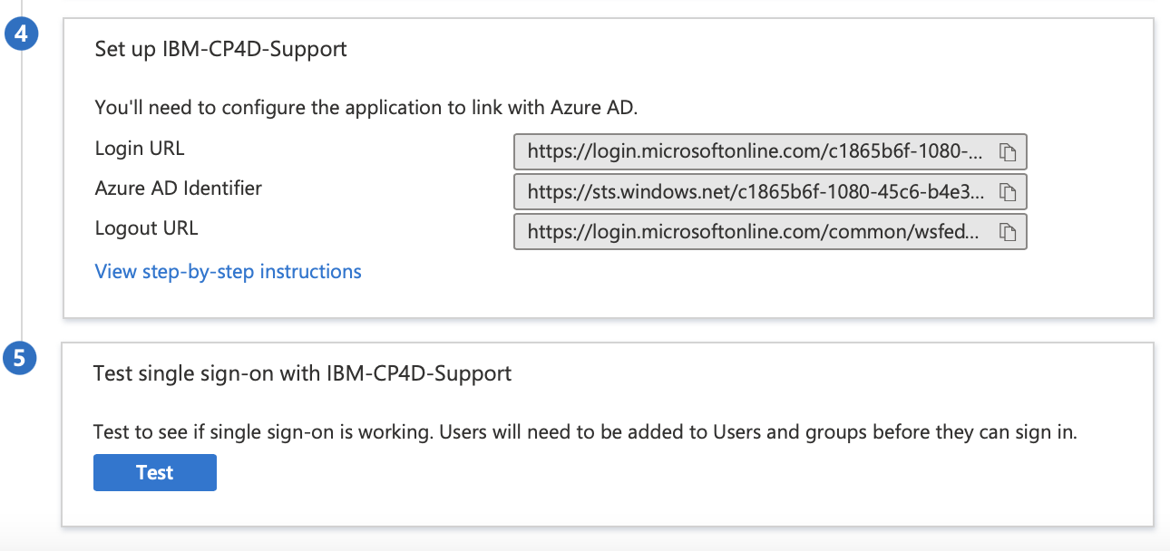
- Once the above step is completed, click save and skip the test.
- Next step is to add the samlConfig.json file in the CP4D usrmgmt pod.

Setting UP CP4D SSO:

Reference link: https://www.ibm.com/support/producthub/icpdata/docs/content/SSQNUZ_latest/cpd/install/saml-sso.html

Please follow the below steps to configure Single Sign-on for CP4D.

- Log in to your Red Hat® OpenShift® cluster as a project administrator

oc login openshift_url:port

- Enable SAML by running the below command.

oc exec -it -n namespace \
$(oc get pod -n namespace -l component=usermgmt | tail -1 | cut -f1 -d\ ) -- bash -c “vi /user-home/_global_/config/saml/samlConfig.json”

Replace the value of namespace where CP4D is installed.

- In samlconfig.json file, specify the appropriate values for your environment.

{
"entryPoint": "https://login.microsoftonline.com/c1865b6f-1080-45c6-b4e3-7229f279195d/saml2 <the logon URL value from step 4 of the Single Sign on setup > ",
"fieldToAuthenticate": "http://schemas.xmlsoap.org/ws/2005/05/identity/claims/emailaddress",
"spCert": "",
"idpCert": "<single line converted certificate base64 file acquired in “Set up Single Sign-on with SAML “ method> ",
"issuer": " Identifier (Entity ID) created in the previous steps.",
"identifierFormat": "urn:oasis:names:tc:SAML:1.1:nameid-format:emailAddress",
"callbackUrl": " https://cloudpak_web_URL/auth/login/sso/callback " ,
"disableRequestedAuthnContext": “true”
}

- Save the file and exit.
- Run the following command to delete the usermgmt pod.
oc delete pods -l component=usermgmt

- Wait for few minutes for the usermgmt pods to be in running state.
- After the pods are started please follow the below steps.

  - Go directly to the web client log in page by appending the following path to your Cloud Pak for Data URL: /auth/login/zen-login.html.
  - Log in to the web client as the admin user or another administrator with user management permissions.

- Test the connection from the azure portal.

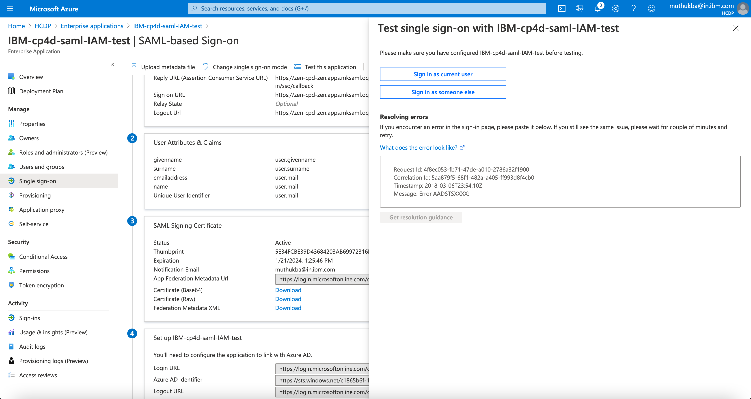

- You should be able to login to CP4D web UI using sso.

