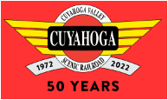
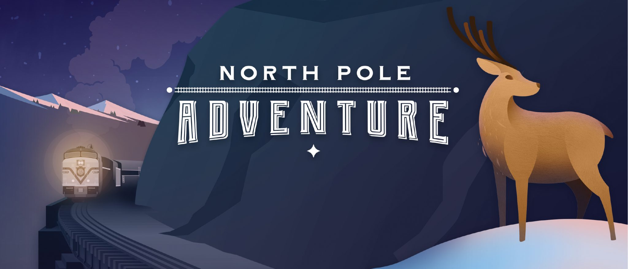

On the evening of Sunday, December 11th, our chapter is volunteering at the “North Pole Adventure” event sponsored by the Cuyahoga Valley Scenic Railroad (CVSR). We will be outside at the “North Pole” aka the CVSR Fitzwater Maintenance Yard in Valley View, OH. There will be off-train, outdoor opportunities for volunteers.
Volunteers will be dressed as Elves to assist Santa in delivering his Holiday Magic.
The chapter will provide volunteers with hot cocoa and seasonal treats after the event.
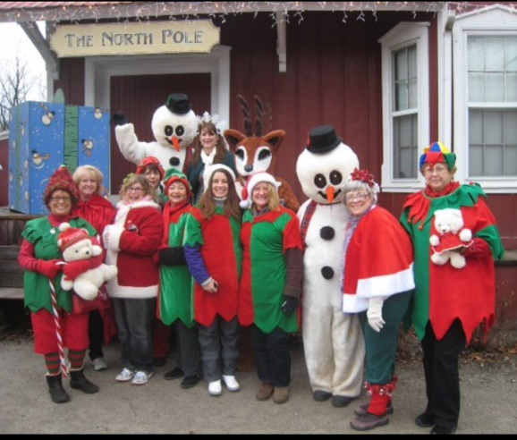
Date: Sunday, December 11th, 2022
Time: 4:30pm to 7:00pm
Location: Brecksville Station
9141 Riverview Rd
Brecksville, OH 44141

The CVSR will bus all volunteers to the “North Pole”
Register today:

Deadline to register: Tuesday, Dec 6th. Don’t miss this fun Holiday event.

