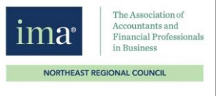
IMA NorthEast Regional Council
STUDENT AND PROFESSIONALS CONFERENCE
Date: Saturday, April 2, 2022 – 8:30 AM to 4:30 PM (Program begins at 9:15 AM)
Where: UMass Lowell Inn and Conference Center – 50 Warren Street – Lowell, MA 01854
SPEAKERS:
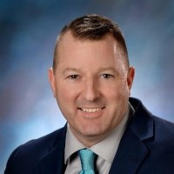
Dave Sackett – AI as your Financial Auditor
Dave Sackett is a former CFO and is now the Chief Solutions Architect for Visibility Corporation. He belongs to financial networking groups and writes articles for Forbes Financial Council. He speaks about AI, blockchain, ERP and digital automation. He runs the website www.davesackett.com and is open to connecting on LinkedIn with his audience members.
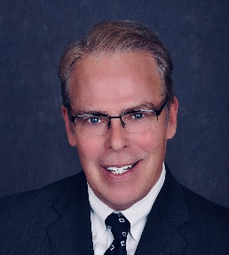
David O’Brien – Creating an Accountability Mindset
David O’Brien is President of CT based WorkChoice Solutions, a trusted provider of leadership training, coaching and consulting services that was founded in 2000. His HR and Organizational Development consulting career spans 30 years and includes key leadership and P&L responsibility within a variety of industries including manufacturing, healthcare and financial services. He is also the author of two very popular leadership books and is an in-demand speaker on the topic of leadership excellence.
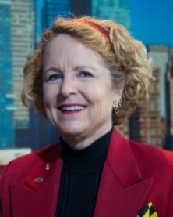
Jennifer Elder, CSP, CPA – Panel Moderator
Are you ready to be seen and be heard? Jennifer Elder, CSP, CPA, is a finance coach working with smart professionals who want to develop their professional brand, communication and connection skills to immediately influence, impact, and elevate their success. Transform from an un-heard nerd to admired advisor!
After 15 years as a CFO in manufacturing, construction, and services, Jennifer understands the difference between information and influence. As a keynote speaker Jennifer is known for being energetic and enthusiastic. She has presented to over 15,000 people in 48 states and 6 countries. She makes the complicated simple, practical and profitable.
Jennifer is the co-author of “Faster Disaster Recovery” published in 2019 by John Wiley and Sons. CPA Practice Advisor named Jennifer one of the Top 25 Women in Accounting in 2018.
Jennifer earned the designation of Certified Speaking Professional (CSP), making her one of only 12 people worldwide who hold both the CPA and CSP designations. ﻿
Jennifer is an avid skier who currently lives with her spouse and 2 cats north of nowhere in Thornton, NH.
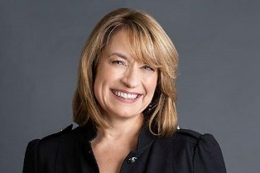
Claude-Helene McIntyre, CMA - Panelist
Claude-Helene McIntyre, CMA, has over 30 years’ experience in leadership positions at privately held small to mid-size companies. Claude has been the CFO at ARBURG Inc. since 2015. ARBURG is a subsidiary of German based ARBURG GmbH, a global leader in the manufacture of high-end injection molding machines for plastics processing.
Claude has served as CMA Director and President of the IMA Hartford Chapter. Claude holds a BS in Accounting from Central Connecticut State University and is currently pursuing her MBA at UMass Lowell. She also serves on the Board of Directors at Key Human Services, a nonprofit organization that provides individuals with disabilities the opportunity to live full and meaningful lives within their community.

Tyler Gillis - Panelist
Tyler Gillis is a motivated 2019 graduate from Central Connecticut State University with a bachelors in Accounting Sciences. During his time as a student at CCSU he assumed the role of the Accounting Society’s Treasurer for two years. He is currently employed by Arburg Inc. in Rocky Hill, Connecticut as a Staff Accountant and his responsibilities include cost accounting, account reconciliations, and month end reporting. Tyler is an active board member of the IMA Hartford Chapter and is currently studying to be a Certified Management Accountant; thus far he has completed the Part I examination.
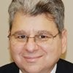
Gregory Lainas - Panelist
Gregory A. Lainas, retired in 2021 as a Senior Vice President of Robert Half Management Resources, a division of Robert Hal International, Inc. Robert Half Management Resources is a consulting firm providing accounting, finance and business systems professionals on a project or interim basis. Greg started with Robert Half International, Inc. in 1987 with the contract finance and accounting division (formerly known as Accountemps). In May of 1998, he started the Management Resources division in the Hartford office. He has earned Chairman’s and President’s Club status in both divisions.
In 2014 Greg became the first person in the history of Robert Half to attain twenty million in gross margin. Prior to coming to Robert Half International, Inc., Greg worked for ESPN, Whittlesey and Fleet Bank. Greg received his Bachelors Degree in Business Administration from Northeastern University. He was the 2011-2012 president of the Connecticut Society of CPAs and previously served as a trustee on the CTCPA’s Accounting Scholarship Foundation. Greg also serves on an advisory board at Post University and Central Connecticut State University. He has spoken at IMA, FEI and CTCPA events. He is a member of the IMA and CTCPA. He was a president of the Waterbury IMA.
He is featured on the podcasts Change Your Mindset/Improv Is No Joke, episodes 22, 30 and 52.
Greg resides in Plantsville, Connecticut and his email is glainas@cox.net.

