Celebrate the 50th Anniversary of Your NorthEast Regional Council
with your own NERC Logo Shirt that proclaims “50 Years Strong”!

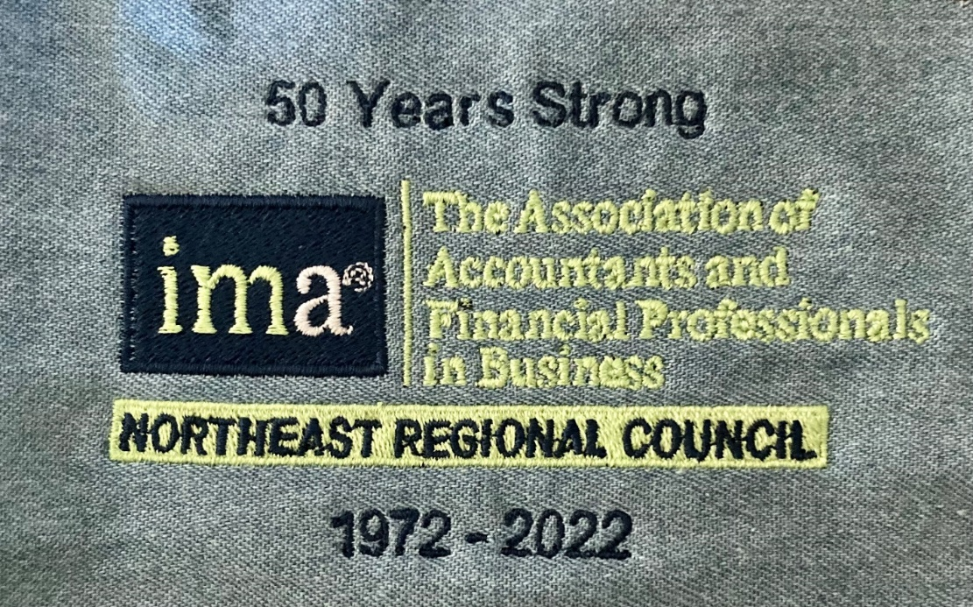

When you wear your NERC Logo Shirt people will see that you are a proud member of the IMA and its NorthEast Regional Council.

The NERC is offering medium weight long-sleeved denim shirts with the above logo embroidered over the left chest panel. Men’s denim shirts have a pocket, women’s denim shirts do not.
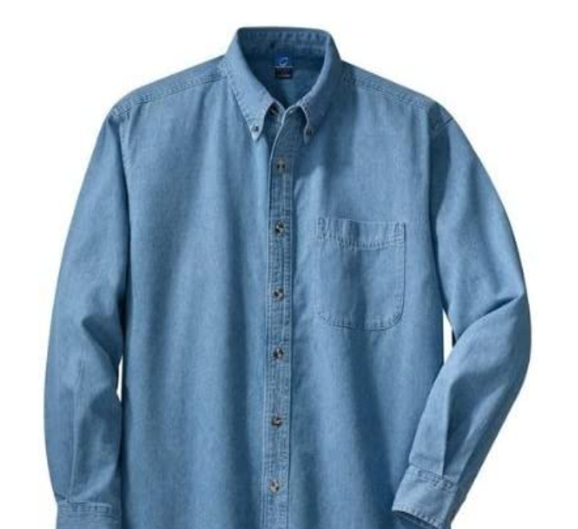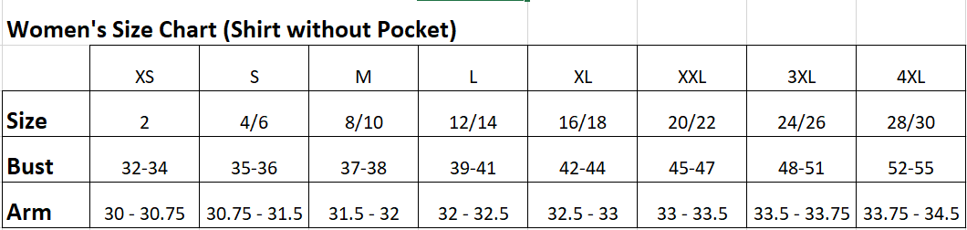

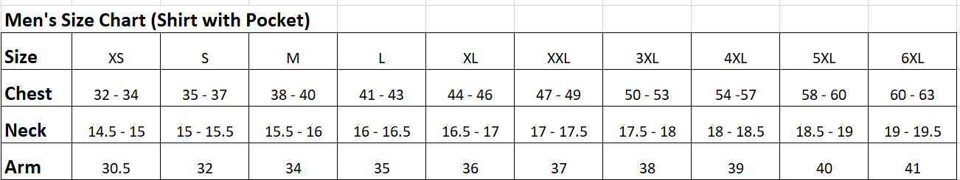

These NERC Logo Shirts are being produced by a “woman owned, cottage industry” in the USA.
The cost of these shirts is $38 for sizes up to XL and $42 for sizes 2X up.

To order your shirt please complete the order form below and send it via email to Kim at Cardinal Works (see below).

IMA 50th Anniversary Shirt Order Form

Name________________________________________ Phone #________________________________

Address______________________________________________________________________________

Email______________________________________________

Men’s Shirts $38 each |  |  | Women’s Shirts $38 each
Small |  |  | Small
Medium |  |  | Medium
Large |  |  | Large
X-Large |  |  | X-Large
Men’s Shirts $42 each |  |  | Women’s Shirts $42 each
2X-Large |  |  | 2X-Large
3X-Large |  |  | 3X-Large
4X-Large |  |  | 4X-Large
5X-Large
6X-Large

*Please fill-in the quantity of shirts next to the size you wish to purchase*

Shipping - flat rate of $10 per order

Please complete this order form and return it to kim@cardinalworks.com

Credit cards accepted: Visa, Mastercard, American Express

Card Number _________________________ Full Name on Card ________________________

Expiration Date _______________________ CVV number _____________________________

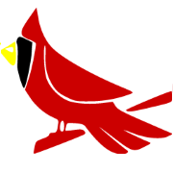
Cardinal Works
Embroidery & Custom Printing

